|  |  |  |
| --- | --- | --- |
|  | FACULTEIT LETTEREN EN SOCIALE WETENSCHAPPEN  **SINT-ANDRIESSTRAAT 2**  **2000 ANTWERPEN**  **BELGIE** | o:\My Pictures\KULeuven.jpg |
|  |  |  |
| Masterproef aangeboden tot het verkrijgen van het diploma Master of Arts in de **journalistiek** |  |  |
|  |  |  |

**Our schedule for tonight.**

**The programming of European PSBs:**

**its genres, origins and online presence**

Door: Jonathan Hendrickx

Promotor: Michaël Opgenhaffen

ACADEMIEJAAR 2015-2016

# Abstract

Deze Engelstalige masterproef behandelt de verscheidenheid in programmaties van verschillende Europese openbare televisieomroepen (PSBs). Van acht ervan werd de zender met het hoogste marktaandeel geselecteerd. De programmering van die acht zenders, werd nauwkeurig onder de loep genomen aan de hand van de televisiegidsen op de officiële websites van de omroepen zelf, op drie verschillende manieren.

Ten eerste werden alle uitgezonden programma’s tussen twaalf uur ’s middags en middernacht op zeven op voorhand vastgelegde dagen ingedeeld in een lijst van tien genres. Daaruit bleek dat de categorie *Drama* de meest populaire is, op de voet gevolgd door *News & Current Affairs* en het door sommigen voor openbare omroepen verguisde *Reality & Variety* op een derde plek.

Ten tweede werd het land van oorsprong van elk uitgezonden programma binnen dezelfde afgebakende periodes bepaald, om zo een overzicht te krijgen van de verhouding tussen eigen producties en geïmporteerde programma’s. Bij die tweede groep werd nog eens een onderscheid gemaakt tussen uitzendingen van Europese origine, van Amerikaanse origine en van een origine elders in de wereld. Dat onderzoek wees uit dat 75,2% van alle programma’s uit het eigen land komen, en dat dus iets minder dan een kwart geïmporteerd wordt. In totaal is 17,1% afkomstig uit andere Europese landen, bedraagt het percentage Amerikaanse geïmporteerde programma’s 6,5% en komt 1,2% uit andere gebieden in de wereld.

Ten derde werd er dieper ingegaan op *catch-up television*, of de mogelijkheid van openbare omroepen uit om hun publiek de kans te geven programma’s na hun lineaire uitzending (terug) te bekijken via het internet. Bijna twee derde van alle programma’s kunnen online teruggevonden worden na hun uitzending, maar de verschillen zijn hemelsbreed: bij de IJslandse omroep kan 98% teruggekeken worden, bij de Oekraïense tegenhanger amper 6%. De Vlaamse VRT is de tweede slechtste leerling van de klas, met slechts 22% van alle uitzendingen die integraal online teruggekeken kunnen worden. Een eigen videospeler wordt verwacht in de loop van 2017.

Tot slot zal geopperd worden om de onlinerol van openbare omroepen te verstevigen, en die ook te bestendigen door ze te verankeren in de namen van de openbare omroep zelf. Dat is de beste en meest zichtbare manier voor PSBs om aan te tonen dat ze naast op radio en televisie ook op het internet hu mannetje kunnen staan.

# Acknowledgements

It might be difficult to believe for people who read this, but I have to admit that I thoroughly enjoyed writing and compiling this master’s thesis. It enabled me to delve deeper than ever before in one of my pet interests, the wonder world of television, and its rich history and variety. Watching commercial breaks from the late 1980s on YouTube suddenly felt less wrong as I felt that in one way or another I could use it for the further development of this thesis.

First and foremost, I would like to thank my promotor, Michaël Opgenhaffen. To be honest, I never thought he, or any promotor for that matter, would accept my proposal of devoting an entire master’s thesis to the programming of European public broadcasters, but he did. During the course of writing this thesis, I made many changes to the research I wanted to carry out and the scope of it, but Mr. Opgenhaffen gave me a sense of sky-high liberty that I found most enjoyable to work with. After working with me for two years now – I also devoted my bachelor’s thesis to public broadcasting under his auspices – I’m convinced that he’s more than fed up with the topic by now. So to you, Mr. Opgenhaffen, thank you very much for sticking by me and answering my questions and emails (though not always instantly).

Secondly, I wish to thank my fantastic group of friends. You know that someone is a real friend when you can talk to him or her in the middle of the night about the amount of Drama broadcasts on Hungarian public television. I won’t write down all names here out of fear to leave someone out, but you know who you are and how I feel about you. Besides, this is not an Oscar acceptance speech, so no need to throw names around within 45 seconds holding a tiny golden statue in my hand.

And finally, special thanks to my boyfriend, who was always willing to endure my compelling tales about the lack of documentaries on Portuguese state TV, and thus now involuntary knows more about public broadcasting in Europe than 99.99% of the people he knows – the 0.01% being of course me.

# Table of contents

Preface 7

List of tables 8

List of figures 9

1 Literature study 11

1.1 On patchwork quilts. Defining public broadcasting 12

1.1.1 Conclusion 13

1.2 On common denominators. A history of European television 15

1.2.1 Western European television 15

1.2.2 Eastern European television 20

1.2.3 Conclusion 21

1.3 On remit. The relationship between PSBs and governments 23

1.3.1 The revenues of PSBs (1999 & 2013) 24

1.3.2 The cost of public broadcasting per country and per capita (2013) 25

1.3.3 The remit of PSBs 26

1.3.4 Case study: The Flemish management contract (2016 – 2020) 27

1.3.5 Conclusion 30

1.4 On ratings and shares. Measuring public broadcasters’ success 31

1.4.1 The Peoplemeter 32

1.4.2 Conclusion 34

1.5 On programming. The American dominance on Western European broadcasters 35

1.5.1 Imported television shows on European PSBs (1983) 35

1.5.2 Fiction on European TV channels (2006 – 2013) 38

1.5.3 Heritage of programmes broadcasted on European TV channels (2014) 39

1.5.4 Conclusion 39

1.6 On online. Public broadcasters and the Internet 40

1.6.1 Defining convergence 40

1.6.2 The EU’s ambiguous and passive stand 41

1.6.3 Online television: public broadcasters’ on-demand services 42

1.6.4 Conclusion 43

2 Research questions 44

3 Methodology 46

3.1 The constructed week sampling 46

3.2 Method 47

3.2.1 Genres 47

3.2.2 Imports 47

3.2.3 Online presence 48

3.2.4 Example of the chosen method 48

3.3 Selected broadcasters 49

3.3.1 Fact sheet 52

4 Results 53

4.1 Global results 54

4.1.1 Genres 54

4.1.2 Imports 54

4.1.3 Online presence 55

4.2 Results per country 56

4.2.1 Belgium (Flanders): Eén 56

4.2.2 Finland: TV1 58

4.2.3 Germany: ZDF 60

4.2.4 Hungary: Duna TV 62

4.2.5 Iceland: RÚV 64

4.2.6 Portugal: RTP1 66

4.2.7 Ukraine: Pershyi Natsionalnyi 68

4.2.8 United Kingdom: BBC One 70

4.3 Results per genre 72

4.3.1 Drama 72

4.3.2 Comedy 72

4.3.3 Documentary 73

4.3.4 Lifestyle & Infotainment 73

4.3.5 Sport 74

4.3.6 Animation & Children 74

4.3.7 News & Current Affairs 75

4.3.8 Reality & Variety 75

4.3.9 Factual 76

4.3.10 Other 76

4.4 Results per day 77

4.4.1 Monday (1 February 2016) 77

4.4.2 Tuesday (16 February 2016) 77

4.4.3 Wednesday (16 March 2016) 78

4.4.4 Thursday (10 March 2016) 78

4.4.5 Friday (26 February 2016) 79

4.4.6 Saturday (13 February 2016) 79

4.4.7 Sunday (6 March 2016) 80

4.5 Conclusions 81

4.5.1 Genres 81

4.5.2 Imports 82

4.5.3 Online presence 84

5 Discussion 85

5.1 Suggestions for the future of PSBs 87

5.2 Recommendations for further research 90

5.3 Possible pitfalls 91

Bibliography 92

Books and (online) journal articles and papers 92

Websites, news articles and press releases 95

Appendices 98

# Preface

This master’s thesis will ultimately argue three things:

1. That Drama is the most common genre appearing on the most popular European public television channels;
2. That over three quarters of all programmes aired consists of local productions
3. That roughly two thirds of all programmes is available to be watched (again) via the Internet, using an online viewing platform operated by the public broadcaster itself.

Those findings will be preceded by a literature study divided into six chapters, each dealing with different compartments belonging to the scientific field of research on public service broadcasters (PSBs). The chapters include:

1. Attempting to form a suitable definition for public broadcasting
2. Trying to write a coherent history of European PSBs and their common history
3. Providing a clear overview of the variety of existing relationships between PSBs and their respective governments
4. Describing the ambivalent relationships between PSBs and viewing figures or ratings
5. Focussing on existing research on the heritage of programming on European PSBs, with special attention given to the American impact
6. Presenting an overview of the at times difficult relationship between PSBs, their governments and the Internet.

At the end, I will discuss how the results of my study can be interpreted in different ways, what the figures could possibly mean, and how future research in the same field(s) could possibly be carried out by future students and/or researchers.

# List of tables

**Table 1:** Revenues of European public service broadcasters in 1999 and 2013

(Brants & De Bens, 1999; Vanhaeght et al., 2015) 22

**Table 2:** The total funding, price of the license fee and actual funding per capita of public broadcasters

in 2013 (Vanhaeght et al., 2015) 23

**Table 3:** The basis of the programme requirements set for PSB and their obligation and monitoring

(Betzel, 2003; Hendrickx, 2016) 24

**Table 4:** TV Ratings & TV Audience Measurement across the World (ITVE.org, 2007) 30

**Table 5:** Imported television shows per broadcaster in the year 1983 (Varis, 1985) 33

**Table 6:** Main sources of imported programmes in Western and Eastern Europe in the year 1983

(Varis, 1985) 33

**Table 7:** Heritage of programs aired at public broadcasters in 2014 (Vanhaeght et al., 2015) 36

**Table 8:** On-demand services of European public broadcasters (Vanhaeght et al., 2015) 39

**Table 9:** Selected days to investigate as part of the constructed week sampling

(Hendrickx, 2016) 43

**Table 10:** Combined genres (Film Victoria, 2010) 44

**Table 11:** Selected countries and their main public channels (Hendrickx, 2016) 47

**Table 12:** Imported television shows per broadcaster in 1983 & 2016

(Varis, 1985; Hendrickx, 2016) 79

# List of figures

**Figure 1:** Belgium – genres (example) 47

**Figure 2:** Belgium – imports (example) 48

**Figure 3:** Belgium **–** online presence (example) 48

**Figure 4:** Countries to be investigated 49

**Figure 5:** Global results – genres 53

**Figure 6:** Global results – imports 53

**Figure 7:** Global results – online presence 54

**Figure 8:** Belgium (Flanders) – genres 55

**Figure 9:** Belgium (Flanders) – imports 56

**Figure 10:** Belgium (Flanders) – online presence 56

**Figure 11:** Finland – genres 57

**Figure 12:** Finland – imports 58

**Figure 13:** Finland – online presence 58

**Figure 14:** Germany – genres 59

**Figure 15:** Germany – imports 60

**Figure 16:** Germany – online presence 60

**Figure 17:** Hungary – genres 61

**Figure 18:** Hungary – imports 62

**Figure 19:** Hungary – online presence 62

**Figure 20:** Iceland – genres 63

**Figure 21:** Iceland – imports 64

**Figure 22:** Iceland – online presence 64

**Figure 23:** Portugal – genres 65

**Figure 24:** Portugal – imports 66

**Figure 25:** Portugal – online presence 66

**Figure 26:** Ukraine – genres 67

**Figure 27:** Ukraine – imports 68

**Figure 28:** Ukraine – online presence 68

**Figure 29:** United Kingdom – genres 69

**Figure 30:** United Kingdom – imports 70

**Figure 31:** United Kingdom – online presence 70

**Figure 32:** Genres – drama 71

**Figure 33:** Genres – comedy 71

**Figure 34:** Genres – documentary 72

**Figure 35:** Genres – lifestyle & infotainment 72

**Figure 36:** Genres – sport 73

**Figure 37:** Genres – animation & children 73

**Figure 38:** Genres – news & current affairs 74

**Figure 39:** Genres – reality & variety 74

**Figure 40:** Genres – factual 75

**Figure 41:** Genres – other 75

**Figure 42:** Days – Monday 76

**Figure 43:** Days – Tuesday 76

**Figure 44:** Days – Wednesday 77

**Figure 45:** Days – Thursday 77

**Figure 46:** Days – Friday 78

**Figure 47:** Days – Saturday 78

**Figure 48:** Days – Sunday 79

**Figure 49:** Inform, educate & entertain 81

**Figure 50:** Origin of all imported programmes 82

**Figure 51:** Online presence – comparison 83

# 1 Literature study

The literature study of this master’s thesis aims to present a comprehensive overview of the most informative and known works on European public television broadcasting and the major subjects that it entails. It is divided into six subchapters:

* Chapter 1 provides an overview of existing definitions of what public broadcasting exactly is, and aims to provide a unique one based on those.
* Chapter 2 draws a compact historic overview of the major turning points in (public) television in the 20th and early 21st century, with specific attention given to the wave of deregulation in the 1980s and the launch of private television.
* Chapter 3 discusses the ways how public broadcasters’ programmes are measured in terms of ratings, viewing figures and eventually, success.
* Chapter 4 aims to portray a European overview of the various existing relationships between European public broadcasters and their national governments funding them, focussing on the remit that is expected to be provided. A case study on Flemish public broadcaster VRT delves deeper into the management contracts between the VRT and the Flemish government.
* Chapter 5 focusses on the programming of public broadcasters, more specifically on the heritage of programmes aired and the alleged American domination of foreign programmes aired.
* Chapter 6, finally, presents a summary of the changing dynamics of public broadcasters in the last years, as they moved some of their activity to the world wide web and digital television. Special attention is given to the rise of and differences in on-demand services set up by European public broadcasters.

## 1.1 On patchwork quilts. Defining public broadcasting

*'If everyone demanded peace instead of another television set, then there'd be peace.'*

John Lennon, British singer and songwriter

What is public broadcasting, and how does one define public service broadcasters (PSBs)? A myriad of definitions exists, and even though they all share the same intrinsic principles, there are notable differences in nuances and word use.

Basically, most definitions agree on the fact that it is impossible to define public broadcasting. In the introduction of the book *Public Service Broadcasting in a Multichannel Environment*, first published in 1993, University of Utah professor Newton Minow sees a global consensus in what public service means and stands for, information, education, culture and entertainment, but he also finds these concepts to be so broad that further refinement is needed (Avery, 1993). According to professors Kees Brants and Els De Bens in *Television Across Europe. A comparative introduction* (2000), there is not one theory of generally accepted notion of what public service broadcasting stands for: “[the] patchwork quilt we call the West European broadcasting system was, roughly until the 1980s, based on a belief that the programmes produced one way or the other had to be in the public interest.” Paddy Scannell writes in *British Television. A reader* (2000) that the last parliamentary committee to report on British broadcasting – the 1986 Peacock Committee – noted that it had experienced some difficulty in obtaining a definition of the principle from the broadcasters themselves. In a similar Committee a quarter of a century earlier, the chairman of the BBC’s board of governors had allegedly said that “It was no use trying to define good [public] broadcasting – one recognized it” (Scannell, 2000).

Some of the definitions found in literature focus on the different course of public broadcasting in recent decades. Daniel Biltereyst (2001) writes in a chapter of the book *Western Broadcasting at the Dawn of the 21st Century* that “the old public broadcasting model – with its proclaimed high standards of programming and its regulatory framework requiring it to inform, educate and entertain – was theoretically dominant across Europe, but its practical organization and output strategies were far from unequivocal.” He gives the example of Scandinavia, with a strong traditional vision of public service broadcasting, and of Spain, whose public corporation mainly depended on advertising revenue and commercial programming strategies (McQuail, 1995, in Biltereyst, 2001). The aforementioned Brants & De Bels compare between past and present as well: “It is only recently, with the system more or less in crisis, that decision makers are consciously referring to and nostalgically embracing what are seen as the functions of public broadcasting (Brants & De Bels, 2000).

Attempts have been made to define what public broadcasting exactly is or should be. A UNESCO paper published in May 2000 by WRTVC Chairman Pierre Juneau defines public broadcasting as “a meeting place where all citizens are welcome and considered equal. (...) Its mandate is not restricted to information and cultural development – public broadcasting must also appeal to the imagination and entertain. But it does so with a concern for quality that distinguishes from commercial broadcasting.” The American professor Robert Avery, colleague of Newton Minow, claims in the same book that public service broadcasting “was conceived and fostered within an overarching ideal of cultural and intellectual enlightenment of society” (Avery, 1993). The EBU, the world’s leading alliance of PSBs, claims on its website that “[their] Members believe in a transparent world of communication for the common good, creating content that freely informs, educates and entertains the public, and continue striving to perform to the highest standards with moral integrity and maximum efficiency.” In October 2012, all active EBU Member – 73 broadcasters from a total of 56 different countries – signed *The Declaration on the Core Values of Public Service Media*, identifying six core values shared by public service media (PSM):

1. **Universality**

The PSM aim to reach and offer their content to all segments of society, with no-one excluded. Everyone, everywhere, underlining the importance of sharing and expressing a plurality of views and ideas.

1. **Independence**

The PSM want to be trusted programme-makers, trustworthy in all programming, in all genres and formats, from news to entertainment, from science to sport, from culture to education.

1. **Excellence**

The PSM act with high standards of integrity and professionalism and quality, and strive to create benchmarks within the media industries.

1. **Diversity**

The PSM’s audiences consist of a diverse range of interest groups: differing generations, cultures, religions, majorities as well as minorities. The PSM strive to be diverse and pluralistic in the genres they program, the views they express and the people they work with.

1. **Accountability**

The PSM want to listen to their audiences and engage in a permanent and meaningful debate, whilst remaining transparent and subject to constant public scrutiny.

1. **Innovation**

The PSM want to enrich the media environment of the countries and regions they work in, by striving to be a driving force of innovation and creativity and aiming at new formats, new technologies and new ways of connectivity with their audiences.

### 1.1.1 Conclusion

It is clear to see that there is no clear-cut definition of PSBs. The most common ground can be found in the *The Declaration on the Core Values of Public Service Media*, which does not aim to provide a definition either, but does list a set of values that are signed, and thus shared, by all of the EBU’s active member broadcasters. Giving a personal definition of something that cannot be defined properly is most certainly not easy, but one attempt is the following:

Public broadcasting is a service that has the mission to inform, educate and entertain the general public, in a way that has to be notably different from the means that commercial broadcasting use. As in the majority of the cases the general public pays for its public broadcasting, directly or indirectly, it has the right to expect first-class information, education and entertainment for anyone and at any time.

The following announcement will be a spoiler alert, but this small chapter of the literature study will actually serve as the perfect preamble for what is to come, both in this literature study as well as the actual research and its results. The impossibility to come up with one wholesome definition for what public broadcasting is, will only be confirmed by the upcoming closer looks at other aspects of PSBs, and their humongous differences.

## 1.2 On common denominators. A history of European television

*'Watching television is like taking black spray paint to your third eye.'*

Bill Hicks, American stand-up comedian and musician

As previously proven, there is no general definition of what public broadcasting exactly is or entails. However, when looking at the course of public broadcasting in Europe throughout the 20th and early 21st century, there are many striking similarities to be found. The aforementioned Newton Minow (1993) claims in the foreword of his *Public Service Broadcasting in a Multichannel Environment* that there is a remarkable similarity among countries in the identification of important public service issues.

By no means does this part of the literature study aim to be a complete and comprehensive overview of the roughly 80 years of history that European television has spawned thus far. Instead, it wants to provide a brief glance of how thinking and acting on public broadcasting and television as a whole have changed throughout the decades.

### 1.2.1 Western European television

#### 1.2.1.1 Until the 1980s: The monopoly era

The first national broadcasting organisation in Europe, and the entire world, was the British Broadcasting Corportation or BBC, founded in the United Kingdom in 1922, according to Paddy Scannell (2000). The main purpose of having a centralized, state-owned broadcaster was to avoid an expansion of licensed broadcasters, which had caused chaos in the United States. Throughout the 1920s and 1930, the majority of the European countries experienced similar issues with fights over air waves, and subsequently emulated the British model (Scannell, 2000). Esteve Sanz (2012) writes that the first BBC Charter, enacted in 1927, influenced the BBC and many European broadcasters to see broadcasting as a source of information, culture and education for the masses.

Bignell and Fickers (2008) write that prior to the outbreak of the Second World War in 1939, regular television broadcasts were already available in the United Kingdom and Nazi Germany. Both countries showed their broadcasts initially in cinemas or specially created viewing rooms, called *fernsehstuben* in German. By 1937, over a hundred pubic venues for viewing television broadcasts had emerged in the United Kingdom (Corrigan, 1990, in Bignell & Fickers, 2008). According to Amoudry (1997) in Hickethier (2008), British television broadcasts were suspended entirely during the Second World War, which led to a worldwide stagnation of television development.

After the War, television in Western European countries rapidly emerged as a medium for the propagation of consumption, leisure and individualism, as opposed to its philosophy as means of implementation of ideology and political values to the individual in the Eastern countries (Hickethier, 2008). Television spread as a contagious virus in all European countries in the 1950s and 1960s, with public broadcasters starting regular television broadcasters across the continent. In Belgium, the NIR/INR (*Nationaal Instituut voor de Radio-omroep/Institut National de Radiodiffusion*), was founded in 1930, with nationwide radio broadcasts starting in early 1931, as stated by Antoine, d'Haenens, and Saeys (2001). However, regular television broadcasts did not start until the 31st of October 1953, simultaneously in both the Dutch-speaking Flemish side in the north and the French-speaking Walloon side in the south of Belgium (Antoine, d’Haenens and Saeys, 2001).

Gerhard Eckert (1965) distinguished a certain European style of style of television which had developed in the 1950s, in spite of the different institutional settings and political contexts. The style was marked by the purpose of being a nationalised and largely independent media entity. Eckert claimed that the ideology of public service broadcasting, in accordance with its aim to educate, is perhaps the strongest common denominator of the diverse European television landscape (Eckert, 1965 in Hickethier, 2008). Similarly, Hilde Van den Bulck (2007) mentions Dejonghe (1999), who claims that television policy in the 1950s and 1960s can roughly be divided into two parts, applicable for a large portion of European public broadcasters:

1. Many broadcasters emerged as monopolistic public institutions, leading to policies adopted from similar, modern institutions which serve as models, such as the British Broadcasting Corporation (BBC).
2. Many broadcasters operated from their inception within their local possibilities and needs of the cultural hemisphere. In the Flemish case, this resulted in a clear Flemish policy, away from the in the 1950s still dominant French language, also educationally and culturally. This policy was not enforced by a government or other larger players, but rather derived from the developments within the television sector (Dejonghe, 1999 in Dhoest & Van den Bulck, 2007).

#### 1.2.1.2 The 1980s and onwards: The deregulation era

According to a European Commission report by Esteve Sanz (2012), the current economic and cultural logic of television ratings, which had been leading the American television industry since its very inception, was of minor importance for European public broadcasters in the 1970s. The various different European political cultures were mirrored in their respective regulated broadcasting systems. Whereas Scandinavian countries developed independent public broadcasters, countries such as Belgium saw a decentralized broadcasting system with strong politicised elements (Sanz, 2012). A new broadcasting decree for then BRT was enacted by the Flemish government in December 1979, as stated by Saeys (2007). It enabled that same Flemish government as of 1980 to appoint high civil servants in BRT’s Board of Directors, to vote in all governing bodies and to check on the financial situation of the broadcaster (Saeys, 2007 in Dhoest, 2007).

The 1980s saw a surge in the amount of private television channels funded through advertisements. The market shares and daily audiences of public broadcasters declined as a result of the sudden competition with new, private broadcasters. At the end of the 1990s, the television industry was already involved in the digitization and the Internet, bringing the promises of openness into the core of the medium again (Sanz, 2012).

Looking closer at legislation, the European Commission released a green paper[1] on “Television Without Frontiers” in 1984. At first the paper wanted to remove barriers to the free movement of television programmes across the continent, bearing in mind cable and Pay TV and programme sponsorship. Ten years later, the Council of Europe’s Fourth European Ministerial conference on Mass Media Policy said that public broadcasters “should supply broad and varied programming that is informative, invites public debate and caters to all segments of the population” (Brants & De Bens, 2000). The competence of national Member States in the funding of public sector broadcasting was confirmed in the Amsterdam Treaty, enacted in 1999 (Sanz, 2012). In more detail, it recognized the role of public service broadcasters in providing for democratic, social and cultural needs that are not met by the market, as written on the official website of the European Union (2015).

As the PSBs in Europe were all at least partly owned by their national governments, all broadcasters had to follow guidelines and laws stipulated by those governments looking over them and at the same time (partly) funding them. Coppens, d’Haenens and Saeys (2001) distinguish five major periods in Western European broadcasting regulation:

1. The first broadcasting laws enacted in the early 1920s were purely for technical norms, as no regulation was needed.
2. Most developed countries passed actual broadcasting legislation between roughly 1925 and 1935, including the establishment of state monopolies on broadcasting in many countries.
3. Throughout the 1940s and 1950s, all existing broadcasting regulation had to be adapted to the arrival of television. Up until then, broadcasting had been a matter uniquely reserved for radio.
4. In the 1980s, state monopolies were abandoned and massive deregulation from governments more in favour of private enterprise revolutionized broadcasting.
5. Since the early 21st century, broadcasting has become more international in nature and is converging with other media such as the Internet (Coppens, d’Haenens & Saeys, 2001).

As of the 1980s, changes were noticed in the political views on broadcasting. Many of the obligations on programming were relaxed or entirely removed, and the new-founded private broadcasters had to undergo far fewer restrictions. Dahlgren (2000) suggests that the so-called deregulation of public service broadcasters had three key elements:

1. The break-up of the monopolies of public service broadcasters, enabling a more competitive television landscape.
2. The commercialization of broadcasting, enabling the launch of private service broadcasters with advertising as their source of income.
3. The so-called transnationalization (Dahlgren, 2000). This for instance enabled Belgian private channel VT4 upon its launch in 1995 to transmit to Flanders in Dutch, but from London. According to Antoine, d’Haenens and Saeys (2001), VT4 was granted a license by the Flemish Commissariat for the Media in January 2001, after the monopoly of the main Flemish private broadcaster VTM was put to an end through the Advertising Decree of April 1998.

It is important to note where the sudden urge of deregulation emerged from. Dahlgren claims it all started with much larger, ideological shifts in the political climate of western societies. Before the deregulation in the 1980s, the decades after the second World War had been marked by ‘regulation’: social welfare states were developed within capitalist economies, based upon the general consensus that society had to guarantee a minimal level of well-being for its citizens. According to Sylvia Harvey (2000), this started to fade away in the 1970s due to the global oil crisis and the subsequent development of a strong, international neo-liberal political shift to the right in most European countries. The so-called Thatcherism, after the late former Conservative British Prime Minister Margaret Thatcher, entailed many previously public bodies and services being sold off, privatized and operated for profit (Harvey, 2000). Public service broadcasting was said to be ineffective, too bureaucratic and less creative. Private service broadcasting, on the other hand, would be giving the public what it wanted. However, the general pattern is that commercial broadcasters tend to display considerably less diversity in the programming, because of their economic logic aimed at the ‘great middle’ (Dahlgren, 2000).

As the deregulation ties in with larger changes in ideological climate, both are inseparable from larger social developments. Cultural differentiation, related to the large immigrant populations in many Western European countries, gave those societies more pluralism in its composition and shape. The cultural differentiation has risen especially in the domain of leisure and consumption. As the degree of affluence of most West Europeans increased in the 1960s and 1970s, more people became engaged in a consumer-based leisure, causing markets to expand and the general public having far more options. This suggests that it is now much more difficult to satisfy the ever growing television audience with just one or two channels, but also that the audience will be more fragmented across the various channels they can choose from (Dahlgren, 2000). That shift led to the emerging television landscape and the abundance of channels that we are nowadays accustomed to.

In the 1980s and early 1990s, public service broadcasters (PSBs) all across Europe saw a steep fall in ratings as they had to undergo the loss of their monopoly, the introduction of competition, deregulation and an overall ideological shift in favour of market forces, processes of media globalization and the increasing cultural diversification of the population. According to Hultén and Brants (1992), there are basically three ways for PSBs to respond:

1. Adaptation: to abandon the public service vision and to copy the style of the rival commercial broadcasters.
2. Purification: to ignore ratings and competition and pursue its own vision, unaffected by competition
3. Compensation: to adjust to the new realities. The compensation strategies vary greatly, but are all framed by the dilemmas of adaptation – begging the question why viewers should pay a license fee to see what they can watch for free at private service broadcasters – and purification – begging the question why viewers should pay a license fee for programmes only watched by an elite minority. This way to respond was generally pursued by most PSBs (Dahlgren, 2000).

#### 1.2.1.3 The 2010s: The Audiovisual Media Services Directive

In recent regulations, the European Union enacted the Audiovisual Media Services Directive (AVMSD) in 2010, as stated on its official website, Europa.eu (2015). The directive requires EU countries to coordinate their national legislation and to follow minimum standards for the following:

* Advertising, with rules and restrictions for products such as tobacco, and no more than 12 minutes of advertising per hour.
* Major events, such as the Olympics, which must be available to a wide audience.
* Protecting children, with violent and/or pornographic programmes only scheduled late at night or with limited access through parental control.
* Promotion of European films and audiovisual content, with at least half of the schedules of European television broadcasters having to be allocated to European films and television programmes.
* Accessibility, with all audiovisual content made accessible to people with visual or hearing impairments (Europa.eu, 2015).

Between 6 July and 30 September 2015, the European Commission organized a public consultation on the AVMSD for all inhabitants of the European Union to fill out. 434 replies were counted, the majority of which came from national representative associations and non-governmental associations (both 18%). The highest amount of replies per country were counted in the United Kingdom (49), Germany (31) and Belgium (29). For more details on the replies garnered by the European Commission, see Appendices 1 and 2 (Digital Agenda for Europe, 2015). Preliminary trends observed in the consultation indicate three key points thus far:

1. There is a convergence of views in the need for possible rule changes on the scope of application of the AVMSD.
2. There is support for maintaining the current status quo as regards the country of origin principle, accessibility for persons with disabilities, listed events, short news reports and right of reply.
3. There is no clear consensus on commercial communications, the protection of minors and the promotion of European works (Digital Agenda for Europe, 2015).

A full report of the consultation is to be published online “in due course”. The results will feed into an evaluation of the AVMSD and the Impact Assessment which accompanies the new legislative proposal in the course of 2016. On 4 March, the European Commission released a press release about three studies that it has commissioned to prepare the revision of the AVSMD. These studies will deal with:

1. The exposure of minors to alcohol, advertising on TV and on online services;
2. The on-demand audiovisual markets in the European Union (2014 and 2015 developments);
3. A study on data and information on the costs and benefits of the AVMSD. (Digital Agenda for Europe, 2015).

#### 1.2.1.4 Private broadcasting: Not so new at all

The public service model, implemented in the 1920s and 1930s, was generally dominant in Europe until approximately the mid-1980s, when commercial, private broadcasters started taking up market shares and viewers due to the widespread deregulation. However, commercial broadcasting in Europe was founded as early as 1929, with the launch of Luxembourg’s national broadcaster CLT, which was private from the start. Today CLT is better known as RTL of the RTL Group, a leading European entertainment company with television and radio stations in many different European countries, including Belgium, The Netherlands and Germany (Brants & De Bens, 2000). With the exception of two Western European countries, public TV channels held on to their monopolies until the late 1980s.

European commercial television started in the United Kingdom. In 1954, ITV (Independent Television) was founded, challenging the BBC television broadcasts (Scannell, 2000). As the BBC had done before, ITV too served as a model for other broadcasters in Europe, but mainly in microstates such as Monaco and the aforementioned Luxembourg. Those states, with too few residents to pay license fees and fund a television station, opted for advertising revenues from the start and deliberately aired their programmes to neighbouring countries as well (Hickethier, 2008). Finland was the second European country where commercial broadcasting was founded, with broadcasts funded by commercials starting in 1957. MTV, not to be confused with Music Television as it stands for “Mainos-TV”, Finnish for “Advertisement Television”, was established as an independent private company. It had to pay 20% of the money it gained by broadcasting commercials to the public broadcaster YLE, and in exchange, it received 20% of the airtime on its eventual two channels, YLE TV1 and YLE TV2. In all other European countries, commercial television would not emerge until the 1980s. (Brants & De Bens, 2000).

### 1.2.2 Eastern European television

So far, we have looked extensively at the history and course of public services television in Western Europe. But for a complete European picture, we need to look at the other end of the Iron Curtain as well. Surprisingly little literature is available on the history of Eastern European television. In December 2010, the fifth book in the Italian-based series *Il filo d’Europa* appeared, edited by Cigognetti, Srvetti & Sorlin. concentrating on the research report of the project “Media and community culture. A European history through TV”. It focuses in-depth on how broadcast systems of seven Eastern European countries represented and represent national and international history in their broadcasts, and contains insightful information on the workings of public broadcasters in Eastern Europe, now and in the past.

A few examples come from Hungary and the former Czechoslovakia, which prove Hickethier right when he said earlier on this literature study that Eastern countries’ broadcasters had the philosophy as means of implementation of ideology and political values to the individual (Hickethier, 2008). As a perfect means to entertain the masses and spread the view of the Communist Party on national and international history, the two Hungarian state television channels MTV1 and MTV2 invested extensively to enable themselves to produce their own historical programmes, as stated by Vincze (2010). The most important and relevant program in Hungary during the reign of the Soviets was, unsurprisingly, the history program *Száza-dunk*, or “Our Century”, which ran for 23 years between 1965 and 1988 (Vincze, 2010). Alternatively, the state broadcaster of Czechoslovakia was marked by the erratic scheduling of its programmes, according to Ferenčuhová (2010), with Documentary series usually being broadcasted only once a month or vanishing after one or a few episodes had been broadcasted. A brief surge of social and political liberation in 1968 had caused more critical and recent programming, but following the occupation of Czechoslovakia in August 1968 following the Warsaw Pact, the content on the state broadcaster again became ideologically rigid, with many of the Western features being replaced by Soviet ‘ideologically appropriate’ films and all discussion programmes disappearing from the screen. Between 1990 and 1993, the state broadcaster as well as the country itself were split into two, and on January 1, 1993, Slovakia and the Czech Republic got their own public broadcasters, STV and ČT. (Ferenčuhová, 2010).

It wasn’t until after the fall of the Iron Curtain and the many coups d’état that subsequently followed all across the East of Europe that the availability of Western television programmes on Eastern European television vastly increased, according to Mihelj (2012). Local audiences as well as broadcasters were curious about things Western, after decades of heavily restricted and politically loaded cultural exchanges. A similar pattern was that in the early 1990s, the public broadcasters in Eastern Europe too were suddenly confronted with competition from private broadcasters. The public broadcasters had to seek cheap ways to fill schedules and at the same time retain audiences, creating a boost in the popularity of American Drama series such as *Dallas* and *Beverly Hills 90210* (Mihelj, 2012).

### 1.2.3 Conclusion

As happened before in this literature study with a definition of public broadcasting, shaping a one clear-cut history has proven to be fairly complicated as well. Coppens, d’Haenens and Saeys (2001) have attempted to extrapolate four major models for public broadcasting all of Europe, both West and East, classifying them according to the political and legal forces that affect them:

1. The authoritarian model, which aims to make broadcasting a part of the State. Radio and television are to support the government at any cost.
2. The Communist model, which is often perceived as a subcategory of the authoritarian model, but does have some distinctive features, as it prohibits private media ownership. The media are instead owned by the working class, i.e., the Communist Party.
3. The Western, Paternalistic model, which operate with the top-down approach: media policy is a product of what the authorities believe the audience needs and wants. Most European broadcasters are good examples of this model, and they illustrate how their functioning has been evolving into the fourth model.
4. The Western, Libertarian model, which focuses on the media’s commercial or advertising function, which is argued to have become the third function of the media besides providing information and entertainment, in order for broadcasters to assure financial independence (Coppens, d’Haenens & Saeys, 2001).

Finally, Coleman and Rollet also notice similar patterns in the rise of public broadcasting in Europe in *Television and Europe* (1996) and thus are able to provide an appropriate vision of the course of public broadcasting that was followed nearly everywhere identically. They say that public television started with a single national channel per country, with the emerge of a second national channel from the 1960s on. Both channels would be administered, financed and of course influenced by the state. As commercial channels were founded and state monopolies were abandoned, tensions rose across broadcasters in the entire continent between the two roles that the public broadcasters had until then both taken upon them: the role of the protector and promotor of a nation’s cultural and linguistic heritage, and the role of entertainer which is required to increase the rating figures. (Coleman & Rollet, 1996).

The rating figures will be further elaborated upon in the fourth chapter of this literature study.

## 1.3 On remit. The relationship between PSBs and governments

*'Seeing a murder on television can help work off one's antagonisms. And if you haven't any antagonisms, the commercials will give you some.'*

Alfred Hitchcock, British film director and producer

From its inception, public broadcasting services in Europe were fully supported by their governing bodies. Gradually throughout the decades, the majority of the PSBs have been allowed to broadcast a (limited) amount of commercials or to have specific programmes sponsored. The story is very different per different broadcast, with opposite moves and regulations existing. Indulging in the specific state of any broadcaster would lead us too far, but in this chapter, a brief overview of the key regulations and broadcasters is presented.

According to Brants and De Bels (2000), public television channels in Europe are mostly funded through license fees. Online dictionaries such as Business Dictionary describe a license fee as “a form of a use tax charged by government entities for the granting of a license to conduct an activity.” Or to put it simpler and in the television perspective: people who want to “use the public service broadcasting”, as in watching and listening to programmes broadcast on television and radio channels, have to pay for it, directly or indirectly. Most of the time, the license fees are collected by official authorities, with only a few exceptions: the BBC in the United Kingdom and the ÖRF in Austria collect the fees themselves (Brants & De Bels, 2000). The same goes for DR in Denmark, NRK in Norway and SVT in Sweden, as stated by Vanhaeght (2015) and her fellow researchers. While most countries use or have used a form of license fee or tax to be paid by the general audience, not in every country do the corporations themselves receive the full amount of fees or taxes paid. That makes public service systems vulnerable to and dependent on political decision making (Brants & De Bels, 2000).

As the new commercial channels turned out to be extremely successful in all European countries upon their launch in the mid-1980s, the public service broadcasters who already were allowed to air a limited amount of commercials saw a sharp fall in their advertising revenues. For instance, according to Ros and Thomass (2007), the German state broadcaster ARD saw its commercial revenue decreasing from 19% in 1988 to a mere 4.1% six years later. In some European cases, public broadcasters were allowed to air advertisements long before commercial television would enter the local television landscape. In The Netherlands for instance, the STER (*Stichting Ether Reclame*), the foundation that broadcasts ads on Dutch public radio and television, was founded as early as 1965. According to the Dutch Advertising Code (2011), STER is not allowed to exceed the legal maximum of 10% of the airing time per year and 15% per day to schedule commercials. Programmes may also not be interrupted for commercials, but instead only be broadcast before and afterwards (Dutch Advertising Code Authority, 2011).

The fact that the ways of funding a public service broadcaster in Europe have always been very far apart from each other, is proven by two very contrasting examples, in Spain and Denmark. After the fall of the Franco regime in 1975, the Spanish government decided that its state broadcaster RTVE was to be financed by advertising revenue and only very limited public financing, a then unique situation in Europe (Brants & De Bels, 2000). In the year 1999, Spanish public broadcaster RTVE received only 13% of its income via a license fee, with an astounding 75% coming directly via advertising and/or sponsoring (European Audiovisual Observatory, 1999, in Brants & De Bels, 2000). In 2009, the right-wing government promised a sudden overhaul of all existing Spanish public financing law, and as of January 1, 2010, all RTVE broadcasts have been commercial-free, as stated by Elola (2015). The broadcaster saw a revenue of over €450 million annually evaporate, and the implemented tax levied on private broadcasters for airing extra commercials did not result in the expected break-even. The state entity now has debts of over €700 million euros, and continues to lose money (Gómez, 2011 in Elola, 2015).

In Denmark on the other hand, there are two state broadcasters, DR and TV2, of which only TV2 is allowed to broadcast a limited number of commercials, as stated by Jauert, Poulsen & Søndergaard (2007). The newly elected right-wing government in 2002 proclaimed that it would privatize TV2 within 100 days, but it failed to do so (Jauert et al., 2007). As of 2016, its privatization is still pending. TV2 remains the only legal commercial broadcaster in Denmark, but is still owned by the government as well, according to Svendsen (2011). Until 2004, both public broadcaster DR and private broadcaster TV2 received money from the license fee. Even on TV2, commercials are still only allowed in between programmes (Svendsen, 2011).

### 1.3.1 The revenues of PSBs (1999 & 2013)

The table underneath is a merger of two existing tables on the revenues garnered by public service broadcasters in different European countries, split between revenues obtained via public financing and advertising and/or sponsoring. By “public financing”, we mean both money paid by the residents of the respective country in direct taxes and/or license fees and government funding. “Commercial revenues” contain advertisements and sponsoring, but also program sales to other broadcasters. The first half of the table derives from the European Audiovisual Observatory and deals with figures from 1999. The second half comes from a study on public broadcasting, ordered by the Flemish government and published in June 2015 by the universities of Brussels, Antwerp and Leuven. Its figures are applicable for the year 2013.

|  |  |  |  |  |
| --- | --- | --- | --- | --- |
| **Country** | **1999** | | **2013** | |
| **Public financing (in %)** | **Commercial revenues (in %)** | **Public financing (in %)** | **Commercial revenues (in %)** |
| Austria | 46 | 53 | 61 | 39 |
| Belgium (Wal)[2] | 65 | 34 | 71 | 29 |
| Belgium (Fla)[3] | 69 | 31 | 66 | 34 |
| Denmark | 91 | 9 | 89 | 11 |
| France | 44 | 56 | 83 | 17 |
| Ireland | 35 | 65 | 59 | 41 |
| Norway | 97 | 3 | 98 | 2 |
| Sweden | 94 | 6 | 94 | 6 |
| Switzerland | 71 | 28 | 76 | 24 |
| The Netherlands | 69 | 22 | 70 | 30 |
| United Kingdom | 78% | 15% | 71% | 29% |

***Table 1:*** *Revenues of European public service broadcasters in 1999 and 2013 (Brants & De Bens, 1999; Vanhaeght et al., 2015)*

Elaborating extensively on the differences in financing of every listed nation’s broadcaster would lead us too far. If anything, the figures prove that public financing has increased in some countries, with heavy upticks in Austria, France and Ireland. In the case of France, the heavy decrease in advertising and/or sponsoring can be explained by a law enacted in 2009 by the French parliament that forbids all channels of the French public broadcaster France Télévisions to air commercials between eight o’clock in the evening and six o’clock in the morning. Notable as well is the superior position of public service broadcasters in Scandinavian countries, where the neo-liberal thinking of the 1980s which had largely marked the end of the era of only public financing for public broadcasters never really took off (Vanhaeght et al., 2015). In some cases, the figures do not add up to a complete 100%. That is because sometimes, broadcasters have other ways of funding which do not fall in the public or commercial category. That is proven at the revenues of Flemish broadcaster VRT published in its 2014 annual report, where 2.7% of all earnings yielded was categorized as “Other incomes”, without further specification. Results for the year 2015 were not yet available. (VRT, 2015).

### 1.3.2 The cost of public broadcasting per country and per capita (2013)

The Flemish research conducted by Vanhaeght and her colleagues in 2015 provides insightful figures on three aspects of funding of PSBs for the year 2013:

1. Firstly, the table underneath shows the total funding of a public broadcaster per country.
2. Secondly, it shows the amount of the license fee, which is not used in every European country and is the only way of garnering earnings directly from a nation’s tax payers.
3. Thirdly, it shows the financing of public broadcasters per capita, or how much of one person’s tax money goes to it. This figure differs from the amount of the license fee, as it has been stated earlier that not all of the money that the license fee generates actually goes to the public broadcaster.

|  |  |  |  |
| --- | --- | --- | --- |
| **Country** | **Total funding**  **(in million €)** | **Price of the annual license fee**  **(in € & if applicable)** | **Funding per capita**  **(in €)** |
| Austria | 1008 | 193.92 | 118.82 |
| Belgium (Wal) | 324 | / | 70.34 |
| Belgium (Fla) | 449 | / | 68.59 |
| Denmark | 561 | 323.68 | 100.27 |
| France | 3727[4] | 131.00[5] | 58.55 |
| Ireland | 364 | 160.00 | 76.29 |
| Norway | 682 | 343.42 | 133.86 |
| Sweden | 831 | 239.96 | 86.24 |
| Switzerland | 1312 | 375.60 | 163.96 |
| The Netherlands | 834 | / | 49.66 |
| United Kingdom | 7135 | 171.32 | 111.34 |

***Table 2:*** *The total funding, price of the license fee and actual funding per capita of public broadcasters in 2013 (Vanhaeght et al., 2015)*

Again, a full review of the amounts would make this literature study far too elaborate. But some cases jump to the eye and have to be noted: the license fee was abolished in Belgium and The Netherlands. In the case of The Netherlands, this happened in 2000 because of risen collection costs, according to a 2006 report by the Electronics Communications Committee. In exchange, the income tax was increased, in order for the Dutchmen and –women to pay indirectly for their public broadcaster NPO. (Electronics Communications Committee, 2006). Walloon broadcaster RTBF has the smallest budget with 324 million euros to spend in the year 2013. Unsurprisingly, the British BBC and French France Télévisions make the two best funded state broadcasters.

### 1.3.3 The remit of PSBs

In an unpublished paper for a conference of the EPRA (European Platform for Regulatory Authorities) in Naples in May 2003, Dutch researcher Betzel lists EU-documents that stress the pivotal role of public broadcasting in society (Betzel, 2003):

* In 1997, The Protocol to the Amsterdam Treaty clarified that every Member State had to set up and organise its own public broadcasting system, had to define its public service remit and had to provide for the funding of that public service.
* In 1999, a Resolution of the European Council stated that public service broadcasting needed to be enabled to strive for providing a wide range of programming in accordance with its remit, in order to address society as a whole.
* In 2001, the European Commission said that it required its Member States to give clear definitions of the remit of their public broadcasters, to entrust that remit to one or more broadcasting organisations, and to establish effective means of monitoring its fulfilment (Betzel, 2003).

The aforementioned “remits” mean that for the funding that public broadcasters receive from governments, they expect something in return. Betzel gives the example of specific audiences at which PSBs should aim their programmes, such as ethnic minorities and disabled people. In all countries, the remits are defined in Decrees, Charters or Media Acts, varying per different European country. The way PSBs are to be held accountable for their programme activities, as well as the control of the way PSBs fulfil their remit, is very different from country to country. Greece, Albania, Bulgaria and Romania are the only European countries without existing remit (Betzel, 2003). The relationship between governments and public broadcasters is expressed a myriad of different ways. In some countries, contracts and charters are agreed upon every few years to renew the relationship, but in other countries, state laws simply stipulate the guidelines for broadcasting, sometimes only public, but sometimes also private. The following is a merger of two tables by Betzel, stipulating the basis of the programme requirements set for PSB by each national government, and if and how the requirements are reported and monitored. Where necessary, the table was updated with more recent information.

|  |  |  |  |
| --- | --- | --- | --- |
| **Country** | **Basis** | **Obligation to report** | **Monitoring by media authority** |
| Belgium (Flanders) | Management Contract | To the Flemish Government | By the Flemish Regulator for the Media |
| Finland | Law | To the Finnish Communications Regulatory Agency | By the Finnish Communications Regulatory Agency |
| Germany | Specific Interstate Treaties | No | No |
| Hungary | Law | To the Hungarian Parliament | No |
| Latvia | Agreement (with media authority) | To the National Broadcasting Council | By the National Broadcasting Council |
| Portugal | Contract of Concession | To the Ministry of Finance | No |
| Spain | Law | To a Follow Up Commission | No |
| Sweden | Charter (with government authority) | To the Swedish Government and the Swedish Broadcasting Commission | By the Swedish Broadcasting Commisison |
| The Netherlands | Law | To the Dutch Media Authority (*Commissariaat voor de Media*) | By the Dutch Media Authority |
| United Kingdom | Internal: BBC  License: others | To the Independent Television Commission | By the Independent Television Commission |

***Table 3:*** *The basis of the programme requirements set for PSB and their obligation and monitoring (Betzel, 2003; Hendrickx, 2016)*

As always, the differences are remarkable. In Germany, public broadcasting is arranged through treaties per *Bundesland* or state, and they have no obligation to report to any government or regulatory body. In several countries, there is no monitoring by an independent media authority, whereas one authority exists for both reporting and monitoring in Finland, Sweden and the United Kingdom.

### 1.3.4 Case study: The Flemish management contract (2016 – 2020)

After declining rating figures in the early 1990s, due to the very popular launch of commercial network VTM, the Flemish broadcaster then known as BRTN made an internal overhaul. As of 1996, the organization became a public limited company, which according to Van den Berghe (2010) guaranteed more autonomy and a normal functioning, comparable to that of any economic corporation. Along with the new corporation form, it was decided that the Flemish broadcaster and the Flemish Government would have to agree on and sign new management contracts every five years. This step was generally seen as a positive one, as the contracts provide a much more transparent system of reporting about reaching the required policy objectives, both to the government as the general public (Van den Berghe, 2010). Management contracts were enacted in 1997, 2001, 2006, 2011 and 2015, and all took effect the following year. The current management contract, running between 1 January 2016 and 31 December 2020, was agreed upon by the VRT’s own Board of Governors, led by president Luc Van Den Brande and vice-president Ellen Van Orshaegen (VRT, 2016), and Sven Gatz, Minister of Media in the Flemish Government as a representative of the liberal party Open VLD. It was signed formally at a press conference on 21 December 2015 (Minister of Media Gatz & VRT, 2015).

In the management contract, the ten brands that the VRT comprises are formally stipulated:

* Three television channels (mainstream channel Eén, “highbrow” channel Canvas, and children’s channel Ketnet)
* Five radio channels (“highbrow” channel Radio 1, mainstream channel Radio 2, alternative channel Studio Brussel, classical channel Klara and youth channel MNM)
* One news website (deredactie.be, slated to be transformed into vrtnieuws.be in the course of 2016)
* One brand present on television, radio and the Internet related to sports (Sporza, which takes time from the aforementioned channels for all sports broadcasts airing on VRT (VRT, 2016)).

The management contract starts from six basic values:

1. Independent and reliable.
2. Excellent and qualitative service.
3. For everyone and with everyone.
4. Flemish identity in its diversity.
5. Creative, innovative and durable.
6. Open, transparent and constructive.

Alongside these values, the contract stipulates that the VRT will operate in the following five years within the framework of seven strategic objectives:

1. **Relevant for everyone**

The VRT has to reach as many Flemings as possible with a value-driven offer in its programming.

1. **Information, culture and education are prioritized**

The VRT gives main attention to information, culture and education, both broadened and compounded.

1. **Public added value for entertainment and sports**

Education and sports with an added educative, informative and/or creative value with regard to social cohesion form an integrant part of the VRT’s mission.

1. **Renewed brand strategy with VRT as quality label**

The VRT is responsible for a varied portfolio in brands, which aim to reach all Flemings. VRT as a brand name will be used to underline the differentiated character of the public offer.

1. **Future-oriented, digital and innovative**

The VRT will evolve into a digital media organization, simultaneously consolidating its online offer and investing in the development of innovative narrative structures and formats.

1. **Reinforcement of the media-ecosystem**

The VRT stimulates a qualitative strong and economically liveable landscape to maintain a pluralistic and diverse offering in an ever more internationalized context.

1. **Efficiency and a nimbler organization structure**

The VRT continues to work on a more modern, nimble and dynamic media organization, computing the Transformation Plan that will take effect in the course of this management contract (Flemish Government, 2015). The Plan ties in with the new management contract. It will be developed in the course of 2016, and has to make sure that the VRT can become a smaller, yet more effective corporation. Without additional measures, the VRT would suffer a deficit of over 25 million euros by 2020 (Debackere, 2015). On 26 April 2016, the Board of Directors approved of a proposal of the Transformation Plan. It was enacted that a maximum of 215 jobs would be cut, of which between 70 and 80% would happen through natural outflow. Trade unions have stated that they will try to maintain all jobs (Rens & Van Poucke, 2016).

Furthermore, the management contract stipulates the financing of the VRT. Between 2015 and 2019, 29.5 million euros will be cut from its annual budget, with the government funding gradually decreasing from 294.4 million euros in 2013 to 261.4 million by 2020. In exchange, its commercial revenues are allowed to increase from 61.4 million euros in 2013 to 72.8 million annually as from 2016 (vrt.be, 2016). Commercial revenues are gathered from advertisements on radio channels and sponsoring of radio and television broadcasts. The VRT’s three television channels will thus remain ad-free, regardless of the sponsoring and so-called *Boodschappen van algemeen nut* (personal translation: messages of general use), which allow government institutions, humanitarian organizations and subsidized cultural movements to inform the public in advertisement-like infomercials (var.be, 2016).

Finally, the management contract concludes with an exhaustive list of performance criteria that the VRT has to fulfil. These criteria deal with matter such as the reach of VRT’s brands and on- and off-screen presence of minorities. A few examples:

* Every week, the VRT has to reach at least 85% of the entire Flemish population with at least one of its brands.
* In all of its own programming, the VRT has to make sure that by the year 2020 at least 40% of all people on-screen is female and at least 7.5% is member of a minority.
* The VRT will continue to offer online news to expats and people interested in Flanders in English, French and German.
* By 2017, an online video platform will launch, enabling Flemings to watch the VRT’s own programming on demand (Flemish Government, 2015).

### 1.3.5 Conclusion

If we can draw any definite conclusions from what has been outlined so far in this literature study, it is that definite conclusions are impossible to draw, as the media landscape and regulations vary greatly amongst different European countries. As it was impossible to find one clear definition of what public broadcasting exactly entails, finding one shared history, one shared means of measuring PSB success and now as well one kind of relationship between PSBs and their local governments has proven to be impossible. The VRT uses a management contract in its contacts with the Flemish government, but their eastern neighbours from Germany use interstate treaties, whereas their southern neighbour Austria has all of its rules for PSB stipulated in the state law. And while public broadcasters in France and Spain have encountered tighter rules on airing advertising, the Flemish VRT has been enabled the right to gather more commercial revenues.

To put the European differences in perspective, an entirely different story can be found in the United States. According to an article in The Washington Post by Brad Plumer (2012), the American public television and radio broadcasters PBS and NPR receive just 15% and 2% respectively of their annual budget from the government, with corporate sponsorship and merchandise deals as main sources of income instead (Plumer, 2012).

We now know the different ways in which European PSBs obtain their funding, necessary to output programmes. But those programmes must of course be enjoyed by a considerable part of the local audience for them to stay on the air – just as it happens with private broadcasters. This subject will be tackled in the next subject of this literature study.

## 1.4 On ratings and shares. Measuring public broadcasters’ success

*'Television is chewing gum for the eyes.'*

Frank Lloyd Wright, American writer and architect

According to Sanz (2012), and as stated in previous chapters of this literature study, the public broadcasters in Europe had their broadcast monopoly until somewhere in the 1980s. Viewing figures had not mattered that such up to then, as in most cases there were only one or two national channels that the audience could choose from. It was only when commercial television was launched and the actual competition to gain television viewers started, that ratings began to matter properly and public broadcasters around Europe adopted the logic of ratings and audiences. Sanz claims that the “ratings language” became hegemonic across all the major players in the media landscape, and that public broadcasters started scheduling more “commercial” programmes to counter the sudden success of private broadcasters. The author goes on arguing that the new media landscape, including fragmentation of audiences, has led to a switch from the traditional, quantitative ratings culture to the new and more qualitative culture of communities and the emergence of undergoing and complex projects towards its monetization (Sanz, 2012). A UNESCO essay published in 2000 about public broadcasting by WRTVC Chairman Pierre Juneau has “universality” as main principle of public broadcasters, implying that PSBs have to aim to be “used” by the largest possible number. That does not imply that ratings should be optimized at all times, but rather that PSBs should endeavour to make the whole of their programing accessible to the whole population. Further on, Juneau questions ratings as a means of evaluation, claiming that they are ill-suited for measuring the public broadcaster’s success in fulfilling its mandates and missions. Beyond ratings, PSBs must measure the public’s satisfaction with their broadcasting as well. This has to be done to the extent that public broadcasting will be perceived as different and necessary, even for those who listen less to radio or watch less television (Juneau, 2000).

In most Scandinavian countries public broadcasters are the biggest players in the local television landscapes, whereas in many Eastern European countries, they continue to fail to reach great audiences, reserved for public broadcasters. In countries such as the United Kingdom, though, genuine rating wars have been going on for decades between public broadcaster BBC and private broadcaster ITV. As reported by Foster (2015) in The Daily Telegraph, ITV accused BBC in November 2015 that its “intensively competitive” scheduling damaged ITV’s broadcasts, by repeatedly putting on their own shows such as *Strictly Come Dancing* and *Silent Witness*, long-running winners in British ratings, against ITV content such as *The X Factor* and *Broadchurch* (Foster, 2015). BBC’s approach, be it “intensively competitive” or not, seems to pay off nonetheless: in March 2016, BBC One averaged a market share of 21.06%, compared to 12.04% for ITV One (BARB, 2016). On 11 May, The Daily Telegraph headlined “BBC told to stop race for ratings”. Reporter Patrick Foster wrote that the BBC’s founding mission statement, “to inform, educate and entertain”, will be rewritten for the first time ever. The need for distinction and impartiality will be added to the adapted version. An additional postscript will contain more detailed information about “how programmes should be clearly delineated from those offered by the commercial sector”. The Department for Culture, Media and Sport of the British government noted about the original mission statement that it was very “broad”, and currently causes the BBC to risk “competing for ratings” rather than quality or distinctiveness, “under the entertainment banner” (Foster, 2016).

### 1.4.1 The Peoplemeter

Winfried Schulz (2000) argues that the audience makes television a mass medium, but at the same time a television program creates its mass audience. Viewing figures, or from here on referred to simply as ratings, are of paramount interest for program managers, television producers and advertisers as a means of measuring the success of a certain broadcast. If a program has high ratings it is assumed to have met the viewers’ needs and interests, which is one criterion of responsiveness and accountability of a television channel (Mitchell & Blumler, 1994 in Schulz, 2000).

Audience measurements have to be standardized and reliable. In 1997 the European Broadcasting Union (EBU), the world’s leading alliance on public service broadcasters, undertook an initiative with the aim to make the existing European rules on audience measurements more compatible across countries (EBU, 1997 in Schulz, 2000). The so-called Peoplemeter has become the standard technique of measuring audiences globally. Meter equipment is attached to a television set and records what program on what channel is being watched and by who. The data logistics of this system allows for both a swift preliminary result and an elaborate statistical analysis, usually available to the public within 24 hours (Schulz, 2000). Even though the arithmetic procedures used in calculating the audience size may differ per country, the terms used in ratings research are universal. A few of the key terms, along with their definitions:

* A rating is the average percentage of the entire population of a country or region viewing across a specified period of time. Ratings can relate to individuals as well as to households.
* The number of viewers is calculated by multiplying the ratings with the base number of the population.
* A (market) share is the percentage of the population tuned to a particular program or channel out of all those using television at that time.
* The reach is the percentage of the population who saw a specified amount of a program or of a channel over a specified period. For instance, in the United Kingdom, the defined conventional amount is three consecutive minutes.
* Some countries use an Appreciation Index, a score which indicates how much each broadcast is liked by its viewers (Schulz, 2000).

An Icelandic example, derived from Gallup (2016): the screening of an episode of the American crime series *Castle* on the first channel of the local state broadcaster, RÚV, on Friday 18 March 2016 scored a rating of 20.4%:

* The rating figure means that of all Icelandic people aged between the ages of 12 and 80, over one fifth watched *Castle*.
* That rating translates into a number of viewers equalling 50.000.
* The market share was 62%, meaning that of all Icelandic people aged between the ages of 12 and 80 watching television during the broadcast of *Castle*, 62% watched that very broadcast.
* The total reach was 25.2%, meaning that over one quarter of all Icelandic people aged between the ages of 12 and 80 watched at least a portion of the episode.

Even though the rules and principles have somewhat been standardized, various market research institutes are active across Europe to measure the success of television broadcasts. A few examples:

|  |  |  |
| --- | --- | --- |
| **Country** | **Research Institute** | **Peoplemeter since** |
| Austria | GfK Austria | 1991 |
| Belgium | CIM | 1997 |
| Bulgaria | TNS | 1999 |
| Estonia | TNS Emor | 2003 |
| France | TRCC Médiamétrie | 1989 |
| Greece | AGB Nielsen Media Research | 1988 |
| Italy | AGB Italia | 1986 |
| Lithuania | TNS Gallup | 2000 |
| Switzerland | IHA-GfK | 1985 |
| United Kingdom | BARB | 1981 |

***Table 4:*** *TV Ratings & TV Audience Measurement across the World (ITVE.org, 2007)*

In the case of very small European countries, no automated audience measurement system exists. Antoine (2000) gives the example of Luxembourg, where every day 1000 interviews are conducted via telephone. The interviewees are members of a panel comprising 3522 individuals, and they are asked solely to report which channels they watched between 7:30 PM and 8:30 PM. This automatically creates skewed figures that cannot be compared to ratings in other countries. For instance, due to the large Portuguese diaspora active in Luxembourg, the international channel of Portugal’s state broadcaster RTP had a market share of 5.4% in 2000, based on the interviews (Antoine, 2000).

Finally, it’s important to note that measuring the success of broadcasts has in fact been a long term activity by some European PSBs, but of course not in the way as we know it today. According to Joke Bauwens (2007), the Flemish public broadcaster, then known as BRT, started investigating what viewers were watching and listening to as well as how they enjoyed the broadcasts already in 1969. Today, the collected data is not exactly regarded as the most trustworthy because of the rudimentary research methods used (Bauwens, 2007 in Dhoest & Van den Bulck, 2007). The BRT was in fact the first broadcaster worldwide which also investigated the appreciation of broadcasts among their viewers, instead of simply measuring viewing figures, as stated by Leo Bonte (2003). 1500 Flemings were required to keep a diary of all programmes they watched, and to write down whether they rated them as “very good”, “good”, “adequate”, “inadequate” or “bad”. Prior to the Peoplemeter by the CIM in 1997, the BRT had started using an *audimeter* (audience meter) in 1988, with a panel of just 300 families throughout Flanders (Bonte, 2003).

### 1.4.2 Conclusion

In many of the debates sparked in recent years over public broadcasting comes the eternal question as to if, how and why rating figures should matter to a public service broadcaster, which after all relies on funding from the state government and not from advertisers. The previous example of the BBC and ITV in the United Kingdom has proven that in some cases, commercial broadcasters accuse their public counterparts of being too competitive. In a 2005 essay entitled *Impact or content?: Ratings vs Quality in Public Broadcasting*, Associate Professor of Media Studies at the VU Amsterdam Irena Costera Meijer claims that the dilemma of ratings versus quality can be pushed further to a new dimension, in which programme-makers of public broadcasting need to identify a third group of viewers, next to the two already existing and commonly known groups. Besides having the consumers and the citizens, as well the ‘enjoyers’ have to be taken in account. Only when the addition of the concept of the ‘enjoyer’ is integrated in professional quality discourse, will it be possible to supersede the dilemma (Meijer, 2005). On a final note, the Flemish public broadcaster VRT attempts to answer the pivotal question “How important are ratings to a PSB?” in the Frequently Asked Questions-section of its website. The answer translates as follows:

“Ratings are important, as they prove that the VRT fulfils its mission: to reach a maximum audience possible in Flanders with its content. The reach is one of the performance criteria that the Flemish government has set in the agreement with the VRT. However, the figures of the Appreciation Index too matter, as they show directly whether or not a program is perceived as quality by the viewers (VRT, 2015).”

## 1.5 On programming. The American dominance on Western European broadcasters

*'I find television very educating. Every time somebody turns on the set, I go into the other room and read a book.'*

Groucho Marx, American comedian and film and television star

It has been discussed earlier that whilst public broadcasting has existed and still exists in a myriad of forms across our continent, there are at the same time striking similarities. This part of the literature study will emphasize one typical case exemplifying and proving that point: the ever so popular imported American shows on all European public broadcasters, and the debate it has sparked since decades. The means of this chapter is to serve as an interlude to a much more and current in-depth study on the programming of European public television broadcasters, which is currently an existing void in PSB research.

According to Daniel Biltereyst (2001), one obvious consequence of trade regulation was the growing, worldwide success of US cultural products. This also had its effect on television and the programming across Europe. In the late 1980s, the policy-makers of the European Commission had heavily – and successfully – lobbied for the deregulation of the media industries and the abandonment of the broadcast monopolies once held by public broadcasters. Ironically enough, the sudden proliferation of new channels did not result in the expected growth in production and employment within the local audio-visual sector. On the contrary: especially the US cultural industry benefitted the most. The most problematic category was fiction, in both movies and series. Fiction accounted for a share of up to 40% of a broadcaster’s television output, and the demand for popular fictional material has increased exponentially as a result of the increasingly competitive nature of the European audio-visual scene (Biltereyst, 2001). The massive imports of American television products already began in the 1960s and soared in the 1970s, when the international flow of television programmes began to intensify (Browne, 1968 and Fortner, 1993 in Biltereyst, 2001). This is proven by a testimony of Rita Vanhoudt in the 2004 book *De Jaren ’60. (On)bekend en (on)bemind*, who writes about her Flemish youth in the 1960s and the role of television in it: ‘Everyone loved *Peyton Place[6]*. (...) Cycling, news broadcasts, *Bonanza* [7]and *The Flintstones*[8]: those were the most popular shows around (Vanhoudt, 2004 in Kerff & Smeets, 2004).

### 1.5.1 Imported television shows on European PSBs (1983)

In an essay called *International Flow of Television Programmes*, first published in 1985 by UNESCO and written by Finnish media professor Tapio Varis, figures are given for the percentage of imported television shows per broadcaster in the year 1983. A few examples:

|  |  |  |  |
| --- | --- | --- | --- |
| **Country** | **Broadcaster** | **Imported programmes in 1983 (in %)** | **Imported programmes in 1983 broadcast in prime time (in %)** |
| Austria | ÖRF | 43 | 61 |
| Belgium (Flanders) | BRT[9] | 28 | 33 |
| Belgium (Wallonia) | RTBF | 29 | 28 |
| Denmark | DR | 46 | 32 |
| Finland | YLE | 37 | 37 |
| Germany | ARD | 13 | 7 |
| Hungary | MTV[10] | 26 | 35 |
| Iceland | RÚV | 66 | 66 |
| Portugal | RTP | 39 | 39 |
| United Kingdom | BBC | 15 | 21 |

***Table 5:*** *Imported television shows per broadcaster in the year 1983 (Varis, 1985)*

In the same essay, Varis as well compiled rankings of the origin of the imported television programmes from all European broadcasters of the year 1983. He made a distinction between broadcasters on both sides of the Iron Curtain, which was at that time still effectively and visually dividing the European continent into two parts.

|  |  |  |  |
| --- | --- | --- | --- |
| **Western Europe** | | **Eastern Europe** | |
| Source area | % of total import | Source area | % of total import |
| United States | 44 | USSR | 24 |
| United Kingdom | 16 | Federal Republic of Germany | 16 |
| Federal Republic of Germany | 7 | France | 11 |
| France | 5 | United Kingdom | 8 |
| Other Western Europe | 8 | United States | 5 |
| East Europe & Soviet Union | 3 | Czechoslovakia | 3 |
| Eurovision | 7 | Hungary | 4 |
| Co-production | 4 | German Democratic Republic | 4 |
| Other countries | 6 | Italy | 4 |
|  |  | Yugoslavia | 3 |
|  |  | Other countries | 18 |
| TOTAL | 100 | TOTAL | 100 |

***Table 6:*** *Main sources of imported programmes in Western and Eastern Europe in the year 1983 (Varis, 1985)*

The differences between West and East are very clear. Especially the dominance of American imported programmes in the Western hemisphere catches the eye. Unsurprisingly, its share in the Eastern block was far less impressive, but mainly programmes from the Soviet Union were purchased and rebroadcast on various other broadcasters.

Biltereyst mentions a comparative research conducted in 1988 by Dutch researcher Ben Manschot, in which he analysed the programming schedules of television stations in Belgium, The Netherlands, Germany and the United Kingdom between 1965 and 1986. One of the many interesting outcomes of Manschots analysis is that fiction had increasingly become more popular, but while the imported fiction from countries such as the United States had tripled, the production of domestic Drama production had heavily gone in decline (Manschot, 1988 in Bilteryst, 2001). Figures from Euromedia showed that the share of American fiction on European television had increased from 36% to 56% between 1988 and 1991. In that same period, the share of home-made fiction had fallen from 37% to 17% (De Bens, 1992, in Biltereyst, 2001). Needless to say, such an example of American dominance in a strong strategic economic domain soon enough became a major topic on the European policy agenda. In 1989, the “European Without Frontiers” proposal was approved and took effect in October 1991 for all broadcasters within the European Community, which then only comprised twelve European nations, as written by Castille (2001). The proposal stated the “deregulatory principle of mutual recognition of channels in the EC” (Humphreys, 1996 in Bilteryst, 2001), but also included protectionist quotas reserving a majority of broadcasting time for European material; a clear move against American imports (Biltereyst, 2001). Biltereyst claimed in 1995 that the American fiction on European television channels was so ubiquitous that it stimulated convergence and undermined Europe’s cultural diversity. European viewers do however invariably prefer locally made fiction, which yields higher ratings than imported fiction from countries such as the United States (Biltereyst, 1995).

To summarize: the policy line of deregulation among European broadcasters on the West side of the Iron Curtain, both public and private, throughout the 1980s actually reinvigorated the flood of imported programmes. Most television stations had developed a strategy of audience maximization, based on extended airtime and cheap popular shows. In the case of private broadcasters, this was to maximize profits by running advertisements, in the case of public broadcasters in order to regain audiences. Thus, the US and its blooming television and movie sector turned out to be the main economic beneficiary of the Western European deregulation scheme (Biltereyst, 2001).

#### 1.5.1.1 *Dallas* as the global hit show of the 1980s

The impact of popular imported television series such as the primetime soap opera *Dallas* in the 1980s was so enormous in the European continent that the Dutch language even created a word for it: *dallasificatie*, or dallasification. In a 1991 essay, professor Els De Bens claimed that it the so-called dallasification had rendered itself inevitable. The Flemish public broadcaster, then known as BRT, started to broadcast episodes of *Dallas* on Thursday evenings. The aim was to counter the popular programmes on the Dutch public broadcaster NPO which were extremely popular among Flemish viewers as well until the launch of private broadcasting in 1989 (Antoine, d’Haenens and Saeys, 2001). As BRT saw its market share decline steeply from 53% to 31% between 1989 and 1990, it had to intervene. But without proper budget for more domestically produced fiction serials, only more popular American imports would be necessary. On a side note: research indicated that of all Flemish viewers watching foreign channels, an astounding 74% did so to watch American imported serials, either subtitled by the Dutch public broadcaster, without subtitles at the British BBC or dubbed into French or German at TF1 and ARD respectively (De Bens, 1991).

*Dallas* had its peak in the early 1980s, both in the United States and Europe. According to an article in The Guardian by William Leath, an estimated 360 million people worldwide witnessed how Kristen was revealed as the shooter of J.R. Ewing, with the episode first airing in November 1980 in the US and later on across the European continent. In Germany, *Dallas* started airing in June 1980 on state broadcaster ARD, without commercials and dubbed into German, as stated by Moran (2000). Melodrama was suddenly revalorized in a popular television genre. This was then taken up in locally produced series such as *Die Schwarzwaldklinik*, which owed a direct debt to the American prime time soap operas (Hofmann, 1988; Kreutzner and Seiter, 1995 in Moran, 2000). According to Allen (1996), in West-Germany alone, *Dallas* had a record audience of 22 million viewers in 1983. The series ended its run after fourteen seasons in May 1991.

### 1.5.2 Fiction on European TV channels (2006 – 2013)

A report published by the European Audiovisual Observatory published in February 2015, written by André Lange and entitled *Fiction on European TV channels (2006 – 2013)*, sampled public broadcasters programming schedules in 17 different European countries within a time lapse of seven years. The key findings were published in a press release. The report shows that there is consistently less fiction being aired among European public broadcasters: from 53.1% in 2006 to 50.5% in 2013. Lange also researched the origin of the fiction programmes aired, making a distinction in five different kinds:

1. Films produced for television (so-called TV movies)
2. Series and soap operas
3. Animated series (omitting feature-length animated movies)
4. Feature-length cinema movies (including animated movies)
5. Short films

Ironically, the cultural and education channels in Europe (with as examples BBC Four in the United Kingdom and Canvas in Flanders), which generally offer the least amount of fiction, devote the most airtime to fiction works of European heritage, with 78.3% of the scheduled fiction; just under one-third consisted of national programmes and two-thirds were imported or were co-productions. The general-interest public service channels devoted 57.6% of their broadcasting schedules to fiction in 2013, with a majority of that figure being non-national works, and thus imported. Unsurprisingly enough, the main origin of non-European fiction works, in all of the aforementioned five categories, is the United States (Lange, 2015).

For a more detailed view of the origin of fiction programmes broadcast by channels in the 17 investigated European countries, see Appendix 3.

### 1.5.3 Heritage of programmes broadcasted on European TV channels (2014)

Flemish research carried out by Vanhaeght and her fellow researchers in 2015 sheds light on the heritage of television content in 2014. The figures in the table underneath do not exclusively count for fiction, but for all programmes aired at a number of public broadcasters in Europe.

|  |  |  |  |  |
| --- | --- | --- | --- | --- |
| **Country** | **Locally produced content (in %)** | **European imported content (in %)** | **American imported content (in %)** | **Other imported content (in %)** |
| Austria | 54.3 | 17.7 | 25.4 | 2.6 |
| Belgium (Fla)[11] | 58.9 | 25.7 | 11.0 | 4.4 |
| Denmark | 43.8 | 27.8 | 18.1 | 10.3 |
| France | 34.1 | 18.2 | 28.8 | 18.9 |
| Norway | 39.1 | 40.9 | 5.9 | 14.1 |
| Sweden | 53.0 | 32.1 | 9.3 | 5.6 |
| Switzerland | 61.4 | 14.1 | 22.2 | 2.3 |
| The Netherlands | 84.2 | 12.0 | 2.4 | 1.4 |
| United Kingdom | 94.3 | 0.5 | 4.1 | 1.1 |

***Table 7:*** *Heritage of programmes aired at public broadcasters in 2014 (Vanhaeght et al., 2015)*

The figures show that especially the public broadcasters in Switzerland, The Netherlands and the United Kingdom (respectivly SRG SSR, NPO and BBC) are majorly self-sufficient and heavily rely on local productions. Meanwhile, DR in Denmark, France Télévisions in France and NRK in Norway rely on foreign productions to fill their schedules for a majority of the time. When looking at the American imported productions specifically, it is notable that Austrian ÖRF and French France Télévisions gives over a quarter of their screening time to programmes imported from the United States. The Dutch NPO and British BBC on the other hand spend the least amount of time on them.

We have to keep in mind that all broadcasters listed above are expected to follow the guidelines of the Audiovisual Media Services Directive, which has been discusses earlier in this literary study. It effectively enforces all European public broadcasters to devote at least half of their broadcasting time to productions originating in the European continent, excluding news broadcasts, sports broadcasts, competitions, commercials and teleshopping (Vanhaeght et al., 2015).

### 1.5.4 Conclusion

This chapter of the literature study has provided us with interesting statistics on the programming techniques of European public television broadcasters, even though they are sometimes outdated or fragmented. A detailed research of what exactly is broadcasted remains to be carried out. The ultimate aim of this master’s thesis is of course to fill that currently existing void.

## 1.6 On online. Public broadcasters and the Internet

*'Television is a medium because anything well done is rare.'*

Fred Allen, American comedian and radio host

In the sixth and final part of the literature study, we shall look at another type of relationship. The surge of the Internet in the late 20th and early 21st century has had its impact on everyone and everything in life, including public broadcasters. Their dynamics were forced to change drastically, moving some of the offered services to the world wide web. As literature in the course of this chapter will show, public broadcasters have moved up to some extent – varying per country and broadcaster – part of their activity solely to the virtual sphere. As it thus seems as if the Internet has emerged as an additional medium on which public broadcasters are expected to serve people, like radio and television, it is more than relevant to take a closer look at the relationship between the public broadcasters and the Internet.

According to Murdock (2000), the age of analogue communications is giving way to a new media landscape based on digital technologies. Instead of broadcasting waves, there is only a stream of separate 0s and 1s. The key to the future of television is to stop thinking about television as television (Negroponte, 1995 in Murdock, 2000). In spite of its age, this definition has not become obsolete at all. Instead, it has proven to be a leitmotiv of where television is heading towards as of 2016. Providers such as Netflix are enabling millions of people worldwide to select from a sometimes huge catalogue of television shows and movies, to watch whatever they want to, whenever they want to. Both private and public broadcasters had to follow suit in order to maintain their audiences. This changed the dynamics of the previously mentioned relationships between European PSBs and the governments funding them. According to Betzel, the public broadcasters in the United Kingdom, the Netherlands, Germany, France, Portugal, Latvia and Bulgaria had a specific part of their annual budget allocated purely for online activity as early as in 2003. Furthermore, PSM in Denmark, Finland, Belgium (Flanders), Luxembourg and Austria already underwent strict rules in advertising on their Internet activities, in the same year (Betzel, 2003). More recent figures seem impossible to come by.

### 1.6.1 Defining convergence

Convergence has always been a key term in the changing online processes of providers such as newspapers and television broadcasters. A myriad of definitions exists, and it is interesting to see how they have changed throughout the last decades.

In its influential Green Paper on convergence enacted in 1997, the European Commission defined convergence as ‘the ability of different network platforms to carry essentially similar kinds of services’ (European Commission, 1997, in Murdock, 2000). The then current convergence can be identified into three major meanings, of which the first one relates to this literature study. The convergence of cultural forms is defined as Internet websites managing to bring all major forms of expression (speech, music, written text, tables of figures, ...) together in one place (Murdock, 2000). Finnemann (2006) claims that the word convergence is a poor term to define the development of an increasingly complex and all-new matrix. The Web enables us to get everything directly on our screen, wherever and whenever we want it. However, the convergence of communication channels implies divergence of the markets and services offered by the converging branches: convergence of broadband channels for phones, TV and internet implies divergence of content and use (Finnemann, 2006). In a 2013 article in the *Journalism Practice* journal, authors Papathanassopoulos and his colleagues argue that convergence, along with digitalization, is the major driver for the demand of new media services, as they have affected the structure of the whole media environments. The authors see the media landscape evolving from a traditional press-broadcasting approach to more personalized and on-demand solutions. The evolvement has singlehandedly accelerated the fragmentation of global media. Traditional linear television broadcasts and daily newspapers are overlooked as an entire new generation of consumers seeks news on the Internet (Papathanassopoulos et al., 2013).

### 1.6.2 The EU’s ambiguous and passive stand

Aslama and Syvertsen (2006) write that Scandinavian public broadcasters have been in the forefront of digital developments. That situation begged the question on the role of PBSs in the ever-expanding multi-channel and multi-media markets. The Internet has become too important for it to be excluded entirely from public service operations, but its role in the service palette and its possible commercial features have been the subject of debate in many countries (Aslama & Syvertsen, 2006). For instance, the news website of the Flemish public broadcaster VRT will cease to exist in its current form, as a free, nation-wide accessible and commercial-free online news outlet, as stated by Flemish Media Minister Sven Gatz in an interview with VRT in July 2015: “The VRT is a radio and television house, and that strength has to be more apparent digitally. So let us rather give the written word to those who are good at it, the newspapers. I am sure though that the VRT will be able to find a perfect balance with all opportunities for the future.” (Willems, 2015). Deredactie.be is slated to emerge as Vrtnieuws.be in the course of 2016.

The EU has maintained a rather ambiguous stand on enabling public broadcasting institutions to evolve into multimedia organizations using new technologies (Näränen, 2003 in Aslama & Syvertsen, 2006). Policy makers in different countries have responded differently to the challenges posted to public broadcasters, ranging from encouraging endeavours to develop new services to introducing restrictions on what public broadcasters are allowed to do with new media. Nonetheless, European public broadcasters are increasingly using the Internet and mobile media. As early as in 2001, some 40% of all active EBU member broadcasters were active in mobile media (Mournier & Drumare, 2001 in Aslama & Syvertsen, 2006). According to a Green Paper on “a fully converged audiovisual world” enacted by the European Commission in April 2013, the Commission had adopted a Communication on the application of state aid rules to public service broadcasters in the light of the new technological developments, including the multiplication of distribution platforms and technologies. A public consultation would be launched by public service broadcasters regarding the significant new services, allowing the Member State to assess their impact on the market and to balance it against its value for society (European Commission, 2013).

### 1.6.3 Online television: public broadcasters’ on-demand services

Previously mentioned research by Vanhaeght and others (2015) shows interesting figures on the on-demand services of European public broadcasters. The table underneath makes the distinction between three things related to this literature study:

1. So-called *catch-up television*, enabling users to watch content of a PSB again through the world wide web, mobile and/or through digital television
2. Previews, which refers to broadcasts of programmes that are first available on-demand and only later become available on television, free or for a small fee.
3. Live streaming, enabling users to watch the public broadcasters’ television channels live through the Internet

|  |  |  |  |
| --- | --- | --- | --- |
| **Country** | **Catch-up television** | **Previews** | **Live streaming** |
| Austria | Yes | No | Yes |
| Belgium (Wallonia) | Yes | Yes | No |
| Belgium (Flanders) | Yes | No | No |
| Switzerland | Yes | No | No |
| Denmark | Yes | No | Yes |
| France | Yes | No | No |
| Ireland | Yes | No | No |
| The Netherlands | Yes | No | Yes |
| Norway | Yes | No | Yes |
| Sweden | Yes | No | No |
| United Kingdom | Yes | Yes | Yes |

***Table 8:*** *On-demand services of European public broadcasters (Vanhaeght et al., 2015)*

All investigated public broadcasters have at least one catch-up service, though the content varies widely. Flemish broadcaster VRT is the only one that does not have an online catch-up service such as the British BBC iPlayer or the Swedish SVT Play, but instead only offers to catch up with missed broadcasts through digital television. Also within the offering of catch-up services, differences exist, as in some cases the public broadcasters co-operate with private channels and/or cable distributors. For instance, Flemish distributor Telenet allows its clients to catch-up with all programmes aired at all channels, public and private, in its own service called Yelo (Vanhaeght et al., 2015).

In a 2013 essay by Nencioni, Sastry, Chandaria & Crowcroft in the publication of the 22nd international conference on World Wide Web in Rio de Janeiro, the authors state that catch-up or “on-demand” television constitutes a significant fraction of peak network traffic. Using data from nearly six million British internet users, they investigated what and how they watch with the BBC iPlayer, which was launched on Christmas Day 2007. Some of their key findings include:

* Program abandonment rates are low, as users are in control of what they want to watch.
* Users prefer to catch-up on serialized content. In the list of watched programmes, serial content constitutes over 79%.
* Users prefer short content: nearly 90% of the mass of the theoretical distribution has been under 60 minutes.
* Users prefer specific genres, such as children’s programmes, comedy and Drama shows, with less attention for music and news broadcasts (Nencioni, Sastry, Chandaria & Crowcroft, 2013).

### 1.6.4 Conclusion

So is online television the end of television? Not according to an essay in the same publication on the 22nd international conference on World Wide Web. Beauvisage and Beuscart claim that the consumption of on-demand television programmes is concentrated and synchronized, and that live broadcasts continue to set the agendas of viewers, enabling a sense of community, reinforced by voting and commenting features of web platforms (Beauvisage & Beuscart, 2013). This is common among talent shows such as *The Voice* or global live events such as the *Eurovision Song Contest*. The 2015 edition of the *Contest* had nearly 200 million unique viewers in over 40 countries worldwide, with a very young skewing audience: on average 44.8% of all 15 to 24 year olds watching television, saw at least a part of the Grand Final of the *Contest* (Storvik-Green, 2015). Those figures prove Beauvisage and Beuscart to be right in the sense that live events continue to attract large global audiences, hence the conclusion that in spite of the ever growing means of watching television programmes, millions of people across the world can still be reunited to watch one show simultaneously.

# 2 Research questions

From the literature study and its six chapters, we can roughly draw six conclusions:

1. There is no such thing as a clear-cut definition of what public broadcasting precisely is, though through organizations such as the EBU, there seems to be a consensus of shared values that all Pan-European public broadcaster share.
2. A clear distinction exists between the history and course of public broadcasters in Western and Eastern Europe. After the fall of the Iron Curtain the differences diminished, and the entire European market was opened up for commercial players in the local television markets in the early 1990s.
3. The relationships between public broadcasters and their respective governments are strictly laid out in a myriad of laws, agreements, acts and/or management contracts. There is no uniform approach in use by governments in order to guarantee the remit of their public broadcasters. In recent years, funding for public broadcasters has decreased in a number of countries, giving them more leeway to find alternative sources to earn money for themselves (through advertising, sponsoring and other activities).
4. Whereas a public broadcaster does not depend (heavily) on advertisement revenues, but rather on funding from its local government, achieving high viewing figures is not of paramount importance. Nonetheless, public broadcasters have the highest market share in many Western European countries, and sometimes they are accused by their private counterparts of being too competitive in their scheduling.
5. Interesting and insightful figures of the programming tactics and origins of programmes broadcast by public television broadcasters in Europe do exist, but most of the time they have become obsolete and are not current enough to draw definite conclusions from.
6. Many governments were early in setting up fixed guidelines and budgets for the online activity of public broadcasters. All investigated public broadcasters offer at least one form of an on-demand service for their viewers to watch their programmes, be it online, mobile and/or digital television.

In brief, as there are no two countries in the world with identical law books, neither is that the case for public broadcasters. Be it in history, means of measuring success, remit, programming or online presence, differences exist everywhere. One notable weak gap in the existing literature of public broadcasting is laid out in chapter five of the literature study. No recent figures exist of the programming of public broadcasters, in terms of a detailed overview of the origin, or genres of broadcasting. In countries such as the United Kingdom and The Netherlands, public broadcasters are said to air too many shows with a too high entertainment value, whereas that type of show is more likely to be produced and aired by private broadcasters. And whilst the research on on-demand services and catch-up television is indeed relevant and current, it fails to provide clear-cut numbers on how much of a public broadcaster’s linear television programming can be watched on-demand. These are the two core points that this master’s thesis will focus on: a detailed look at the linear programming of PSBs, and their means enabling people to watch a portion or everything of that programming in a non-linear way, on-demand, via the Internet.

Based on the literature study with its six chapters and the weak gaps found, we can now formulate three research questions and subsequent hypotheses:

**Research question 1: What exactly do European public broadcasters broadcast?**

This master’s thesis will attempt to make a distinction in a fixed set of categories to place every possible television broadcast in. Extra attention will be given to programmes with an entertainment value and fiction programmes.

**Research question 2: How much foreign programmes do European public broadcasters air?**

As shown in the literature study, recent studies exist of the origins of fiction programmes aired across various public broadcasters, but no attention was given to non-fiction programmes, nor to Eastern European broadcasters.

**Research question 3: How much of public broadcasters’ programming is available online?**

Previously, the literature study has shown that the Flemish public broadcaster VRT is said to be the only one in Europe without having an online catch-up platform, even though one is due to be released in 2017 at the latest. Existing research showed the availability of various catch-up platforms, but did not provide ample figures on how much exactly of one’s linear programming is as well available to watch (again) via the Internet, nor how fast. By looking at the online presence of public broadcasters, this thesis aims to provide detailed figures of the percentage of programmes broadcast linearly are also available in a nonlinear way. This thesis will not focus on catch-up television via mobile or digital television, but instead uniquely on the online offering of programmes set up by European public broadcasters.

# 3 Methodology

## 3.1 The constructed week sampling

To investigate the programming and online activity of European public and commercial broadcasters, we are most likely to be redirected to the official websites of the broadcasters, to consult the TV-guides and, if available, the online catch-up platform. In order to get a representative picture of what is aired across European television, we will look closely into exactly one week of broadcasting. For this we shall use what is known as a constructed week sampling. Hester and Dougall (2007) argue that sample selection is a critical content analysis design decision and must assure that each unit has the same chance of being represented in the collection of sampling units. They found that stratified sampling that yields constructed weeks has been the most convincing response to the problem of systematic content variation in media content. In brief, a constructed week sampling is, as the name reveals, one week’s worth of investigation, but instead of using seven consecutive days in a week, days are picked from several weeks in order to assemble a constructed one (Hester & Dougall, 2007).

This method will aid to make the research more representative. Besides the primetime broadcasts, programming of broadcasters tends to be tedious and repetitive, especially when looked at consecutive days, with usually only apparent differences in weekend programming tactics. Each day of the week will be investigated once, in order to construct an actual week, but then over the span of two months. Hence, all data from here on forward related to programming on European television and their online presence will be derived from schedules of February and March 2016. For seven consecutive weeks in those months, every week a different day will be selected to be investigated. Random.org was used as a means to determine which day would be looked into in more detail in which week, but special caution was given in order to deliberately omit days of important (sports) events that are multicast on several channels at the same time, which would inevitably skew the figures. The schedule can be found in the table underneath.

|  |  |
| --- | --- |
| **Week** | **Date that will be used for the constructed week sampling** |
| 1 February – 7 February | Monday 1 February |
| 8 February – 14 February | Saturday 13 February |
| 15 February – 21 February | Tuesday 16 February |
| 22 February – 28 February | Friday 26 February |
| 29 February – 6 March | Sunday 6 March |
| 7 March – 13 March | Thursday 10 March |
| 14 March – 20 March | Wednesday 16 March |

***Table 9:*** *Selected days to investigate as part of the constructed week sampling (Hendrickx, 2016)*

## 3.2 Method

The aforementioned three research questions will each be answered in a separate part of the Results section of this thesis.

### 3.2.1 Genres

Of each of the randomly selected constructed week sample days, the online available TV guide will be scanned and filtered into a fixed set of ten genres. All screenshots of online TV guides consulted to analyse can be requested upon the reader’s request. The ten combined genres that will be used to distinguish programmes have been used previously to investigate programming scheduling and techniques of FTA (free to air) Australian television by Film Victoria, the Australian state government agency that provides, according to its website, strategic leadership and assistance to film, television and digital media sectors in Australia.

|  |  |
| --- | --- |
| **All genres** | **Combined genre** |
| Action, Adult, Adventure, Drama, Suspense, Thriller, Soap Opera, Fantasy, Film Noir, Crime, Historical, Horror, Murder/Mystery, Musical, Mystery, War, Western, Sci-Fi, Romance | Drama |
| Comedy, Situation Comedy | Comedy |
| Documentary | Documentary |
| Lifestyle (Magazine), Infotainment, Shopping | Lifestyle & Infotainment |
| Sport | Sport |
| Children’s, Animation, Cartoons, Family | Animation & Children |
| News, Current Affairs, Business & Finance, Weather, Parliament, Foreign News | News & Current Affairs |
| Talk show, Variety (including Music), Entertainment, Reality, Game show | Reality & Variety |
| Arts and Culture, Biography, Education, Nature, Science programmes | Factual |
| N/A and miscellaneous genres | Other |

***Table 10:*** *Combined genres (Film Victoria, 2010)*

All programmes broadcast in one of the days to investigate, between 12:00 at noon and 12:00 at night, will be placed in one of the above categories, in terms of absolute minutes of broadcasting. Afterwards, all the minutes per genre will be converted into percentages, in order to get detailed figures as to how big the parts of all ten categories in one average week or day of a public broadcaster is on the biggest public channel.

### 3.2.2 Imports

After having divided the programmes in the abovementioned genres, they will be scanned based on their heritage. A distinction will be made between locally produced programmes and imported programmes. In the former group, it is important to note that sports games being broadcast from the same country as the public broadcasters, or movies or other major productions origination from the same country as the public broadcaster will all be listed as local programmes. The latter group will then be further divided into imports from Europe, the United States of America or other continents and regions in the world, to prove the hypothesis of the second research question either true or false.

### 3.2.3 Online presence

Finally, this thesis as well aims to provide realistic and in-depth statistics on the amount of linearly aired programming available online. To investigate this, the websites of the public broadcasters – or if required, the separate website of their catch-up platform – will be checked seven times. This will happen the days after the randomly drawn seven days for the constructed week sampling, before 12.00 at noon. Based on which broadcasts of the previous day can be found online at that precise time, a distinction will be made between programmes that either are available online, or are not. Only full broadcasts will be seen as valid. Specific scenes or fragments of programmes will not be counted, as calculating the percentages that are in fact online, would lead us too far.

### 3.2.4 Example of the chosen method

As an example, I took the schedule of Eén, the first channel of Flemish public broadcaster VRT, for Friday 29 January 2016, and analysed the programming between 18:00 and 00:00. This sample shows that Eén focussed heavily on Drama and News & Current Affair programmes. For the detailed programming schedule of Eén of Friday 29 January 2016, see appendix 4.



***Figure 1:*** *Belgium – genres (example)*

As we also want to explore the origins of the programmes aired, to get a representative view of imported vs. own productions, we shall look similarly at those figures. The sample shows that of all six hours of broadcasting researched, exactly 50% was made up of imported programming and own programming each. 100% of the imported programming had European origins.



***Figure 2:*** *Belgium – imports (example)*

And finally, we want to know how much of all the content aired between 18:00 and 24:00 is available online through the official video platform. The VRT is one of the only European broadcasters without a proper video platform, but one is due to be released in the course of 2017, as has been stated in the literature study. In spite of that, some of VRT’s programmes are available on-demand on its news website deredactie.be, which will be transformed into vrtnieuws.be in the course of 2016. As the investigated night in this sample was heavily reliant on foreign programming, only the seven o’clock and late news broadcast were available online, as well as the latest weather forecast.



***Figure 3:*** *Belgium – online presence (example)*

## 3.3 Selected broadcasters

We have now laid out what exactly shall be researched, how it will be done, and on which days a constructed week shall be formed. The only thing that is missing, is the list of broadcasters that will be looked into. The European map underneath highlights the eight countries to be investigated in blue:

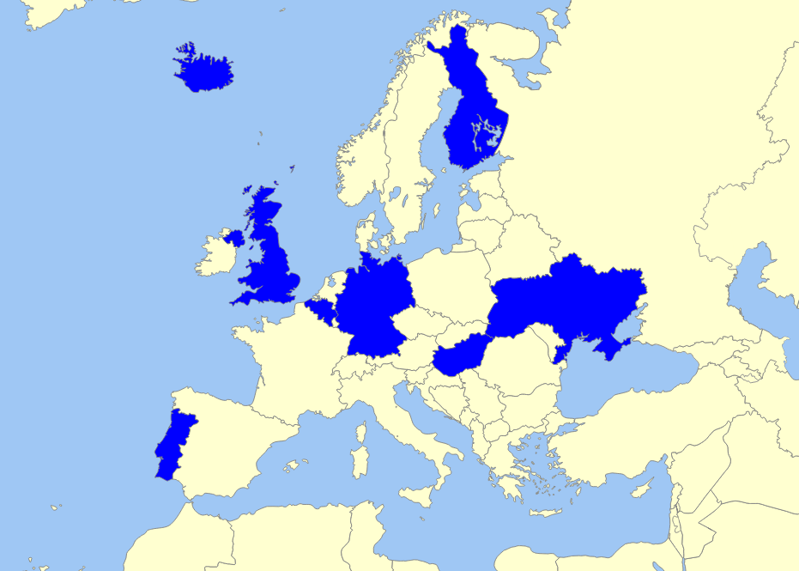

***Figure 4:*** *Countries to be investigated*

In alphabetical order, the list of countries and their main public channels is as follows:

|  |  |  |
| --- | --- | --- |
| **Country** | **Inhabitants in millions** | **Main public channel** |
| **Belgium (Flanders)** | **6.5** | Eén (VRT) |
| Market share (2015) in % | | 31.6 |
| **Finland** | **5.4** | TV1 (YLE) |
| Market share (2015) in % | | 28.5 |
| **Germany** | **82.7** | ZDF (ARD) |
| Market share (2015) in % | | 12.5 |
| **Hungary** | **9.9** | Duna TV (MTVA) |
| Market share (2014) in % | | 7.7 |
| **Iceland** | **0.3** | RÚV (Ríkisútvarpið) |
| Market share (March 2016) in % | | 52.7 |
| **Portugal** | **10.6** | RTP1 (RTP) |
| Market share (March 2016) in % | | 12.4 |
| **Ukraine** | **44.9** | Pershyi Natsionalnyi (NTCU) |
| Market share (2015) in % | | 0.8 |
| **United Kingdom** | **63.5** | BBC One (BBC) |
| Market share (March 2016) in % | | 21.1 |
| **TOTAL** | **223.8** | **Average (in %)** ↓ |
| **Total (Europe)** | **742.5** | **21.0** |

***Table 11:*** *Selected countries and their main public channels (Hendrickx, 2016)*

To determine which public channel is the main one in its competitive television field, I looked at the most recent available market shares of each country’s television landscape. In case there were several different market shares offered, in terms of total viewers and between a certain age demographic, the total viewers option prevailed. It is interesting to note that in the case of Germany, the second public channel ZDF, is larger than the first one, Das Erste, and a similar situation is notable in Hungary. The numbers of inhabitants per country are derived from the respective official statistic bureaus, including the most recent available data for 2016, and are expressed in millions. With a reach of over 220 million people, this research will be relevant for roughly 30% of all European citizens, making it representative for all public broadcasters on the continent. These eight specific countries and their public broadcasters were determined upon based on three parameters:

1. **Variation in geographical position in Europe**

The countries were selected in order to achieve a fair comparison of Eastern, Western, Southern and Northern nations.

1. **Variation in the number of inhabitants per country/region**

Attention is given to both the smaller countries, as to the bigger ones. This leads to more even statistics, as programming tactics differ for smaller and larger broadcasters, depending on the size of their audience and their subsequent allocated budgets.

1. **Variation in the popularity of public broadcasting services**

As the market shares above show, the numbers vary greatly, with between less than 1 percent and over 50 percent market share for public broadcasters.

### 3.3.1 Fact sheet

|  |  |  |  |  |  |  |  |  |
| --- | --- | --- | --- | --- | --- | --- | --- | --- |
| **Fact sheet** | **Belgium (Flanders)** | **Finland** | **Germany** | **Hungary** | **Iceland** | **Portugal** | **Ukraine** | **United Kingdom** |
| **Public broadcaster’s full name** | Vlaamse Radio- en Televisieomroep-organisatie (VRT) | Yleisradio (YLE) | Zweites Deutsches Fernsehen (ZDF) | Duna Médiaszolgáltató | Ríkisútvarpið (RÚV) | Rádio e Televisão de Portugal (RTP) | Natsionalna Telekom-paniya Ukrayiny (HTKY) | British Broadcasting Corporation (BBC) |
| **Launch of public broadcasting** | 1930 | 1926 | 1950 | 1925 | 1930 | 1935 | 1937 | 1922 |
| **Launch of first public television channel** | 1953 | 1958 | 1952[12] | 1957 | 1966 | 1957 | 1965 | 1936 |
| **First broadcast in colour** | 1971 | 1969 | 1967 | 1971 | 1976 | 1975 | 1968 | 1967 |
| **Launch of second public television channel** | 1977 | 1965 | 1963 | 1971 | 2011 | 1968 | 1972 | 1964 |
| **Market share of biggest public television channel** | 31.7% (2015) | 28.5% (2015) | 12.5% (2015) | 7.7% (2014) | 52.7% (March 2016) | 12.4% (March 2016) | 0.8% (2015) | 21.1% (March 2016) |
| **Number of channels** | 3 | 4 | 12[13] | 6 | 2 | 9 | 1 | 7 |
| **Overall market share of the public broadcaster** | 38.5% (2015) | 43.1% (2015) | 36.6% (2015, not counting digital channels) | 16.4% (2014) | 55.0% (March 2016) | 14.4% (March 2016, only of first two channels) | 0.8% (2015) | 28.3% (March 2016, only for BBC One and BBC Two) |
| **Funding** | Government funding + limited advertising + own funding | Public broadcasting tax, commonly known as the “YLE tax” | License fee | The government cooperation Médiaszolgál-tatás-támogató és Vagyon-kezelő Alap (MTVA) | License fee | Government funding + limited advertising broadcasting contribution tax | Government funding | License fee |

# 4 Results

The results section of this master’s thesis is divided into five parts:

1. The global results, the combination of the specific results per country. These qualify best as ‘the European results’, as they are the averages of the eight investigated European public channels.
2. The results per country, every time with a comparison to the European average provided in the first part of the results section. The genres, imports and online presence are discussed separately.
3. The results per genre, every time with a comparison between each country separately as well as the European average provided in the first two parts of the results section.
4. The results per day, every day with a comparison to the European average provided in the first part of the results section.
5. Conclusions that can be drawn from the aforementioned results, including further analyses and insights on the raw figures that this study has provided.

The detailed results per country, with full breakdowns how many minutes each broadcaster divided to each genre per investigated day, are available as appendices.

## 4.1 Global results

### 4.1.1 Genres

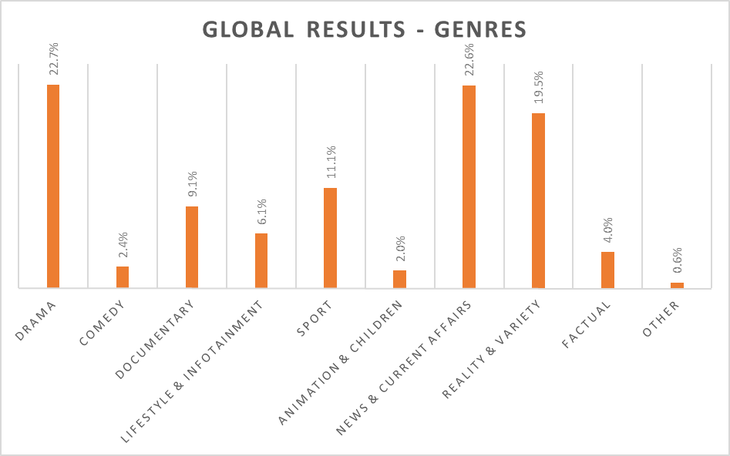

***Figure 5:*** *Global results – genres*

Drama is the narrow winner (22.7%), very closely followed by News & Current Affairs (22.6%). Third is Reality & Variety, with 19.5% of all programmes aired. Not counting the Other programming, the most unpopular category has proven to be Animation & Children, with a mere 2.0% of all programmes aired fitting into that category.

### 4.1.2 Imports

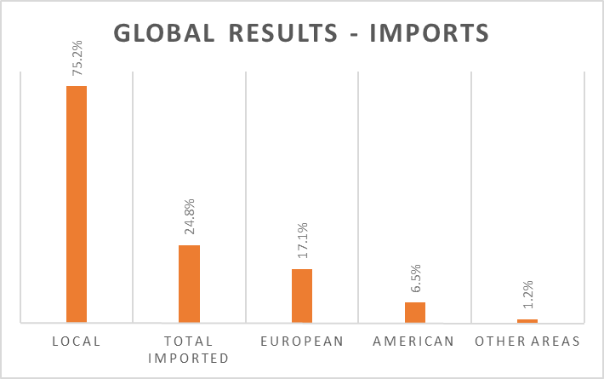

***Figure 6:*** *Global results – imports*

Three thirds of all programmes broadcast at the investigated public channels are local, or originating from their respective countries (including local sports events and locally produced movies). Of the 24.8% of foreign programming, the overwhelming majority comes from other European countries (17.1%), with American broadcasts (6.5%) and programmes from other areas (1.2%) far behind.

### 4.1.3 Online presence

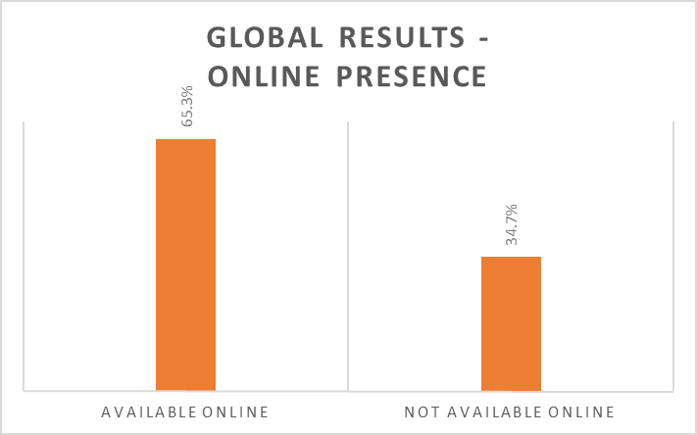

***Figure 7:*** *Global results – online presence*

Just under two thirds of all programmes aired linearly on public broadcasters’ most popular channels can be watched (again) afterwards on online viewing platforms.

## 4.2 Results per country

### 4.2.1 Belgium (Flanders): Eén

The detailed results per country per day for Belgium can be found as appendix 5.

**Key findings:**

* Drama, Sport and Reality & Variety are all more represented than in the European average. News & Current Affairs and Factual are less represented.
* Eén shows more imported programming than the European average, importing more from Europe, the United States and other areas.
* Eén scores very low in the online presence of its linearly broadcast television programmes.

#### 4.2.1.1 Genres

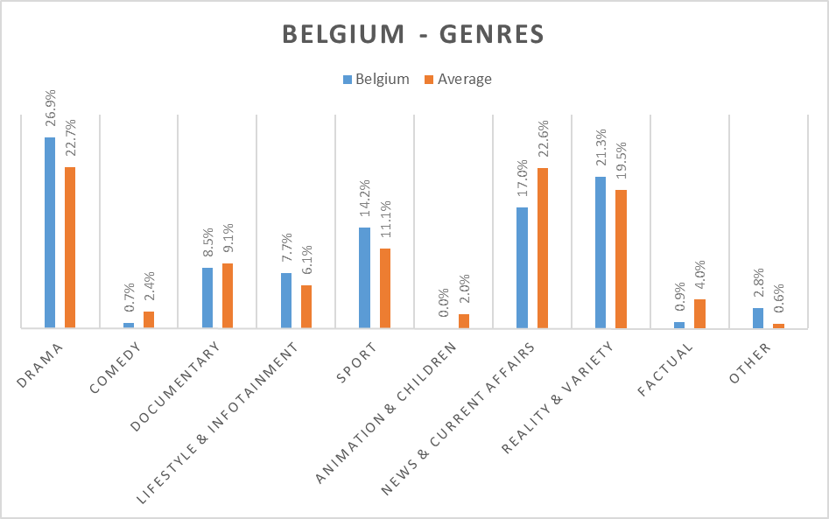

***Figure 8:*** *Belgium (Flanders) – genres*

Eén broadcasts considerably more Drama (+18.5%), Sport (+27.93%) and Reality & Variety (+9.23%), but interestingly enough devotes less screen time to News & Current Affairs programmes (-24.78%). There is no Animation & Children at all, whereas the percentage for Other programming is the highest of all broadcasters researched (+366.66%)

#### 4.2.1.2 Imports

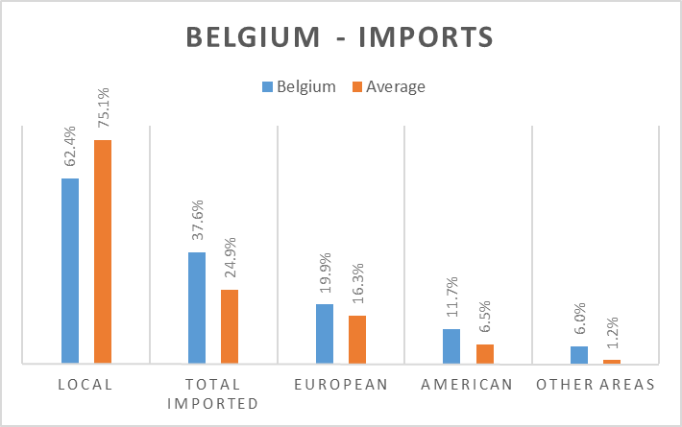

***Figure 9:*** *Belgium (Flanders) – imports*

Eén imports considerably more than the other researched broadcasters, with over one third of all programmes originating in other countries. There are steep increases notable in imports from all areas, European, American as well as other areas.

#### 4.2.1.3 Online presence

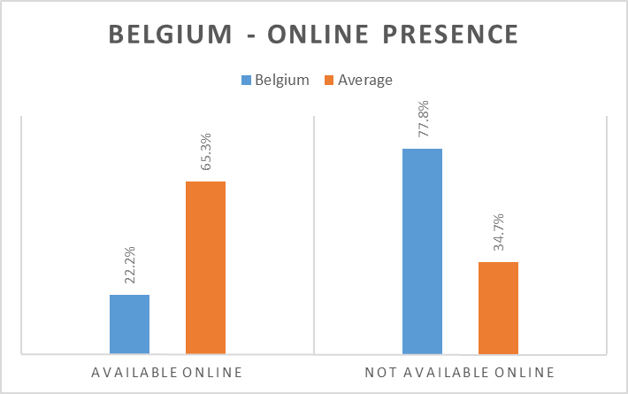

***Figure 10:*** *Belgium (Flanders) – online presence*

Being one of the two investigated broadcasters without an online viewing platform, Eén scores well below the European average, with only 22.2% of all programmes aired being available to watch (again) afterwards online, and all via the news website deredactie.be.

### 4.2.2 Finland: TV1

The detailed results per country per day for Finland can be found as appendix 6.

**Key findings:**

* Drama, Comedy, Documentary and News & Current Affairs are all more represented than in the European average. Lifestyle & Infotainment, Sport and Reality & Variety are less represented.
* TV1 shows less imported programming than the European average, importing more from Europe, but far less from the United States and other areas.
* TV1 scores very high in the online presence of its linearly broadcast television programmes.

#### 4.2.2.1 Genres

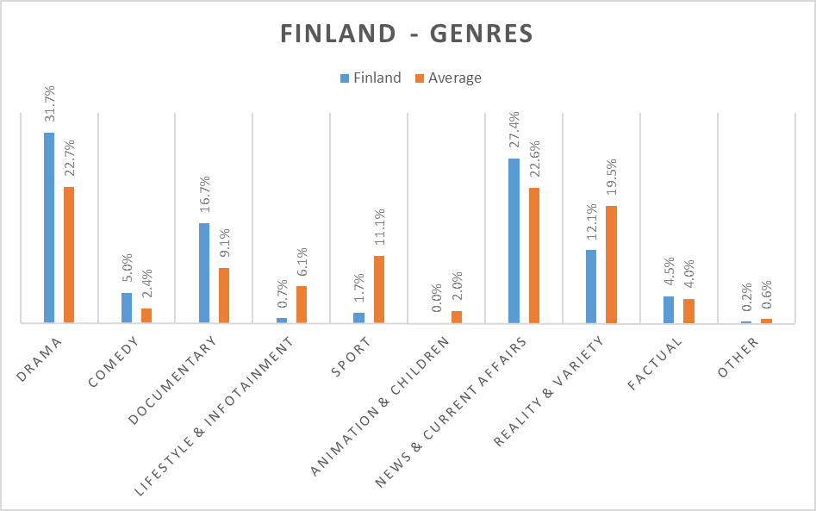

***Figure 11:*** *Finland – genres*

TV1 devotes nearly one third of its entire programming to Drama (+45.8%), which has proven the most popular genre in the aforementioned general results. There is also much more attention for news & current affair programmes (+21.2%) as well as Documentary (+81.5%), whilst considerably less attention is given to sport (-84.7%) and Reality & Variety programmes (-37.9%).

#### 4.2.2.2 Imports

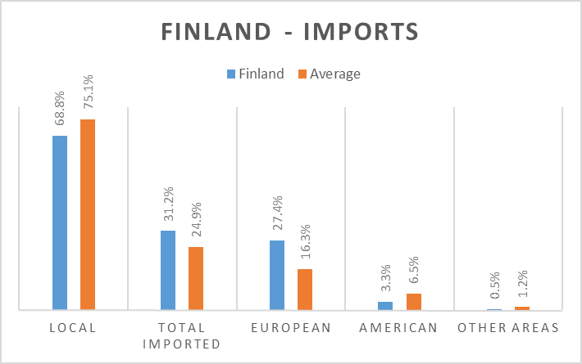

***Figure 12:*** *Finland – imports*

TV1 imports more programmes than the European average (68.8%), with European imports as the overwhelming winner: over one quarter of all programmes aired at TV1 is of European, but not Finnish origin (27.4%).

#### 4.2.2.3 Online presence

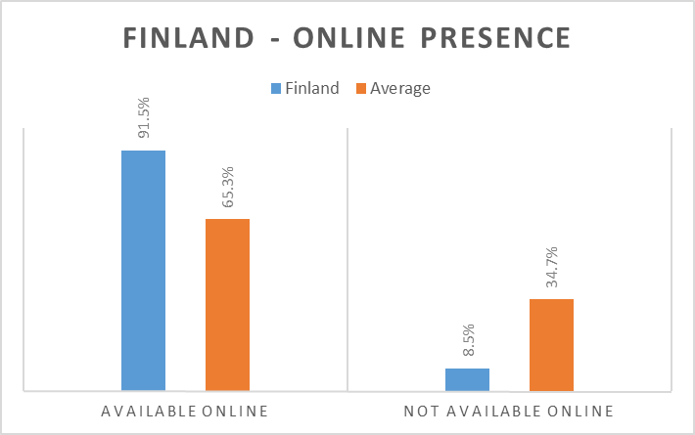

***Figure 13:*** *Finland – online presence*

TV1 and the other channels of YLE have the large majority of ther programmes aired present to watch (again) at their shared online viewing platform YLE Areena, with over 90% of all programmes available.

### 4.2.3 Germany: ZDF

The detailed results per country per day for Germany can be found as appendix 7.

**Key findings:**

* Drama and Lifestyle & Infotainment are all more represented than in the European average. Documentary is less represented.
* ZDF shows less imported programming than the European average, importing equally from Europe, but far less from the United States and other areas.
* ZDF scores very high in the online presence of its linearly broadcast television programmes.

#### 4.2.3.1 Genres

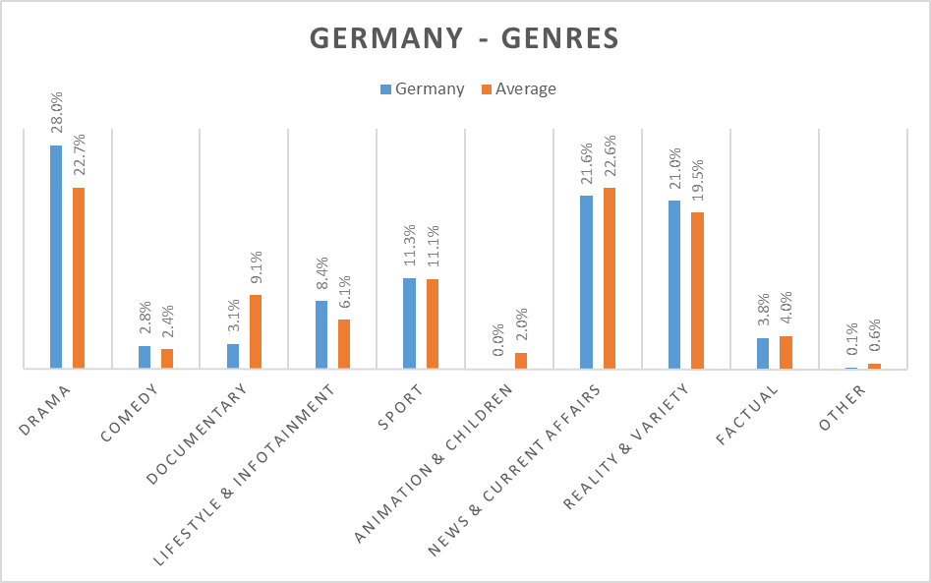

***Figure 14:*** *Germany – genres*

ZDF, the second yet largest channel of public broadcaster ARD, devotes considerably more time in its scheduling to Drama (+23.3%) and Lifestyle & Infotainment programmes (+37.7%) than the European average. Other differences are exceptionally small, with the only notable one being Documentary programmes, with a loss of 27.4% in that category.

#### 4.2.3.2 Imports

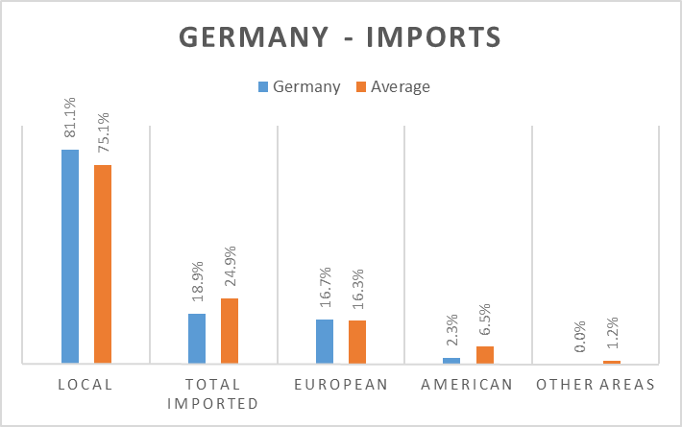

***Figure 15:*** *Germany – imports*

ZDF has over 80% worth of local programming, with only 18.9% imported. European imports prove the most popular, with negligible percentages for imports from the US (2.3%) and other areas (0.0%).

#### 4.2.3.3 Online presence

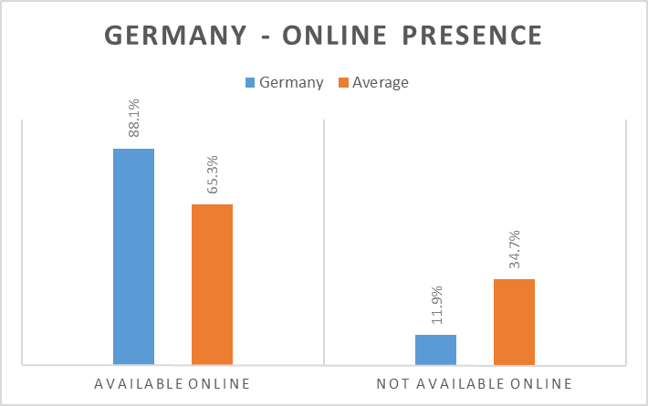

***Figure 16:*** *Germany – online presence*

In the online Mediathek of public broadcaster ARD, the large majority of all programmes aired linearly is available to watch again online. Just 11.9% is not (re)watchable via the Internet.

### 4.2.4 Hungary: Duna TV

The detailed results per country per day for Hungary can be found as appendix 8.

**Key findings:**

* Drama, Comedy and Factual are more represented than in the European average. Sport and News & Current Affairs is less represented.
* Duna TV shows more imported programming than the European average, importing more from Europe and the United States, but not from other areas.
* Duna TV scores inadequately in the online presence of its linearly broadcast television programmes.

#### 4.2.4.1 Genres

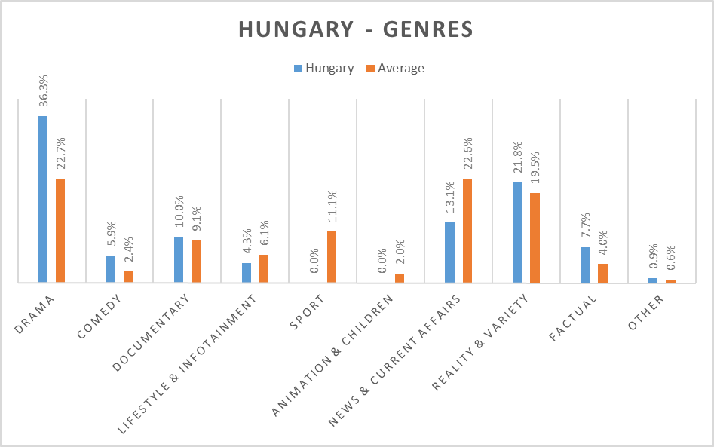

***Figure 17:*** *Hungary – genres*

Duna TV has the largest percentage of Drama programming, with 36.3%, a 59.9% increase on the European average. Considerably less screen time is given to News & Current Affairs (-42.0%) and Sport (-100.0%), which is explained by the fact that public broadcaster MTVA has specific channels solely devoted to news, sports as well as children’s programming.

#### 4.2.4.2 Imports

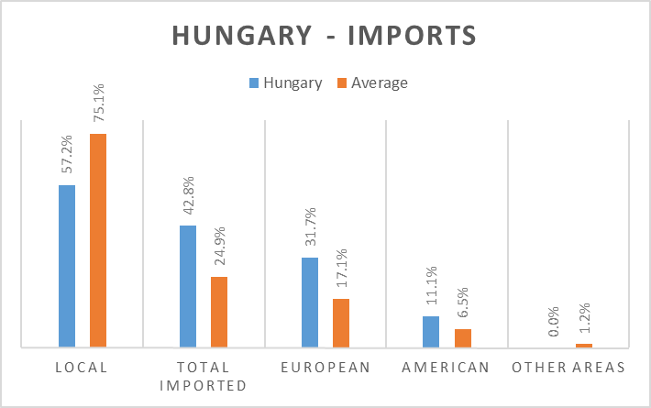

***Figure 18:*** *Hungary – imports*

Over 40% of all programmes aired by Duna TV is imported, with all imports originating in either Europe the United States (11.1%) or other European countries (31.7%).

#### 4.2.4.3 Online presence

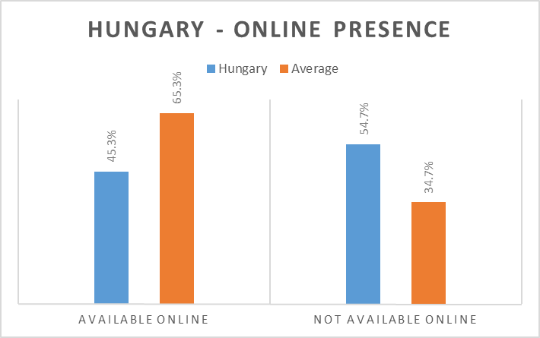

***Figure 19:*** *Hungary – online presence*

MTVA’s online viewing platform Mediaklikk allows Hungarian people to (re)watch nearly half of all programmes aired at Duna TV, with the main focus lying on locally produced shows.

### 4.2.5 Iceland: RÚV

The detailed results per country per day for Iceland can be found as appendix 9.

**Key findings:**

* Sport and Animation & Children are more represented than in the European average. Lifestyle & Infotainment, News & Current Affairs and Reality & Variety are less represented.
* RÚV shows more imported programming than the European average, importing more from Europe, the United States and other areas.
* RÚV scores the highest percentage of all investigated channels in the online presence of its linearly broadcast television programmes.

#### 4.2.5.1 Genres

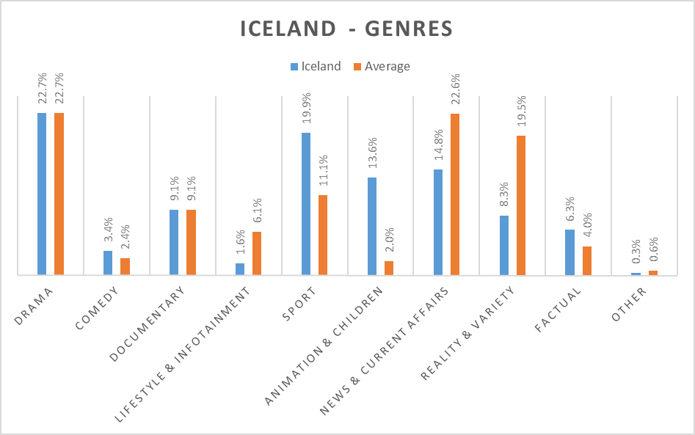

***Figure 20:*** *Iceland – genres*

In the case of RÚV, it is important to note that the channel does not tend to start broadcasting before four o’clock in the afternoon on weekdays. Hence, RÚV does not broadcast the full 12 hours or 720 minutes a day that are researched for all broadcasters, leading the way to skewed results, as they are applicable for less screening time. Interestingly enough, RÚV is identically on par with the European average regarding Drama broadcasts, but devotes considerably more screen time to Sport (+79.3%) and Animation and Children programmes (+580%), in comparison with a drastic fall in News & Current Affairs (-34.5%) and especially Reality & Variety (-57.4%).

#### 4.2.5.2 Imports

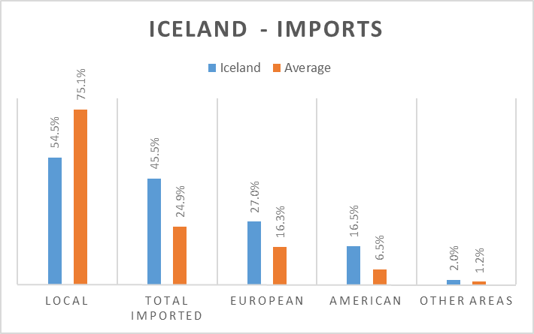

***Figure 21:*** *Iceland – imports*

RÚV imports nearly half of all its programmes (45.5%), with notable increases in both imports from other European countries (27.0%) and the United States (16.5%).

#### 4.2.5.3 Online presence

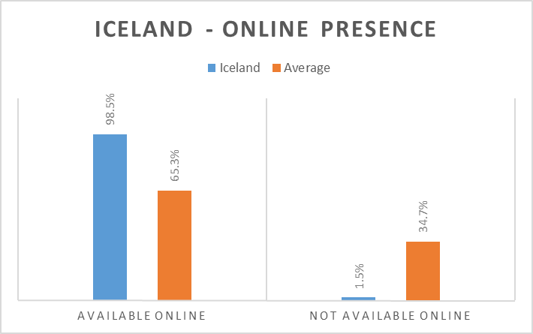

***Figure 22:*** *Iceland – online presence*

An astonishing 98.5% of all broadcasts is available to watch again on Sarpurinn, the online viewing platform at the website of RÚV.

### 4.2.6 Portugal: RTP1

The detailed results per country per day for Portugal can be found as appendix 10.

**Key findings:**

* Lifestyle & Infotainment, News & Current Affairs and Reality & Variety are more represented than in the European average. Drama, Documentary, Sport and Factual are less represented.
* RTP1 shows less imported programming than the European average, importing less from Europe, but equally from the United States, and not from other areas.
* RTP1 scores very high in the online presence of its linearly broadcast television programmes.

#### 4.2.6.1 Genres

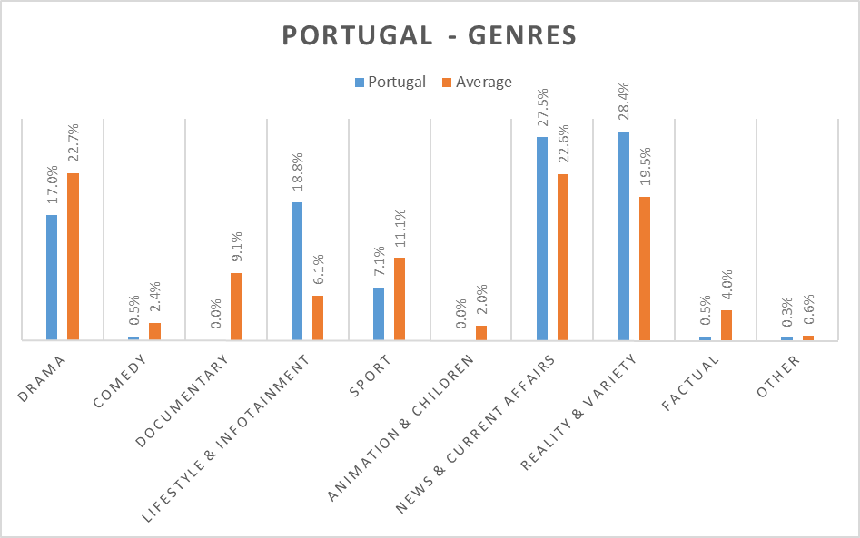

***Figure 23:*** *Portugal – genres*

RTP1 devotes considerably more screen time to Lifestyle & Infotainment (+208.2%) News & Current Affairs (+21.7%) and Reality & Variety (+45.6%), in comparison with less programming belonging to the categories Drama (-25.1%) and Documentary (-100.0%).

#### 4.2.6.2 Imports

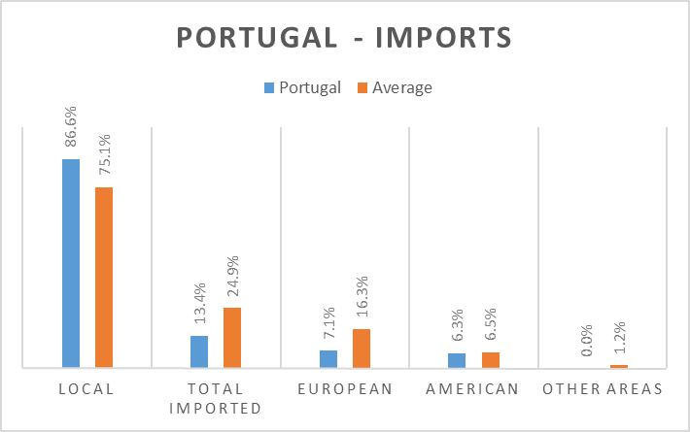

***Figure 24:*** *Portugal – imports*

RTP1 has only 13.4% of its programing originating in other countries, with imports from Europe and the United States nearly on par (7.1% and 6.3%).

#### 4.2.6.3 Online presence

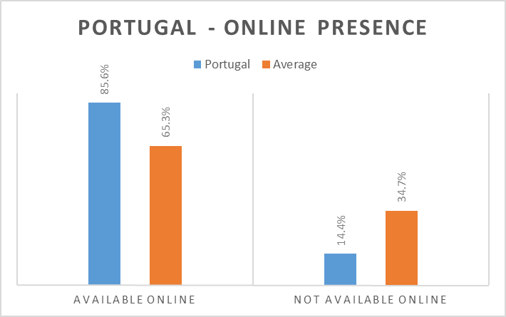

***Figure 25:*** *Portugal – online presence*

RTP Play, the online viewing platform of public broadcaster RTP, allows the Portuguese people to (re)watch over 85% of all programmes broadcast on RTP1.

### 4.2.7 Ukraine: Pershyi Natsionalnyi

The detailed results per country per day for Ukraine can be found as appendix 11.

**Key findings:**

* Documentary, Sport, News & Current Affairs and Factual are more represented than in the European average. Drama, Lifestyle & Infotainment and Reality & Variety are less represented.
* Pershyi Natsionalnyi shows less imported programming than the European average, importing less from Europe and the United States, yet slightly more from other areas.
* Pershyi Natsionalnyi scores the lowest percentage of all investigated channels in the online presence of its linearly broadcast television programmes.

#### 4.2.7.1 Genres

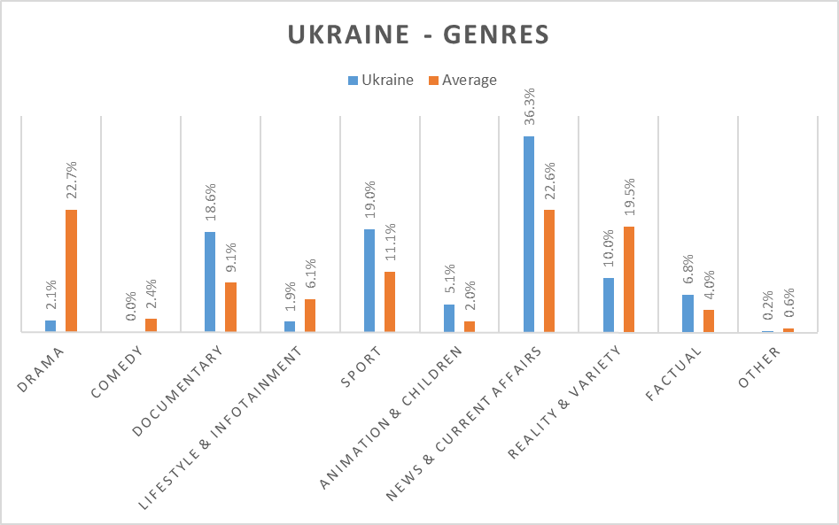

***Figure 26:*** *Ukraine – genres*

Pershyi Natsionalnyi is the odd one out in all investigated broadcasters, with a market share below 1% and an overwhelming majority of News & Current Affairs (+60.6%), Documentary (+104.4%) and sport (+71.2%) programmes. Unsurprisingly, this leads to considerably less attention given to programmes in the categories Drama (-90.7%) and Reality & Variety (-48.7%).

#### 4.2.7.2 Imports

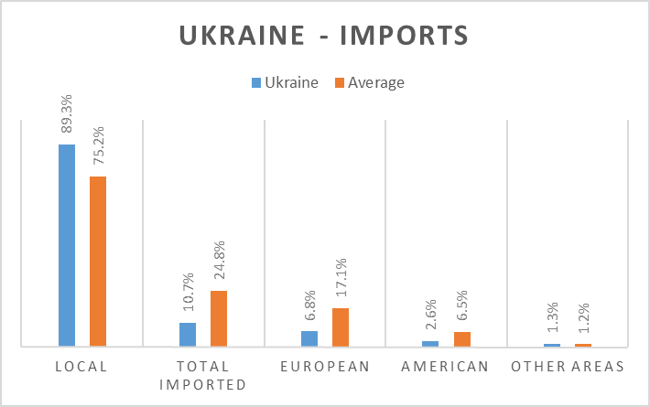

***Figure 27:*** *Ukraine – imports*

Pershy Natsionalnyi devotes considerably more time to locally produced programming than its European counterparts. Nearly 90% of all programmes is made in Ukraine.

#### 4.2.7.3 Online presence

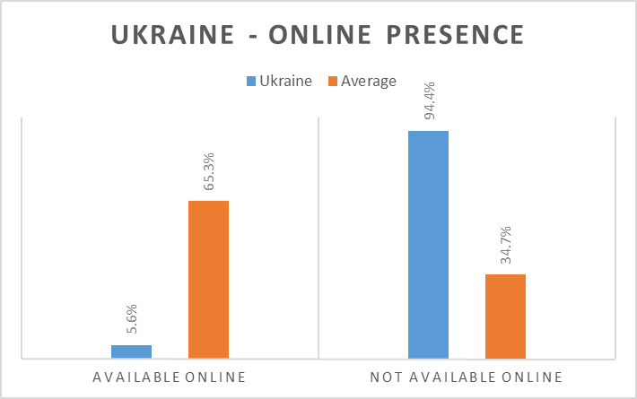

***Figure 28:*** *Ukraine – online presence*

Along with the Belgian Eén, Pershyi Natsionalnyi is the only channel without its own online viewing platform. Some research showed that a considerable portion of its programming is in fact available to watch online, but all squandered on various websites. For instance, a weekly broadcast on American news is placed online at the website of the American embassy in Ukraine. The 5.6% available online counted for the purpose of this research is solely derived from the amount of full programmes available at the official YouTube channel of the broadcaster.

### 4.2.8 United Kingdom: BBC One

The detailed results per country per day for the United Kingdom can be found as appendix 12.

**Key findings:**

* Sport and Reality & Variety are more represented than in the European average. Drama and Lifestyle & Infotainment are less represented.
* BBC One shows less imported programming than the European average, importing less from Europe and the United States, and not all from other areas.
* BBC One scores very high in the online presence of its linearly broadcast television programmes.

#### 4.2.8.1 Genres

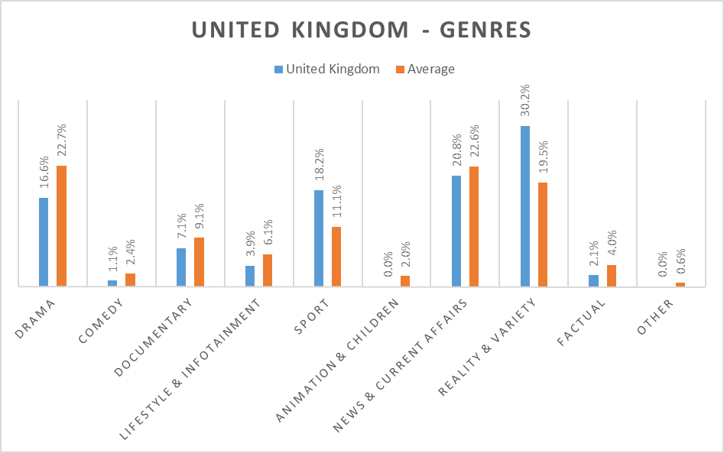

***Figure 29:*** *United Kingdom – genres*

What jumps in the eye immediately is the skyrocketing percentage for Reality & Variety programming: BBC One is in fact the European frontrunner in this genre, with over 30% of its entire schedule devoted to it and a 54.9% gain. Sport is another winner (+64.0%), whereas there is considerably less Drama (-26.9%) and Lifestyle & Infotainment (-36.1%).

#### 4.2.8.2 Imports

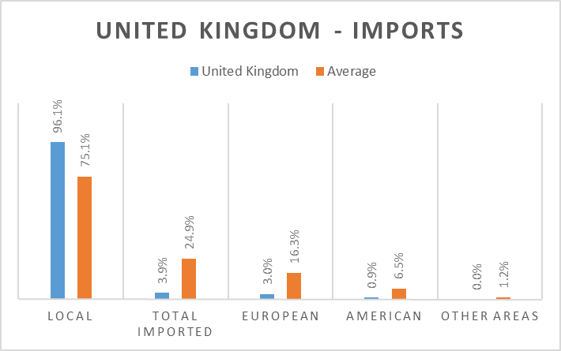

***Figure 30:*** *United Kingdom – imports*

Of all investigated broadcasters, BBC One outputs the highest percentage of locally produced programming, with a mere 3.9% originating in other countries. 3.0% comes from other European countries, with only 0.9% coming from the native English speakers from across the North Atlantic Ocean.

#### 4.2.8.3 Online presence

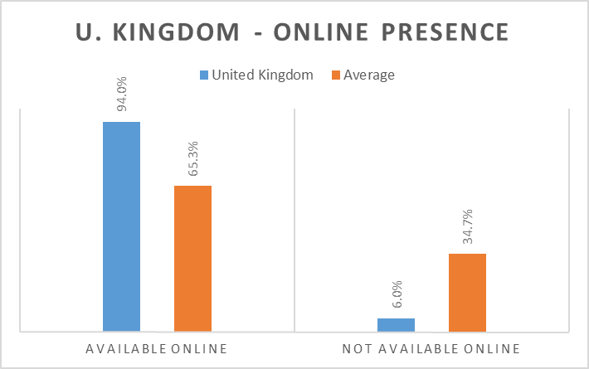

***Figure 31:*** *United Kingdom – online presence*

The BBC iPlayer is known as the European model for online viewing platforms, but ironically enough, “only” 94% of all BBC One broadcasts are available to (re)watch. That percentage is still well above the European average, but less than the Icelandic broadcaster RÚV.

## 4.3 Results per genre

### 4.3.1 Drama

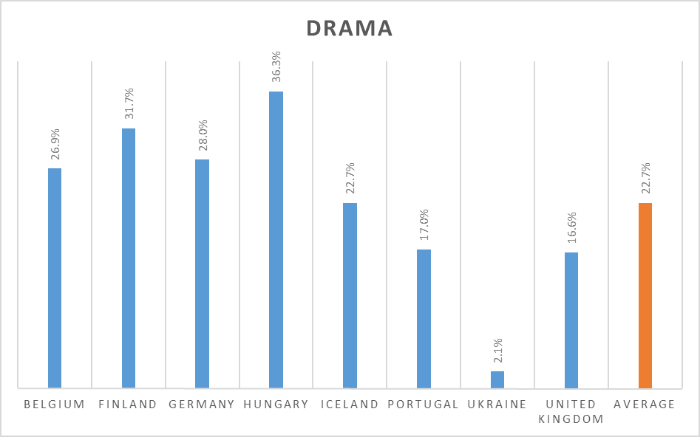

***Figure 32:*** *Genres – drama*

Hungary (36.3%) and Finland (31.7%) devote most time to Drama broadcasts, in stark comparison to Ukraine (2.1%).

### 4.3.2 Comedy

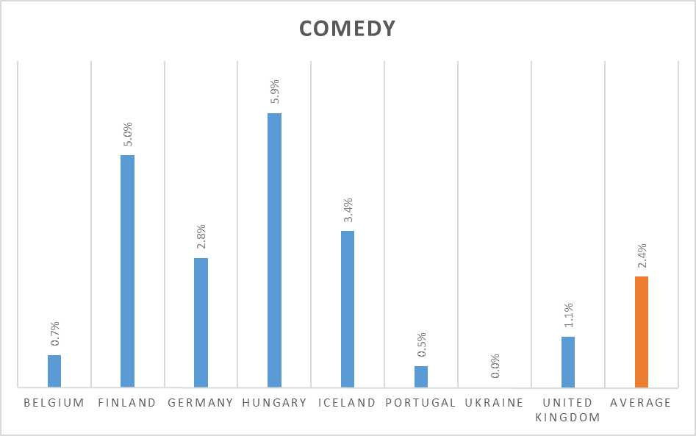

***Figure 33:*** *Genres – comedy*

Low percentages all around, with again Hungary (5.9%) as the most active broadcaster in this genre.

### 4.3.3 Documentary

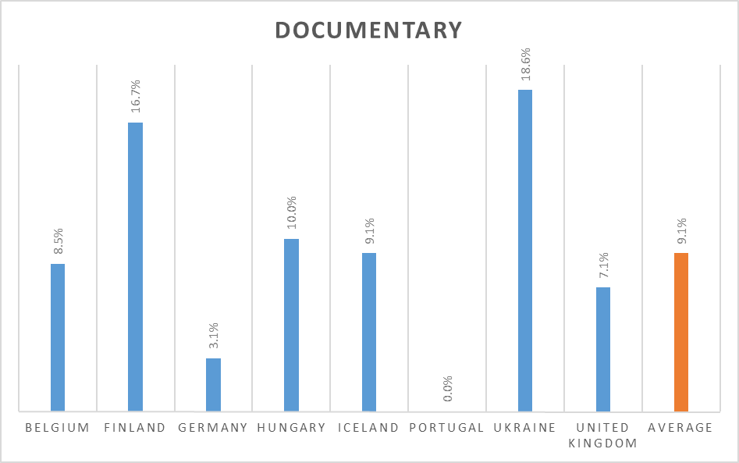

***Figure 34:*** *Genres – documentary*

Ukraine (18.6%) and Finland (16.7%) devote most time to Documentary programmes, as opposed to Portugal, with no Documentary programmes at all (0.0%).

### 4.3.4 Lifestyle & Infotainment

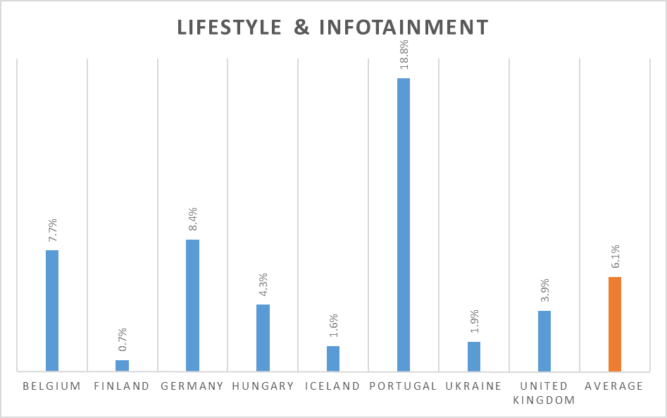

***Figure 35:*** *Genres – lifestyle & infotainment*

Belgium (7.7%) and Germany (8.4%) score above the average, but not as high as Portugal (18.8%).

### 4.3.5 Sport

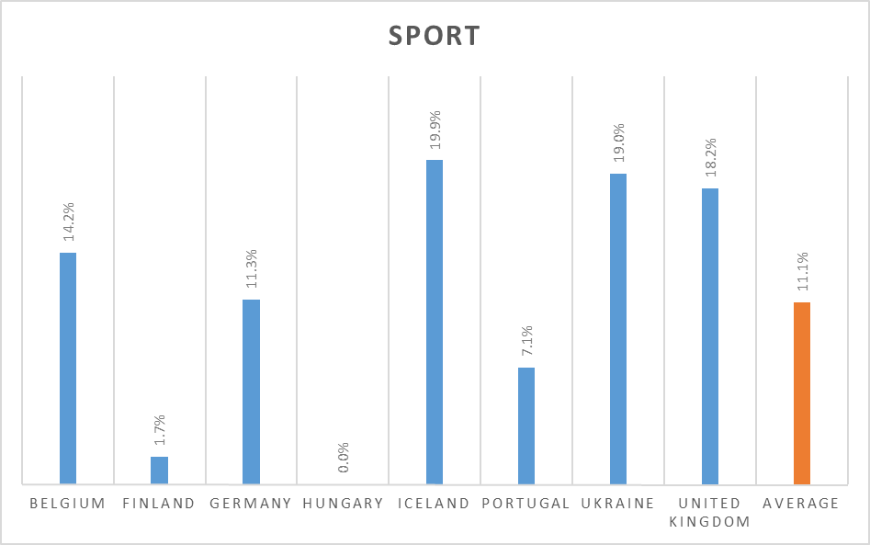

***Figure 36:*** *Genres – sport*

Large differences are notable here, with very low percentages for Hungary (0.0%) and Finland (1.7%), and very high figures for the United Kingdom (18.2%), Ukraine (19.0%) and Iceland (19.9%).

### 4.3.6 Animation & Children

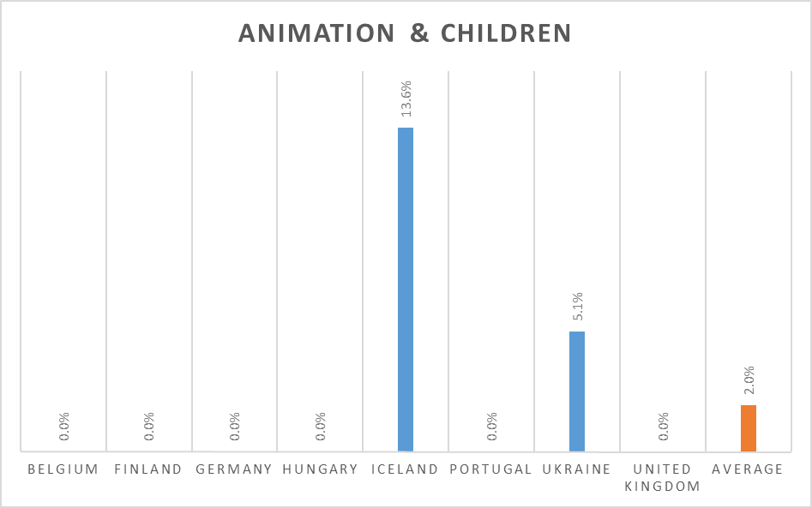

***Figure 37:*** *Genres – animation & children*

Only two broadcasters have more than 0% here, Iceland and Ukraine, bringing the average to 2.0%.

### 4.3.7 News & Current Affairs

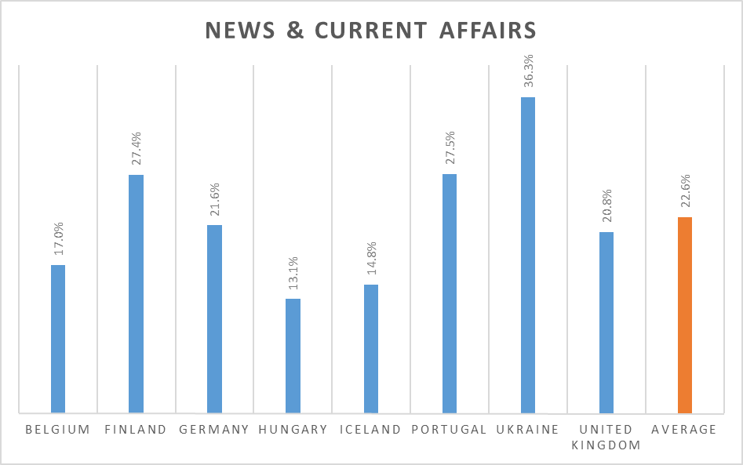

***Figure 38:*** *Genres – news & current affairs*

Ukraine has by far the highest percentage (36.3%), but Hungary (13.1%), Iceland (14.8%) and Belgium (17.0%) all score below the European average of 22.6%.

### 4.3.8 Reality & Variety

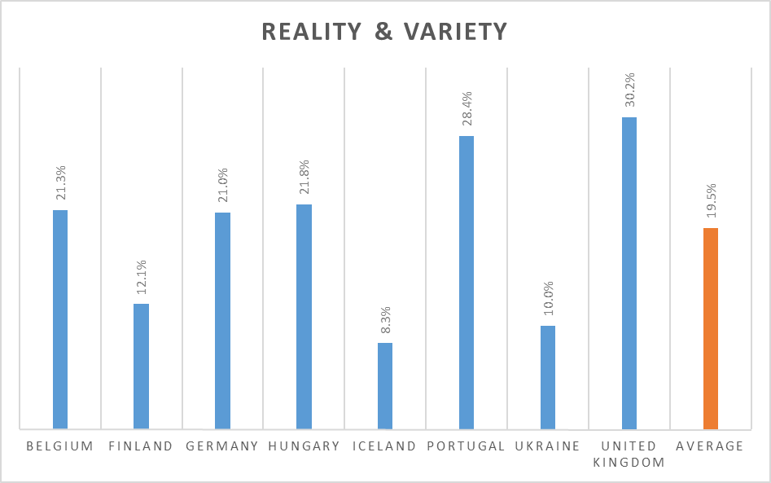

***Figure 39:*** *Genres – reality & variety*

BBC One and RTP1 have the highest scores (30.2% and 28.4%), with only Iceland, Ukraine and Finland below the average.

### 4.3.9 Factual

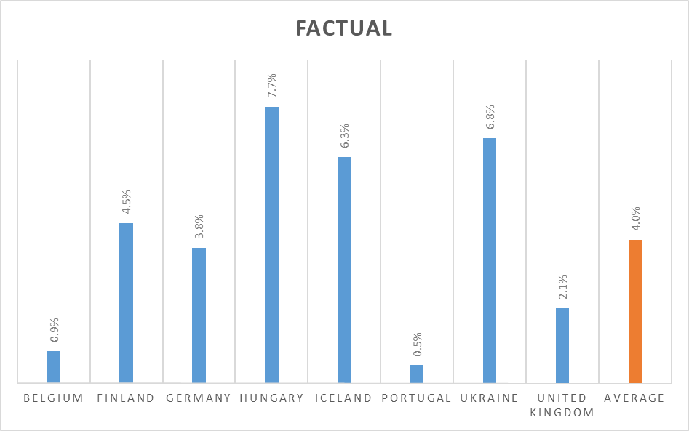

***Figure 40:*** *Genres – factual*

Iceland (6.3%), Ukraine (6.8%) and Hungary (7.7%) score the highest percentages, with negligible scores for Portugal (0.5%) and Belgium (0.9%), both well below the European average.

### 4.3.10 Other

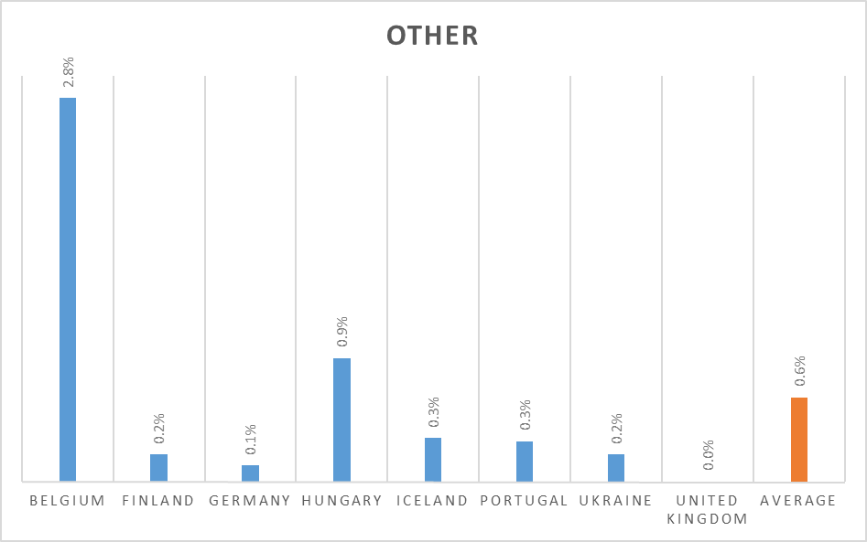

***Figure 41:*** *Genres – other*

Belgium is the ‘winner’ of this category, with 2.8%, due to a show called *Winterbeelden*, which is nothing but webcam footage of European cities.

## 4.4 Results per day

### 4.4.1 Monday (1 February 2016)

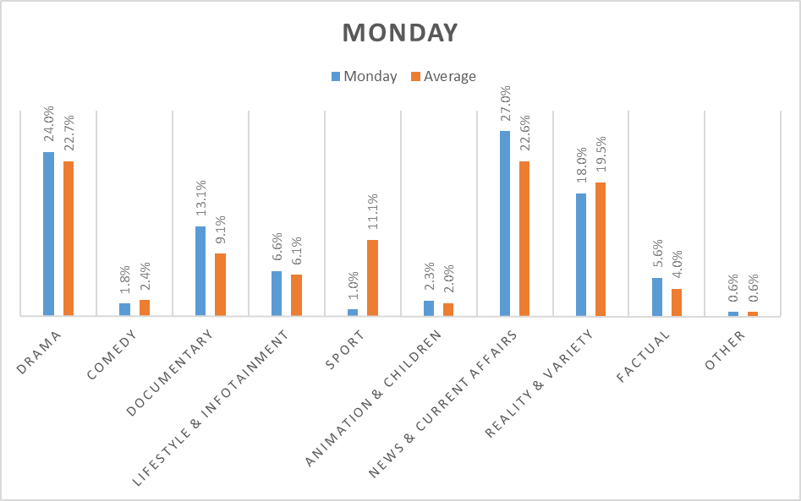

***Figure 42:*** *Days – Monday*

Considerably more screen time is given to programmes in the Documentary (30.5% more) and News & Current Affairs categories (+19.5%).

### 4.4.2 Tuesday (16 February 2016)

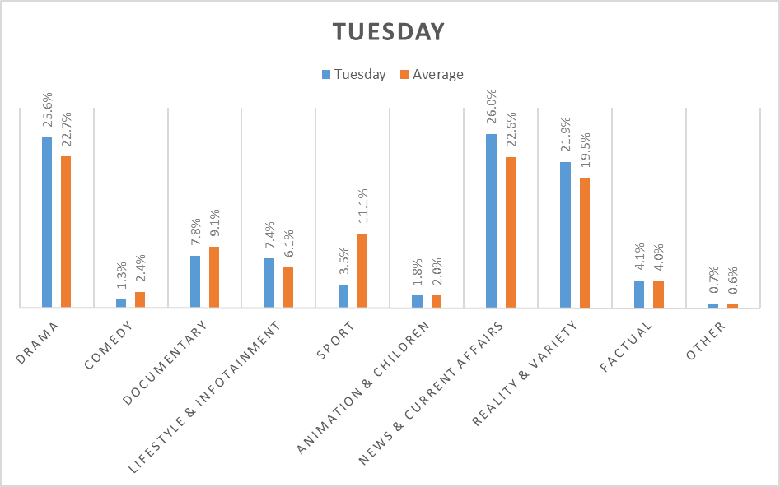

***Figure 43:*** *Days – Tuesday*

Slightly more attention for Reality & Variety (+12.3%), but much less for sport programmes (-68.5%).

### 4.4.3 Wednesday (16 March 2016)

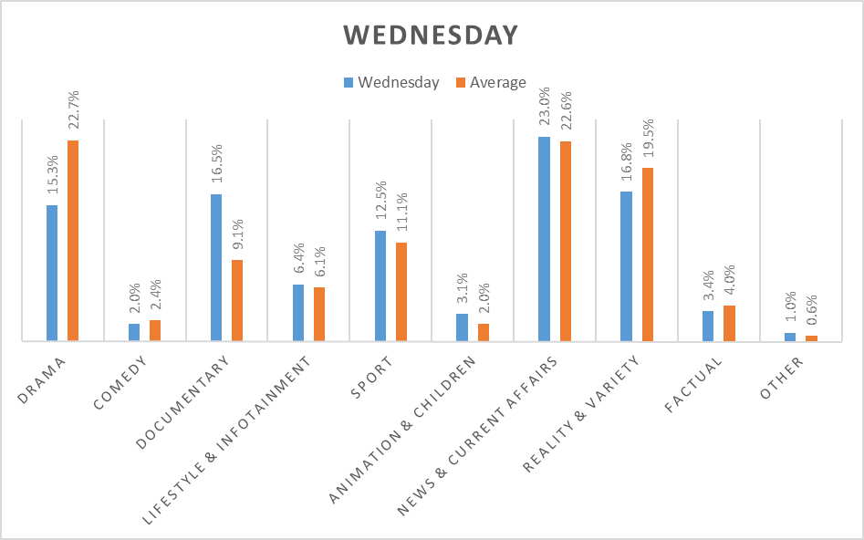

***Figure 44:*** *Days – Wednesday*

A huge increase in Documentary programmes is notable (+81.3%), as well as a sharp decrease in Drama being broadcast (-32.6%). An apparent reason for this is difficult to find.

### 4.4.4 Thursday (10 March 2016)

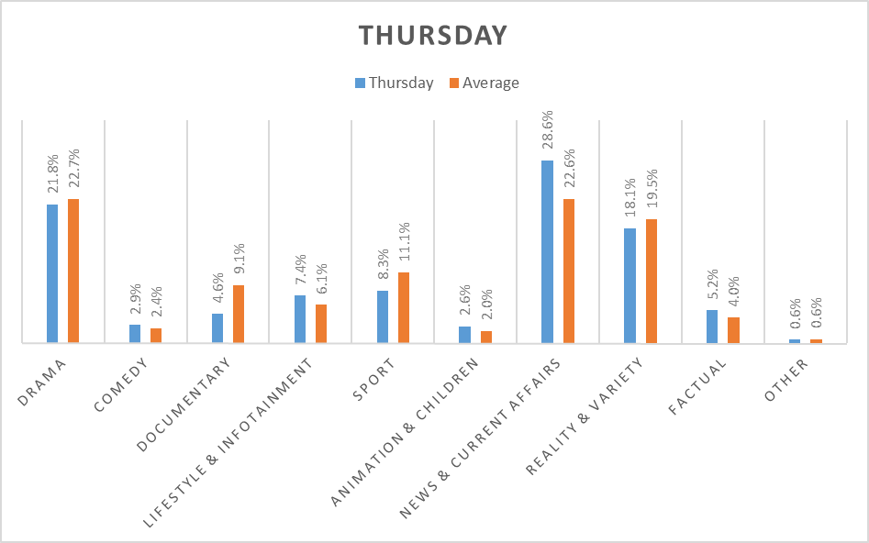

***Figure 45:*** *Days – Thursday*

There is considerably more screen time for News & Current Affair programmes (+26.5%).

### 4.4.5 Friday (26 February 2016)

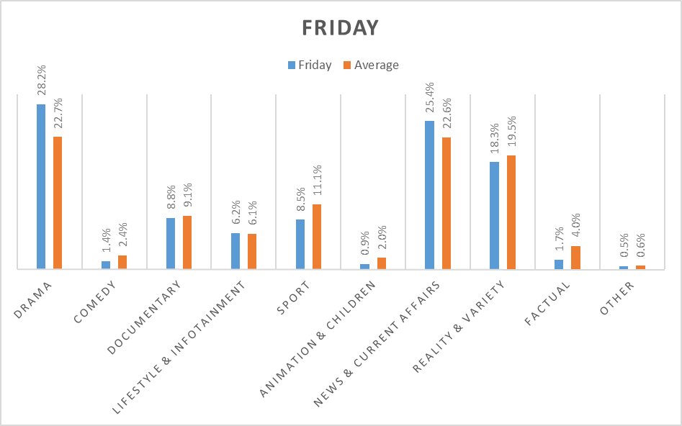

***Figure 46:*** *Days – Friday*

Higher scores for both Drama (+24.2%) and News & Current Affairs programmes (+12.4%).

### 4.4.6 Saturday (13 February 2016)

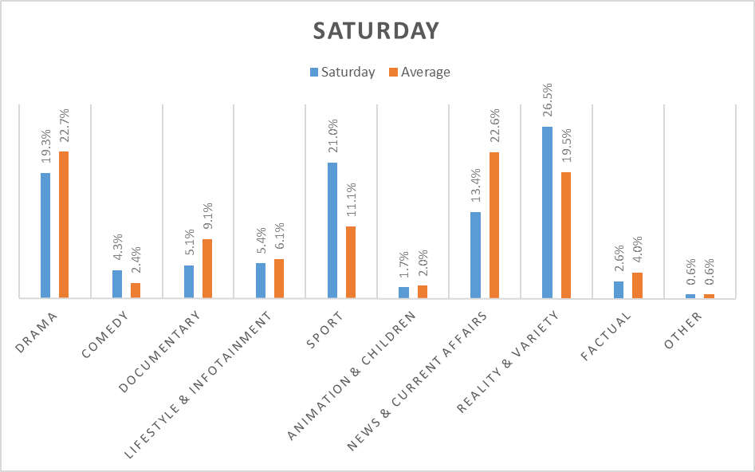

***Figure 47:*** *Days – Saturday*

Due to the weekend, there is far more attention for sport (+89.2%) and Reality & Variety (+35.9%), and less screen time devoted to News & Current Affairs (-40.7%) and Documentary programmes (-44.0%).

### 4.4.7 Sunday (6 March 2016)

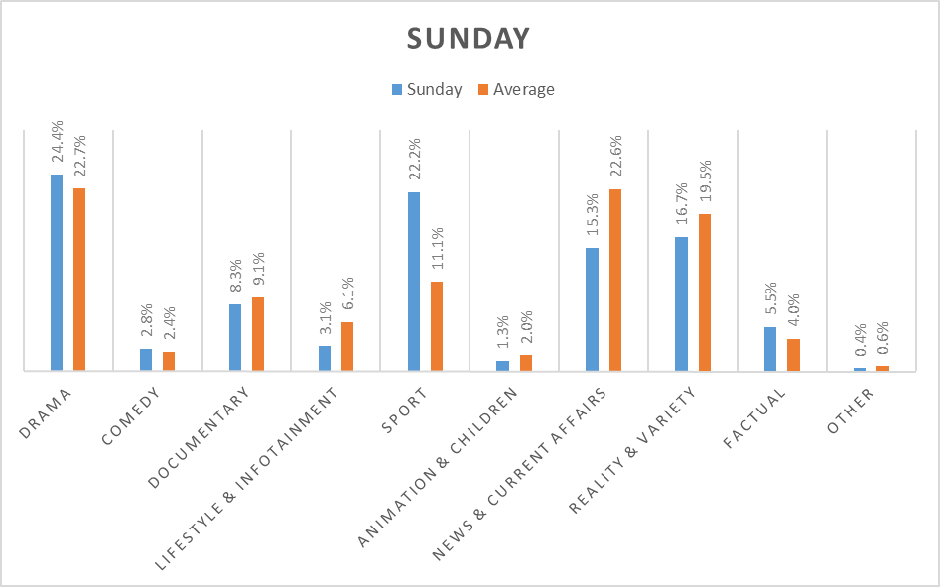

***Figure 48:*** *Days – Sunday*

Interestingly, Reality & Variety scores below the average (-14.4%), as does News & Current Affairs (-32.3%). The biggest increase is noted in sports programming (exactly +100.0%).

## 4.5 Conclusions

### 4.5.1 Genres

The first research question of this master’s thesis was what European public broadcasters actually transmitted on their most popular television channel. In order to analyse that, all programmes broadcast between 12:00 at noon and midnight were divided for a fixed amount of and set of days in a list of ten genres. The global results show that Drama is the most popular genre, accounting for 22.7% of all broadcasts analysed. News & Current Affairs programmes land in a very narrow second place, with 22.6%. This difference is too negligible to draw any definite conclusions from, but it is worth noting that the section Reality & Variety comes in third in the ranking list with 19.5%.

For a different view on the results of the ten genres, the genres were in their turn divided again into three large groups, based on the core elements of what a public service broadcaster should do according to the early chapters of the literature study. These are (along with their respective categories):

1. Inform (News & Current Affairs, Sports)
2. Educate (Documentary, Lifestyle & Infotainment, Factual)
3. Entertain (Drama, Reality & Variety, Comedy, Animation & Children)

The choice of where to put each genre can of course cause stirring debates. The Other category was not counted as the name itself implies that it does not fit in any of the three aforementioned groups. Ultimately I decided to place Sports in the Inform group. It will inevitably be argued that sports broadcasts chiefly contain an element of entertainment, but their paramount aim remains to inform the public on what happens during a sports game of any kind, and what its eventual result is. Lifestyle & Infotainment could have well fitted in all three groups, as programmes in that category have the purpose of informing and educating the public in an entertaining way, with cooking shows being perhaps the most obvious example, but the key element remains educating or teaching the viewers something new. No matter how funny the chef you’re watching may or may not be, at the end he will teach you how to make that risotto, whereas otherwise he would more likely be a stand-up comedian with his own show belonging in the category Comedy. In a similar vein, not all programmes belonging in the category Animation & Children are of course sheer entertainment, as youth news broadcasts for instance are as well counted in this category. But of the eight investigated public broadcasters, I found only one of them to air such a programme, diminishing its impact in the general results and proving that Animation & Children can ultimately be placed in the Entertain group. The results are as follows:

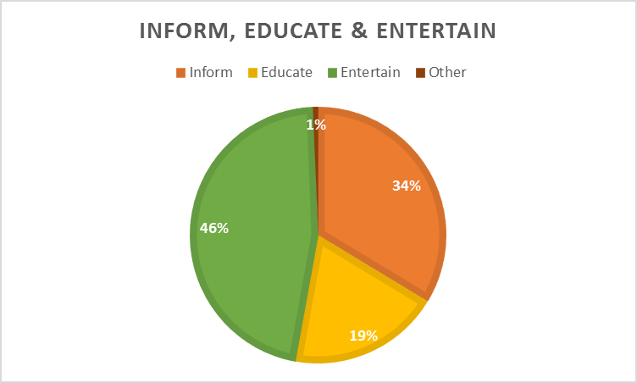

***Figure 49:*** *Inform, educate & entertain*

Entertain is by far the largest group (46%), but interesting to note is that Inform and Educate added up deliver 53% of all programmes, or more than half of all broadcasts and a 7% difference on Entertain. Thus, one possible conclusion is that informing and educating combined is more important for public broadcasters rather than just entertaining their audiences.

### 4.5.2 Imports

Just under one quarter of all programmes aired by the researched channels is imported (24.8%). The previous results sections consistently mentioned the diversification in imports from other European countries, the United States and other countries and areas from across the world as percentages in the grand scheme of local vs. imported programming: of all analysed broadcasts, 17.1% is imported from other European countries, and so on. But it might be interesting to see the relationships merely looking at the 24.8%, or all imports:

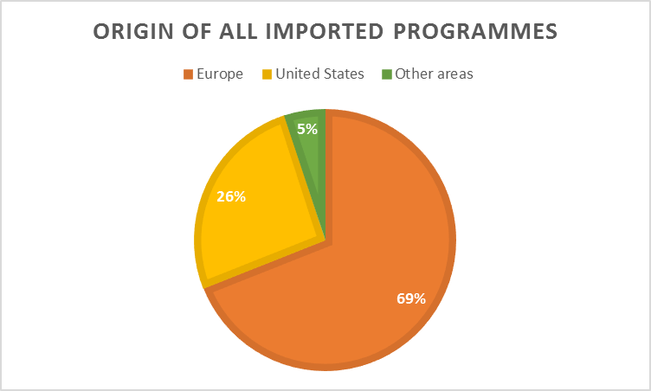

***Figure 50:*** *Origin of all imported programmes*

Nearly seven out of ten of all imported programmes on the researched channels are of European origin, with 26% coming from the United States and a mere 5% from other areas. Two things need to be noted: firstly, this 5% is greatly thanks to the broadcast of the Australian soap opera *Neighbours* on Eén every weekday. Secondly, the overwhelming majority of European imports analysed during the study was in fact found to be off British origins: besides Belgian Eén, also Finnish TV1, Hungarian Duna TV and Icelandic RÚV transmitted British Drama series such as *Downton Abbey* and *Hercule Poirot* on a regular basis. Another often returning country was Germany, with such programmes as *Kommissar Rex* and *Deutschland ’83*.

Comparing these figures to previous research is fairly difficult, as it was either not conducted in similar ways or not with the same countries. Recent research by Belgian universities indicated that Eén imported 41.1% of all its programmes in 2013, the study showed that it was 37.6%. This is of course a lone wolf, and by no means enough to be able to conclude that the import of programmes is decreasing. For a different perspective, results of this research were compared where possible to those of Finnish professor Tapio Varis. The comparison shows differences in the weighing scale of imported programming vs. locally produced programming for 1983 and 2016:

|  |  |  |  |
| --- | --- | --- | --- |
| **Country** | **Broadcaster** | **Imported programmes in 1983 (in %)** | **Imported programmes in 2016 (in %)** |
| Belgium (Flanders) | BRT/VRT[14] | 28 | 37.6 |
| Finland | YLE | 37 | 31.2 |
| Iceland | RÚV | 66 | 45.5 |
| Portugal | RTP | 39 | 13.4 |
| United Kingdom | BBC | 15 | 3.9 |

***Table 12:*** *Imported television shows per broadcaster in 1983 & 2016 (Varis, 1985; Hendrickx, 2016)*

Germany and Hungary are not mentioned in the table above because the 1983 figures dealt with different channels. Ukraine was not used in the 1983 research, hence is impossible to compare. The comparison reveals that there does seem to be a strong tendency for broadcaster to import less programming and produce more local shows, with huge drops in percentages for Iceland, Portugal and the United Kingdom. The sole exception is the Flemish channel today known as Eén, which actually saw an increase on imported programming in its schedules.

### 4.5.3 Online presence

The leitmotiv through the literature study was that there’s a myriad of different organizations, structures, policies, histories and about everything else that one can imagine when taking a close look at different European public broadcasters. This can be extended to the online presence of linearly broadcast television shows. A break-down per country in one table shows the humongous differences in online availability of broadcasted television shows.

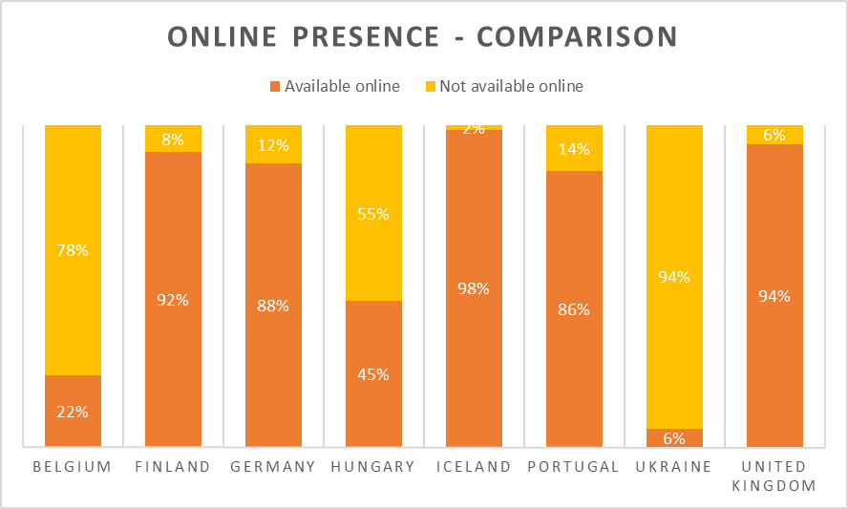

***Figure 51:*** *Online presence – comparison*

Belgium and Ukraine are the only two countries without an existing specific online video platform enabling its audience to (re)watch television programmes. Hungary has such a platform, but allows only limited linear programming to be available on the Internet. The other countries all possess wholesome video platforms, with nearly all of its linear programming present to be watched (again) online.

As no earlier extensive research exists in this specific field, the online presence of linearly broadcast television shows on the most popular channels of European public service broadcasters, it’s impossible to compare these results to previous studies.

# 5 Discussion

The literature study of this thesis has dealt with many different subtopics all relating in one way or another to public broadcasting. It has tried to come up with a suitable definition for PSBs, has made attempts to form a brief historic overview, and has closely looked at the price tags that come along with it. The study attempted to find a shared story in regards to measuring success, programming schemes and schedule contents and the relationship between PSBs and their respective governments, as well as their local audiences and the Internet, and especially on the correlation between all those factors: how governments govern how PSBs treat their local audience on the Internet, or – as measured in the literature study – how willing PSBs are to make available its linearly broadcasted programming online.

In each and every chapter of both the literature study and the results section, there was one ever returning feat, one thing that must strike the reader as it remained consistently the same, time after time: the amount and magnitude of the differences between different countries and different public broadcasters. It has been argued that many PSBs started off similarly in the 1940s and 1950s, and even the wave of neoliberal deregulation swept the whole of Western Europe within one decade, the 1980s, but somewhere in between that and especially after that, it seemed that all public broadcasters lost touch with each other and started an entirely solitary course. Ironically, this all happened during the globalization of the planet, the unification of Western and Eastern Europe, and the subsequent enlargement of the European continent as well as the European Union. Or to put it differently, exactly at the same time in which the world opened up and its inhabitants got to know one another a bit better, public broadcasters and their policies regarding financing, online activity and programming techniques became more and more unique. My aim is not to make too overt political remarks, so I will refrain as best as possible from stepping into that minefield. And even though the next statement is purely based on hearsay and personal feeling, I cannot help but refuse to believe that this increasingly solitary road was only taken for the sake of public broadcasting. But again, no research or study to back me up on this was found, besides proclaiming that Dahlgren and Harvey already fitted neatly into the deregulation schemes of the 1980s into the bigger picture, which begs the question why the individualisation of PSBs should not be part of a bigger cause.

The research presented in this master’s thesis is applicable for roughly one third of the entire European population, as the eight public broadcasters I have investigated cater to audiences of such a combined size. But even with just eight PSBs investigated, the differences are all too clear and large. Only 6% of the output by Ukrainian Pershyi Natsionalnyi can be watched again online. Only 2% of the output by Icelandic RÚV cannot. Finnish TV1 devotes 16.7% of its airtime between 12:00 at noon and midnight to documentaries. Portuguese RTP1 devotes 0.0%. Of all Hungarian Duna TV broadcasts, 31.7% is imported from European countries. For all investigated British BBC Once broadcasts, the figure is 3.0%. And these are just some examples from my research. The literature study has again and again proven that policies can be the complete opposite even in neighbouring countries, for instance by allowing Flemish broadcaster VRT to gather more commercial revenue, while this was heavily reduced for French France Télévisions just a couple of years ago.

*Aficionados* of public broadcasting will interpret the literature study and the results of this thesis as a glorious exemplification of the wuthering variety in European PSBs, and use the point that there is more information and education than entertainment to their advantage. Those people more leaning towards the (neo)liberal side who are in favour or at least not entirely against the notion of reducing the power – and thus, the funding – of PSBs, will find this for exactly the same reasons: seeing that there is no unity on a European level regarding the organization of public broadcasters, and that the entertainment value is of key importance reflected in the programming, there would be no reason why commercial broadcasters wouldn’t be able to do a similar job, away from spending government and/or taxpayer money. They proclaim that PSBs should let some or even all programmes that offer the slightest bit of entertainment go to rival players in the television landscape. Both sides of the spectre present strong arguments, but also have their weak points. The very reason why commercial broadcasting was allowed and the monopoly era of public broadcasters ended during the 1980s, was because the PSBs had no competition whatsoever and were able to do whatever they wanted, irrespective of the likings of the audience it was meant to serve. On the other hand, the Ukrainian programming seems to be ideal scenario for extreme neoliberals – with only 2.1% of the programmes devoted to Drama and a mere 10.0% to Reality & Variety – but a channel void of any programmes that attract large audiences makes it end up with market shares below 1%, as is happening with Pershyi Natsionalnyi at the moment. It is very difficult to speak of a *public service* broadcaster if 99% of an entire population doesn’t have the slightest interest to be served publicly.

It is also rather ironic that the British channel BBC One was found to have the highest percentage of Reality & Variety programmes of all investigated channels. Especially as recent events as reported on in the literature study have shown that the BBC is under tighter scrutiny than ever, with its nearly 100-year-old mission statement set to be rewritten for the very first time since its creation, and ever more criticism on its entertainment programming.

## 5.1 Suggestions for the future of PSBs

I found myself agreeing a lot with one of the strategic objectives in the current management contract between Flemish broadcaster VRT and the Flemish government, which was discussed earlier in the literature study:

‘The VRT stimulates a qualitative strong and economically liveable landscape to maintain a pluralistic and diverse offering in an ever more internationalized context.’

The wording is of course vague enough for many people to read and interpret the sentence in their own way, but one can read it as a statement of responsibility towards public broadcasters. Yes, you are allowed to attract masses with programing that – and we must all admit this – in some cases does not differ all that much from counterparts aired at private broadcasters. But no, that does not mean that you can absorb all market shares and viewing ratings and merely cater the general audience. Unless you are a convinced communist, you should at least agree that a degree of competition is a good thing in order for all parties to try their best to sell what they have on offer to the audience, and thus make what they have on offer better. And again, that is not just applicable for public broadcasting, but I will stop here before getting too politically involved again.

In order to achieve Aristotle’s golden mean, PSBs should identify themselves with programing that is riveting for everyone and at the same time easily distinguishable and more inclusive than shows at commercial broadcasters. Whether or not this is happening adequately right now is a debate that this thesis will not touch upon, especially as one would get eighty different answers for just eight different broadcasters. Here are a few of my personal suggestions for the future of PSBs in Europe:

* In regards to funding, the Dutch system of combined state funding and advertising revenues is definitely among the best ones. Aside from the overtly complicated Dutch public broadcasting system with one foundation serving as public broadcaster and a large number of broadcast organizations based on old religious and political streams among which the screen time is divided, the Dutch financial system, explained previously in the literature study, could prove beneficiary for both the governments and public broadcasters. This will cause commercial broadcasters to outcry that they will have less revenues, but the increased competition has to work both ways, not just in terms of acquiring market shares and solely in the advantage of the private networks out there.
* In regards to remit, it is safe to say that public service broadcasters should be able to report freely on government decisions in news broadcasts, and should not use censorship of any kind to silence opposed voices. To maintain this, a separate, neutral organization should be put up in every country that monitors the workings of PSBs, but without possible side effects from their respective governments. This is of course already the case in many countries – but not all.
* In regards to programming and its heritage, one can safely say that there is currently generally speaking a fair and healthy balance between locally produced shows that also receive adequate public attention and appreciation, as well as strong imports from other countries. As proven in the literature study, all PSBs are required to devote at least half of their screen time to European productions, and Icelandic RÚV broadcasts the least amount of European programmes, with ‘only’ 81.5%. The *Nordic noir* shows such as *The Killing* have proven to be global hits with unanimous critical acclaim, so there is absolutely no need why such programmes should not be sold to and broadcasted by other broadcasters.
* And finally, in regards to the Internet: there are talks in some countries about actually diminishing the role of PSBs online. In the course of this year, the popular news website of Flemish broadcaster VRT, deredactie.be, will be transformed into vrtnieuws.net, where the focus will be “more on the spoken and less on the written word”, as the local minister Sven Gatz has stated. Whilst newspaper websites are of course very capable of informing the audience online as well, again this can be seen as an example of competition that should be allowed to work both ways. If the newspapers fear a loss of advertising revenue because too many people read the ad-free news website of the state broadcaster, then they should invest more in making their own content more attractive, instead of criticizing or attempting to shut down the state-funded competition.

Concerning the online availability of programmes broadcast linearly. it should be mandatory for every self-respecting public broadcaster to realize that linear viewing is not expected to disappear entirely within the next months or years – as proven in the literature study – but online, non-linear viewing is definitely on the increase, and PSBs should keep up with those trends. The majority of them already is taking care very well of this, but of course the looks specifically aim at the Flemish broadcaster VRT. Only “in the course of 2017” will there be an equivalent of BBC’s iPlayer, which makes another quote from the current management contract come across as a bit presumptuous at the moment:

“The VRT will evolve into a digital media organization, simultaneously consolidating its online offer and investing in the development of innovative narrative structures and formats. (VRT, 2015)”

Yes, the management contract is valid until 2020, but if broadcasters catering audiences as small as the Icelandic RÚV manage to have 98% of all their programming up on the Internet to watch (again) by now, it goes without saying that VRT is perhaps just lagging a bit behind. And on a final note, an appeal has to be made: if the VRT, and other investigated PSBs, really wish to pursue more ground on the World Wide Web, I fail to see why they should not be able to put their government-funded money where their mouth is. In the next management contract, it should be announced that VRT is changing its name to VRTI, or *Vlaamse Radio-, Televisie- & Internetomroeporganisatie*, to consolidate its online role once and for all. And one can only hope that some broadcasters will follow suit. This may seem ludicrous right now, but just imagine that the thought of television at some time surpassing radio as a medium seemed impossible to come by just a few decades ago. And radio is anything but dead, and there is no reason to assume that television is a dying medium, unlike some overtly critical and too loud voices. But the Internet has proven that it is here to stay, and if it stays, then rather partly under the auspices of a strong government and an impartial and similarly strong public broadcaster.

Regarding the name change: for a swift moment I thought I was revolutionary and had a new exciting idea for public broadcasters to consolidate their stronger part in the Internet world, but it turns out people were smarter long before I was: already in January 2010 the Walloon public broadcaster changed its name from RTBF, or *Radio télévision belge de la communauté française*, to RTBF.be. ‘This isn’t an anecdotal name change’, stated Jean-Paul Philippot, who is not only the administrator-general of the broadcaster remaining in that function until today, but is also the elected president of the European Broadcasting Union. ‘This change confirms the importance of our move towards the digital network, besides our key activities radio and television.’ (hln.be, 2010) Along with the name change, the website rtbf.be/video was launched, which enabled its audience to (re)watch all linearly broadcast programmes for a period of seven days after its initial airing. This becomes extra interesting when you look at the funding of public broadcasters in the literature study, and notice that RTBF.be is in fact the least funded of them all. VRT, watch, learn, and become VRTI soon.

## 5.2 Recommendations for further research

Of course I hope that this research has contributed a bit to the ongoing investigations in the world of television broadcasting and public service media (policy). Many people have done studies in similar fields to mine – the majority of which I have of course referred to in the literature study of this thesis – but inevitably many others will follow after me as well. Here are a few recommendations which they might find useful in their future research.

For students and/or researchers who wish to investigate on a later date the genres of programming of (European) public broadcasters, I advise them strongly to use the same set of genres as I did. Even though I was at times oblivious to which genre I should allocate certain broadcasts, all in all the list provided was clear-cut enough to distinguish in. Using an Australian compiled list for European research also allowed me to operate without being accused of any bias. Initially I intended to use a list of genres used on the website of the British BBC, but my promotor clearly and correctly told me to avoid that. Should for instance a newly compiled list by the European Commission or another governing body standing above just one public broadcaster be launched, I suggest to choose carefully between that list and the Australian list used in this study.

For those interested in studying the future of imported programming, I strongly advice to keep up with the media directives enacted by the European Commission, and to rely on the former research described in the literature study. Tapio Varis has provided very insightful figures for 1983, and in recent years I have extensively used and referred to the investigation of six researchers by a handful of Flemish universities, which dates only from last year, but will remain relevant for many years to come because of its wholesomeness and complete overview of the topic. An additional tip for students and/or researchers with more time and space on their hands than I have on mine would be to further divide the European imported broadcasts in countries, as Tapio Varis did in his research. In the Conclusions section of the results I expressed that I was convinced that the majority of European imports was British, but I do not possess the correct numbers to officially confirm that statement. Further research upon this would be very welcome and useful.

And finally, for those interested in delving deeper in catch-up television, I would focus further research on digital television and its means for viewers to watch programmes (again). Not only do most broadcasters offer their own catch-up services, both online and on digital television, but nowadays even cable providers have their own services, often free of charge, for their viewers to pause, rewind, record and catch-up on (missed) broadcasts. In the literature study, I cited the Flemish example of Telenet and their service Yelo. A thorough combinatory overview of catch-up services via the Internet as well as online television would provide a more comprehensive overview on the different ways in which viewers can (re)watch television programmes. But by all means is this no excuse for the VRT to stall the launch of its own online platform.

## 5.3 Possible pitfalls

It is important to signal three possible flaws that may arise, and could possibly skew the results, for anyone wishing to pursue similar research in the near future:

1. **Television guides can be tricky**

This research depended entirely on the data provided in the official television guides of broadcasters, available on their official websites. It goes without saying that broadcasters want to inform their audience in the best way possible and thus would never deliberately put wrong programmes or starting times, but it is of course always possible that a few transmissions run late because of many possible reasons. This research could not keep those possibilities in mind, as it would lead us too far, even though it might skew the final results.

Similarly, no attention was given to commercials, also aired on some public broadcasters. As it was not possible to determine when exactly commercial breaks are broadcast whilst studying the online television guides, no reduction in minutes for the planned breaks was taken into account.

1. **There is a fine line between factual and entertainment programmes**

Programmes were only assigned one category, as placing them in two or more separate ones would mix up the percentages and give a skewed image of the programming of public broadcasters. Sometimes it was difficult to find the right nuance and distinguish the correct category for a programme. Two examples:

* A cooking show is factual, as it provides the viewers with information and instructions, but also has a certain entertainment or variety value to it. In this research, the cooking show was ultimately placed in the Lifestyle & Infotainment category, rather than the variety one, as the name infotainment itself implies that the viewer is taught and/or instructed something, in a rather entertaining fashion.
* A youth news broadcast is topical and deals with current affairs, but in a way that is tailored for a specific, young audience. As such, youth news broadcasts were ultimately placed in the Animation & Children category.

1. **News broadcasts and their contents**

In most cases, news broadcasts devote a non-fixed amount of their time to updates about sports. However, as it is impossible to determine how much time exactly based on purely the schedules available on broadcasters’ websites, no news broadcast will be counted in the category sports, unless the broadcaster provides a clear separate news programme purely devoted to sports news. Similarly, many of the excerpts used in news broadcast deal with foreign news, and thus contain imported footage. But seeing that those excerpts are usually very short, and it is again impossible to determine the amount of time that imported footage is shown, all news broadcasts were ultimately placed in the category own programming.

# Bibliography

## Books and (online) journal articles and papers

Allen, R. (1996). As The World Turns: Television Soap Operas and Global Media Culture. In: E. McAnany and K. Wilkinson, ed., 1st ed. *Mass Media and Free Trade. NAFTA and the Cultural Industries*: University of Texas Press.

Antoine, F. (2001). Luxembourg. In: L. d'Haenens and F. Saeys, ed., *Western Broadcasting at the Dawn of the 21st Century*, 1st ed. Berlin: Mouton de Gruyter.

Antoine, F., d'Haenens, L. and Saeys, F. (2001). Belgium. In: L. d'Haenens and F. Saeys, ed., *Western Broadcasting at the Dawn of the 21st Century*, 1st ed. Berlin: Mouton de Gruyter.

Aslama, M. & Syvertsen T. (2006). Policies of Reduction or Renewal? European Public Service Broadcasting in the New Media Era. In: U. Carlsson, ed., *Radio, TV & Internet in the Nordic Countries. Meeting the Challenges of New Media Technology*, 1st ed. Goteborg: Livréna AB.

Avery, R. (1993). *Public service broadcasting in a multichannel environment*. New York: Longman.

Bauwens, J. (2007). De openbare televisie en haar kijkers: oude liefde roest niet?. In: A. Dhoest and H. Van den Bulck, ed., *Publieke televisie in Vlaanderen: een geschiedenis*, 1st ed. Gent: J. Story-Scientia bvba Wetenschappelijke Boekhandel.

Beauvisage, T., & Beuscart, J. (2013). Understanding and Decreasing the Network Footprint of Catch-up TV. *Proceedings Of The 22Nd International Conference On World Wide Web*, *22*(1), 461-462. Retrieved from http://delivery.acm.org/10.1145/2190000/2188077/p461-beauvisage.pdf?ip=130.234.207.14&id=2188077&acc=ACTIVE%20SERVICE&key=74A0E95D84AAE420%2E06A1DC718DC957B2%2E4D4702B0C3E38B35%2E4D4702B0C3E38B35&CFID=576704924&CFTOKEN=10059139&__acm__=1453289966_43a0976ea61203a860f5b85a54765334

Betzel, M. (2003). *Programme performance of public service broadcasting and its mission in the digital age*. 1st ed. [eBook] Available at: http://epra3-production.s3.amazonaws.com/attachments/files/1354/original/Programme%20performance%20of%20public%20service%20broadcasting%20and%20its%20mission%20in%20the%20digital%20age.def.doc?1323685655 [Accessed 11 Dec. 2015].

Bignell, J. and Fickers, A. (2008). *A European television history*. Malden: Wiley-Blackwell.

Biltereyst, D. (1995). *Hollywood in het avondland. Over de onafhankelijkheid en de impact van Amerikaanse televisie in Europa.* Brussel: VUBPRESS.

Biltereyst, D. (2001). Reappraising European Policies to Protect Local Television Content against US Imports. In: L. d'Haenens and F. Saeys, ed., *Western Broadcasting at the Dawn of the 21st Century*, 1st ed. Berlin: Mouton De Gruyter.

Brants, K. & De Bens, E. (2000). The Status of TV Broadcasting in Europe. In: P. Dahlgren, G. Murdock and J. Wieten, ed., *Television Across Europe. A comparative introduction*, 1st ed. California: SAGE Publications.

Castille, V. (2001). The 'Television Without Frontiers' Directive. Mainstream and Independent European Broadcasting in the Digital Age. In: L. d'Haenens and F. Saeys, ed., *Western Broadcasting at the Dawn of the 21st Century*, 1st ed. Berlin: Mouton de Gruyter.

Coleman, J. & Rollet, B. (1996). *Television and Europe*. Oxford: Intellect.

Dahlgren, P. (2000). Key trends in European television. In: P. Dahlgren, G. Murdock and J. Wieten, ed., *Television Across Europe. A comparative introduction*, 1st ed. California: SAGE Publications.

De Bens, E. (1991). De BRT in de pre-VTM-fase: de aanzet tot de dallasificatie van de Vlaamse kijker. In: L. Beheydt, ed., *Taal en omroep*, 1st ed. Rijswijk: Enroprint BV.

Ferenčuhová, M. (2010). Presenting history on Slovak television. In: S. Fenati, ed., *History on television in seven East Europe countries*, 1st ed. Bologna: Centro stampa regionale.

Finnemann, N. (2006). The Internet and the Public Space. In: U. Carlsson, ed., *Radio, TV & Internet in the Nordic Countries. Meeting the Challenges of New Media Technology*, 1st ed. Goteborg: Livréna AB.

Flemish Government,. (2015). *Beheersovereenkomst 2016 - 2020 tussen de Vlaamse Gemeenschap en de VRT*. Brussels.

Foster, P. (2016). BBC told to stop race for ratings. *The Daily Telegraph*, p.1.

Harvey, S. (2000). Channel Four Television: From Annan to Grade. In: E. Buscombe, ed., *British Television. A reader.*, 1st ed. New York: Oxford University Press Inc.

Hester, J., & Dougall, E. (2007). The Efficiency of Constructed Week Sampling for Content Analysis of Online News. *Journalism & Mass Communication Quarterly*, *84*(4), 811-824. http://dx.doi.org/10.1177/107769900708400410

Hickethier, K. (2008). Early TV. Imagining and realizing television. In: J. Bignell and A. Fickers, ed., *A European Television History*, 1st ed. Malden: Wiley-Blackwell.

Hultén, O. and Brants, K. (1992). Public service broadcasting: reactions to competition. In: K. Siune and W. Treutzschler, eds., *Media Policy.* London: Sage.

Jauert, P., Poulson, I. and Søndergaard, H. (2007). Denmark. In: L. d'Haenens and F. Saeys, ed., *Western Broadcast Models: Structure, Conduct, and Performance*, 1st ed. Berlin: Mouton de Gruyter.

Juneau, P. (2000). *PUBLIC BROADCASTING: WHY? HOW?* 1st ed. [eBook] Québec: UNESCO, pp.4-8. Available at: http://portal.unesco.org/ci/en/files/18796/11144252115pb_why_how.pdf/pb_why_how.pdf [Accessed 24 Nov. 2015].

Kerff, M. and Smeets, M. (2004). *De jaren '60*. Antwerpen: Garant.

Lange, A. (2015). *Fiction on European TV channels (2006-2013)*. Luxembourg: Publications Office of the European Union.

Meijer, I. (2005). Impact or Content?: Ratings vs Quality in Public Broadcasting. *European Journal of Communication*, 20(1), pp.27-53.

Mihelj, S. (2012). Television Entertainment in Socialist Eastern Europe: Between Cold War Politics and Global Developments. In: A. Imre, T. Havens and K. Lustyk, ed., *Popular Television in Eastern Europe During and Since Socialism*, 1st ed. London: Routledge.

Moran, A. (2000). Popular Drama: Travelling Templates and National Fictions. In: P. Dahlgren, G. Murdock and J. Wieten, ed., *Television Across Europe. A comparative introduction*, 1st ed. California: SAGE Publications.

Murdock, G. (2000). Digital Futures: European Television in the Age of Convergence. In: P. Dahlgren, G. Murdock and J. Wieten, ed., *Television Across Europe. A comparative introduction*, 1st ed. California: SAGE Publications.

Nencioni, G., Sastry, N., Chandaria, J., & Crowcroft, J. (2013). Understanding and Decreasing the Network Footprint of Catch-up TV. *Proceedings of The 22nd International Conference On World Wide Web*, *22*(1), 965-975. Retrieved from http://delivery.acm.org/10.1145/2490000/2488472/p965-nencioni.pdf?ip=130.234.207.14&id=2488472&acc=ACTIVE%20SERVICE&key=74A0E95D84AAE420%2E06A1DC718DC957B2%2E4D4702B0C3E38B35%2E4D4702B0C3E38B35&CFID=576704924&CFTOKEN=10059139&__acm__=1453286597_c36d822971d447ae07bb976baad51b9a

Papathanassopoulos, S., Coen, S., Curran, J., Aalberg, T., Rowe, D., & Jones, P. et al. (2013). Online Threat, But Television is Still Dominant. *Journalism Practice*, *7*(6), 690-704. http://dx.doi.org/10.1080/17512786.2012.761324

Philippot, J. and Deltenre, I. (2012). *Empowering Society: Declaration on the Core Values of Public Service Media*. 1st ed. [eBook] Le Grand-Saconnex: EBU. Available at: http://www3.ebu.ch/files/live/sites/ebu/files/Publications/EBU-Empowering-Society_EN.pdf [Accessed 24 Nov. 2015].

Ros, G. and Thomass, B. (2007). The Federal Republic of Germany. In: L. d'Haenens and F. Saeys, ed., *Western Broadcast Models: Structure, Conduct, and Performance*, 1st ed. Berlin: Mouton de Gruyter.

Saeys, F. (2007). Statuut, organisatie en financiering van de openbare televisieomroep in Vlaanderen. In: A. Dhoest and H. Van den Bulck, ed., *Publieke televisie in Vlaanderen: een geschiedenis*, 1st ed. Gent: J. Story-Scientia bvba Wetenschappelijke Boekhandel.

Sanz, E., (2012). *Statistical, Ecosystems and Competitiveness Analysis of the Media and Content Industries: European Television in the New Media Landscape*. [online] Luxembourg: Publications Office of the European Union. Available at: http://is.jrc.ec.europa.eu/pages/ISG/documents/TVReportwithnewcoverrevpfmb.pdf [Accessed 2 Dec. 2015].

Scannell, P. (2000). Public Service Broadcasting: The History of a Concept. In: E. Buscombe, ed., *British Television. A reader.*, 1st ed. New York: Oxford University Press Inc.

Schulz, E. (2000). Television Audiences. In: P. Dahlgren, G. Murdock and J. Wieten, ed., *Television Across Europe. A comparative introduction*, 1st ed. California: SAGE Publications.

Svendsen, E. N. (2011). Two Steps Towards a Public Value Test. Danish Public Service Broadcasting Between Two Lines of Control. In: K. Donders and H. Moe, ed., *Exporting The Public Value Test. The Regulation of Public Broadcasters' New Media Services Across Europe*, 1st ed. Göteborg: Nordicom.

Van den Bulck, H. (2007). Het beleid van de publieke televisie: van hoogmis van de moderniteit naast postmodern sterk merk?. In: A. Dhoest and H. Van den Bulck, ed., *Publieke televisie in Vlaanderen: een geschiedenis*, 1st ed. Gent: J. Story-Scientia bvba Wetenschappelijke Boekhandel.

Vanhaeght, A., Ruelens, S., Coppens, P., Claessens, N., Van der Burg, M. and Ichau, E. (2015). *Benchmark van de publieke omroep in Europa: een analyse van het aanbod, financiering en publieksbereik*. [online] Brussel: VUBPress. Available at: https://cjsm.be/media/sites/cjsm.media/files/public/rapport_benchmark-van-de-publieke-omroep-in-europa_20150630.pdf [Accessed 4 Dec. 2015].

Varis, T. (1985). *International flow of television programmes*. 1st ed. [eBook] Paris: Unesco. Available at: http://unesdoc.unesco.org/images/0006/000687/068746eo.pdf [Accessed 26 Nov. 2015].

Vinsze, T. (2010). History on Hungarian Television: an introduction. In: S. Fenati, ed., *History on television in seven East Europe countries*, 1st ed. Bologna: Centro stampa regionale.

## Websites, news articles and press releases

Barb.co.uk, (2015). *Viewing summary - BARB*. [online] Available at: http://www.barb.co.uk/whats-new/monthly-viewing-summary?_s=4 [Accessed 10 Dec. 2015].

Bonte, L. (2003). 50 jaar televisie. Het kijkonderzoek: van meet- tot beleidsinstrument. *De Standaard*. [online] Available at: http://www.standaard.be/cnt/dst24092003_066 [Accessed 24 Mar. 2016].

Debackere, J. (2015). Zo ziet het transformatieplan van de VRT eruit. *De Morgen*. Retrieved from http://www.demorgen.be/tvmedia/zo-ziet-het-transformatieplan-van-de-vrt-eruit-b65bea61/

Digital Agenda for Europe, (2015). *Contributions and preliminary trends of the Public consultation on Audiovisual Media Services (AVMSD) - Digital Agenda for Europe - European Commission*. [online] Available at: https://ec.europa.eu/digital-agenda/en/news/contributions-and-preliminary-trends-public-consultation-audiovisual-media-services-avmsd [Accessed 11 Dec. 2015].

Dutch Advertising Code Authority, (2011). *The Dutch advertising code. Information about the working procedures of the advertising code committee and the board of appeal.* 1st ed. [ebook] Amsterdam. Available at: https://www.reclamecode.nl/bijlagen/20110515_NRC_Engels.pdf [Accessed 13 Jan. 2016].

(EBU), E. (2015). *EBU - Public service media*. [online] Www3.ebu.ch. Available at: http://www3.ebu.ch/about/public-service-media [Accessed 24 Nov. 2015].

Electronic Communications Committee (ECC) within the European Conference of Postal and Telecommunications Administrations (CEPT), (2006). *Analysis of Responses on Fees for Broadcasting and Fees for Non-Commercial and Passive Services*. [online] Available at: http://www.cept.org/documentation/docs/doc98/official/pdf/ECCREP084.PDF [Accessed 5 Dec. 2015].

Elola, J. (2015). What now for Spain’s public broadcaster?. *El País*. [online] Available at: http://elpais.com/m/elpais/2015/03/16/inenglish/1426498650_303671.html [Accessed 4 Dec. 2015].

Epra.org,. (2003). *Naples - WG 1: Programme Performance of PSB - Background Paper*. Retrieved 13 January 2016, from http://www.epra.org/attachments/naples-wg-1-programme-performance-of-psb-background-paper

europa.eu, (2015). *Audiovisual and media*. [online] Available at: http://europa.eu/pol/av/index_en.htm [Accessed 11 Dec. 2015].

European Commission, (2013). *Green Paper. Preparing for a Fully Converged Audiovisual World: Growth, Creation and Values*. 1st ed. [eBook] Available at: http://eur-lex.europa.eu/legal-content/EN/TXT/PDF/?uri=CELEX:52013DC0231&from=EN [Accessed 11 Dec. 2015].

European Union, (2010). *DIRECTIVE 2010/13/EU OF THE EUROPEAN PARLIAMENT AND OF THE COUNCIL of 10 March 2010 on the coordination of certain provisions laid down by law, regulation or administrative action in Member States concerning the provision of audiovisual media services (Audiovisual Media Services Directive)*. 1st ed. [eBook] Available at: http://eur-lex.europa.eu/legal-content/EN/TXT/PDF/?uri=CELEX:32010L0013&from=EN [Accessed 11 Dec. 2015].

Foster, P. (2015). BBC's 'intensely competitive' scheduling damaging our Dramas, ITV says. *The Daily Telegraph*. [online] Available at: http://www.telegraph.co.uk/news/bbc/12014890/BBCs-intensely-competitive-scheduling-damaging-our-Dramas-ITV-says.html [Accessed 10 Dec. 2015].

Het Laatste Nieuws, (2010). RTBF verandert van naam en wordt RTBF.BE. [online] Available at: http://www.hln.be/hln/nl/4125/Internet/article/detail/1053681/2010/01/13/RTBF-verandert-van-naam-en-wordt-RTBF-BE.dhtml [Accessed 28 Mar. 2016].

International-television.org, (2007). *International comparison of TV Ratings & TV Audience Measurement Research Boards and Institutes - International Television Expert Group (itve.org)*. [online] Available at: http://www.international-television.org/tv_audience_measurement_research_boards_and_institutes.html [Accessed 10 Dec. 2015].

Jaarverslag 2014. (2014). [online] Available at: http://www.vrt.be/sites/default/files/attachments/VRT_jaarverslag_2014.pdf [Accessed 4 Dec. 2015].

Leath, W. (2015). Goodbye Texas, hello Woking!. *The Guardian*. [online] Available at: http://www.theguardian.com/stage/2006/nov/14/theatre.pantoseason [Accessed 26 Nov. 2015].

Mavise, (2015). *TV and on-demand audiovisual services in Hungary*. [online] Available at: http://mavise.obs.coe.int/country?id=16 [Accessed 26 Nov. 2015].

Minister of Media Sven Gatz & the VRT,. (2015). *Vlaamse regering & VRT akkoord over beheersovereenkomst*. Retrieved from http://www.vrt.be/nieuws/2015/12/vlaamse-regering-en-vrt-akkoord-over-beheersovereenkomst

Plumer, B. (2012). Why exactly should the government fund PBS and NPR?. *The Washington Post*. [online] Available at: https://www.washingtonpost.com/news/wonk/wp/2012/10/10/why-exactly-should-the-government-fund-pbs-and-npr/ [Accessed 24 Mar. 2016].

Polyák, G. (2015). *Hungary: New Amendment to the Media Act*. [online] Merlin. Available at: http://merlin.obs.coe.int/iris/2015/2/article22.en.html [Accessed 26 Nov. 2015].

Rens, T. and Van Poucke, S. (2016). *Tot 215 banen op de helling bij VRT*. [online] Deredactie.be. Available at: http://deredactie.be/cm/vrtnieuws/cultuur%2Ben%2Bmedia/media/1.2639948 [Accessed 12 May 2016].

Storvik-Green,. (2015). *Nearly 200 million people watch Eurovision 2015*. *Eurovision.tv*. Retrieved 20 January 2016, from http://www.eurovision.tv/page/news?id=nearly_200_million_people_watch_eurovision_2015

Valtioneuvosto.fi, (2015). *Anne Berner. Minister of Transport and Communications*. [online] Available at: http://valtioneuvosto.fi/en/sipila/minister-of-transport-and-communications [Accessed 26 Nov. 2015].

Van den Berghe, L. (2010). *Kenmerken van het management van de VRT als NV van publiek recht. De raad van bestuur en de relatie tot de politiek.* (1st ed.). Gent. Retrieved from http://lib.ugent.be/fulltxt/RUG01/001/490/828/RUG01-001490828_2011_0001_AC.pdf

Var.be,. (2016). *Var - Boodschappen van Algemeen Nut*. Retrieved 13 January 2016, from http://www.var.be/nl/boodschappenvanalgemeennut

Vrt.be,. (2016). *De beheersovereenkomst | VRT*. Retrieved 13 January 2016, from http://www.vrt.be/opdracht/de-beheersovereenkomst

Vrt.be,. (2016). *De financiën | VRT*. Retrieved 13 January 2016, from http://www.vrt.be/opdracht/de-financiering

Vrt.be. (2015). *Hoe belangrijk zijn kijkcijfers voor de VRT? | VRT*. [online] Available at: http://www.vrt.be/faq/hoe-belangrijk-zijn-kijkcijfers-voor-de-vrt [Accessed 10 Dec. 2015].

Vrt.be,. (2016). *About our brands | VRT*. Retrieved 13 January 2016, from http://www.vrt.be/en/about-our-brands

Vrt.be. (2016). *Who is who | VRT*. Retrieved 13 January 2016, from http://www.vrt.be/en/who-who

Willems, F. (2015). *Gatz: "VRT moet samenleving en mediasector versterken"*. [online] deredactie.be. Available at: http://deredactie.be/cm/vrtnieuws/cultuur%2Ben%2Bmedia/media/1.2394311 [Accessed 11 Dec. 2015].

# Appendices

**Appendix 1** Categories of Respondents (Digital Agenda for Europe, 2015) 99

**Appendix 2** Respondents per Country (Digital Agenda for Europe, 2015) 100

**Appendix 3** Origin of fiction programmes broadcast by a sample of TV channels in 17 European countries in 2013 (Lange, 2015) 101

**Appendix 4** Detailed programming of Eén (Belgium) on Wednesday 20 January 2016 between 18:00 and 24:00 (Een.be) 102

**Appendix 5** Detailed programming of Eén (Belgium) during the constructed week sampling 103

**Appendix 6** Detailed programming of TV1 (Finland) during the constructed week sampling 104

**Appendix 7** Detailed programming of ZDF (Germany) during the constructed week sampling 105

**Appendix 8** Detailed programming of Duna (Hungary) during the constructed week sampling 106

**Appendix 9** Detailed programming of RÚV (Iceland) during the constructed week sampling 107

**Appendix 10** Detailed programming of RTP1 (Portugal) during the constructed week sampling 108

**Appendix 11** Detailed programming of Pershy Natsionalnyi (Ukraine) during the constructed

week sampling 109

**Appendix 12** Detailed programming of BBC One (United Kingdom) during the constructed

week sampling 110

**Appendix 1** Categories of Respondents (Digital Agenda for Europe, 2015)

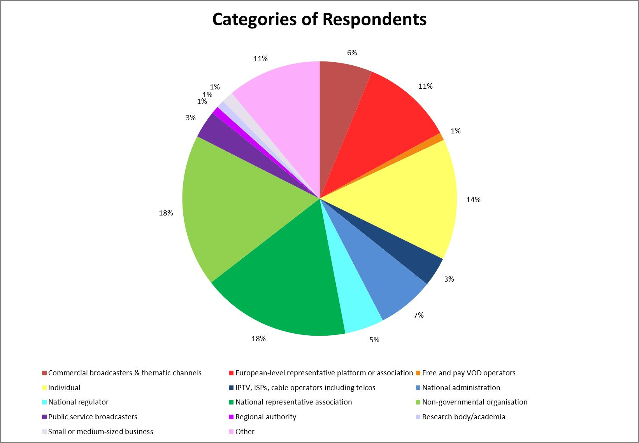

**Appendix 2** Respondents per Country (Digital Agenda for Europe, 2015)

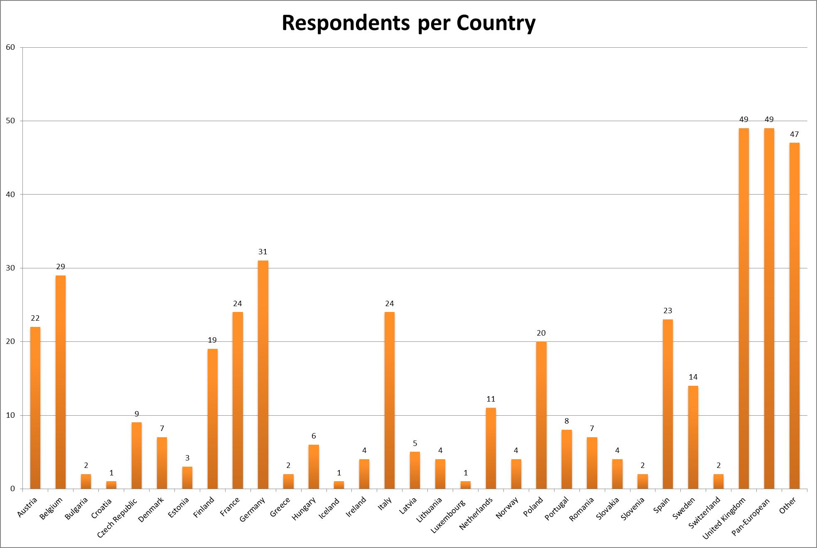

**Appendix 3** Origin of fiction programmes broadcast by a sample of TV channels in 17 European countries in 2013 (Lange, 2015)

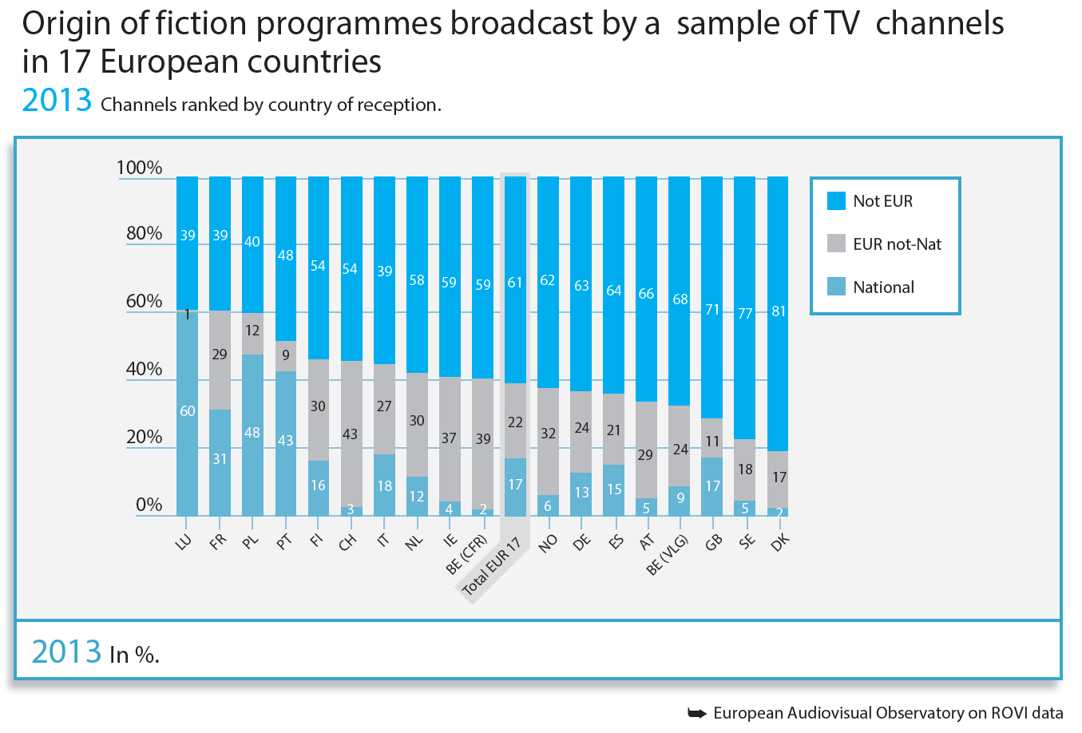

**Appendix 4** Detailed programming of Eén on Friday 29 January 2016 between 18:00 and 24:00 (Een.be)

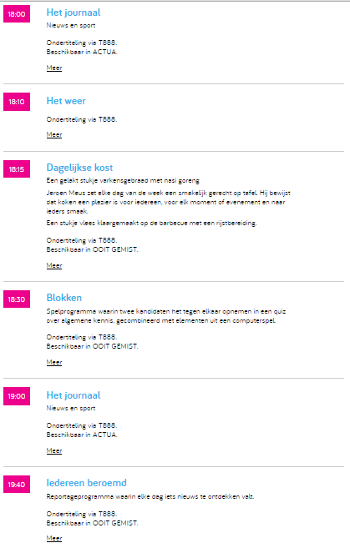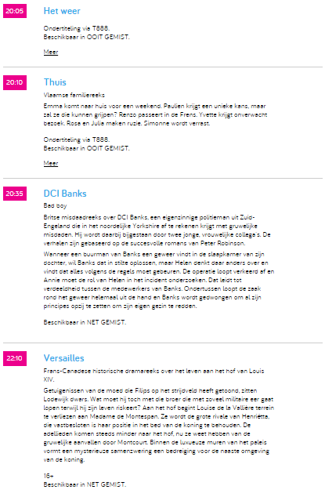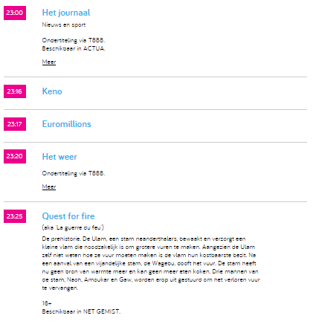

**Appendix 5** Detailed programming of Eén (Belgium) during the constructed week sampling



**Appendix 6** Detailed programming of TV1 (Finland) during the constructed week sampling



**Appendix 7** Detailed programming of ZDF (Germany) during the constructed week sampling



**Appendix 8** Detailed programming of Duna (Hungary) during the constructed week sampling



**Appendix 9** Detailed programming of RÚV (Iceland) during the constructed week sampling



**Appendix 10** Detailed programming of RTP1 (Portugal) during the constructed week sampling



**Appendix 11** Detailed programming of Pershy Natsionalnyi (Ukraine) during the constructed week sampling



**Appendix 12** Detailed programming of BBC One (United Kingdom) during the constructed week sampling



1. Wikipedia defines a green paper as “a tentative government report and consultation document of policy proposals for debate and discussion, without any commitment to action—the first step in changing the law.”
2. The abbreviation “Wal” refers to Wallonia, the French-speaking part of Belgium with RTBF as public service broadcaster.
3. The abbreviation “Fla” refers to Flanders, the Dutch-speaking part of Belgium with VRT as public service broadcaster.
4. Of this amount, €3 054 000 000 went to France Télévisions, with the remainder of the money going to radio broadcaster Radio France.
5. This price only includes television broadcaster France Télévision and omits radio broadcaster Radio France.
6. An American primetime soap opera which ran between 1964 and 1969.
7. An American western series which ran between 1959 and 1973.
8. An American primetime animated series which ran between 1960 and 1966.
9. BRT is since 1998 known as VRT. Between 1991 and 1998, it was briefly called BRTN.
10. MTV is since 2014 known as MTVA.
11. The abbreviation “Fla” refers to Flanders, the Dutch-speaking part of Belgium with VRT as public service broadcaster.
12. This is the year in which the first German public broadcaster, ARD, started transmitting television broadcasts. As said, ZDF is the second public channel, which was launched in 1963.
13. This encompasses all channels by both German public broadcasters, ARD and ZDF, combined.
14. BRT is since 1998 known as VRT. Between 1991 and 1998, it was briefly called BRTN.